Apr. 2011
Group 3
Celina Martin
James Kies
Mike Jones
Yazen Ghannam

Table of Contents
PowerGrid Engineering, LLC
Progress Energy Inc.
Intelligent Driving System for Electric Vehicles
1. Executive Summary 1
2. Project Description 2
2.1 Motivation 2
2.2 Goals and Objectives 3
2.3 Requirements 3
2.4 Specifications 4
2.5 Budget Projection 5
2.6 Milestone Chart 5
3. Background and Research 7
3.1 Mechanical Systems 7
3.1.1 Vehicle Conversion 7
3.2 Electrical Systems 7
3.2.1 Motor 7
3.2.1.1 AC Motors 8
3.2.1.2 DC Motors 10
3.2.1.3 Motor Analysis 12
3.2.2 Battery Supply 15
3.2.3 Solar Power 18
3.2.4 Temperature Sensors & Thermal Control 20
3.2.5 AC Power Input 23
3.2.5.1 Level 1 24
3.2.5.2 Level 2 24
3.2.5.3 Level 3 25
3.2.6 Power Conversion 25
3.2.6.1 AC/DC Conversion 25
3.2.6.2 DC/DC Conversion 29
3.2.6.3 Small DC/DC Conversion 31
3.2.7 Controls 33
3.3 Computer Systems 33
3.3.1 FPGA versus Microprocessor 33
3.3.2 Microprocessor Selection 34
3.3.3 Software Development 35
3.3.4 Touch Screen Options 37
3.3.5 Touch Screen Selection 38
3.3.6 User Interface 39
4. Design 44
4.1 Mechanical Systems 45
4.2 Electrical Systems 45
4.2.1 Voltage Pedal 45
4.2.2 Motor 48
4.2.3 Motor Controller 49
4.2.3.1 AC Motor Controllers 49
4.2.3.2 DC Motor Controllers 51
4.2.4 Battery Supply 52
4.2.5 Sensor/Motor Controller 56
4.2.6 Temperature Sensors & Thermal Control 66
4.2.7 Voltage Measurement 68
4.2.8 Current Measurement 69
4.2.9 AC/DC Power Converter 71
4.2.10 DC/DC Power Converter 74
4.2.11 Small DC/DC Converter 75
4.2.12 Modular Wiring Harness 80
4.3 Computer Systems 86
4.3.1 Class Diagrams for Motor Control System 86
4.3.2 Class Diagrams for User Interface 88
4.3.2.1 Standard Classes 88
4.3.2.2 Basic View 92
4.3.2.3 Advanced View 94
4.3.2.4 Historical View 96
4.3.3 Touch Screen & User Interface 98
4.3.4 Modes 99
4.3.5 Views 99
4.3.5.1 Basic View 100
4.3.5.2 Advanced View 100
4.3.5.3 Historical View 101
5. Prototype 102
5.1 Mechanical System 104
5.1.1 Removing Existing Equipment 104
5.1.2 Rebuilding and Installation 105
5.2 Electrical Systems 109
5.2.1 PIC32 109
5.3 Computer Systems 110
5.3.1 User Interface 110
6. Testing 112
6.1 Mechanical Systems 112
6.1.1 Linear Motion Test Plan 112
6.2 Electrical Systems 115
6.2.1 AC/DC Conversion 115
6.2.2 DC/DC Conversion 116
6.2.3 Auxiliary Power for DOT Certification Test Plan 119
6.3 Computer Systems 121
6.3.1 User Interface System Test Plan 121
6.3.2 Interface Microcontroller Test Plan 123
7. User Manual 123

- Executive Summary

Greenhouse gasses, such as carbon dioxide and methane, are constantly on the rise as society continues to live the “American dream”. These gasses are responsible for climate changes throughout the world and depleting the ozone layer. Unfortunately the many people that feel a sense of confidence from their standards of living don’t understand the repercussions to come. In this particular case the type of transportation vehicles that are used today have a great influence on the environment of tomorrow. Combustible or gas powered vehicles continually emit these pollutants and destroy the environment for future generations. Overall it is important to provide society with the same sense of confidence in their transportation vehicles without altering the environment.

This senior design project is to create an intelligent driving system for any fully electric vehicle. Any electric transportation device can be equipped with this system and provide society with an efficient, reliable and user-friendly vehicle that doesn’t remove any of the standard features of a combustible car. Therefore people are able to maintain the sense of confidence in their vehicles without influencing the environment. This type of vehicle benefits the environment for societies to come, but is capable of benefiting the society of today. As gas prices are on the rise a fully electric vehicle with this system would eliminate more financial burdens. Furthermore the United States dependency on other nations for oil importation would decrease, making a more independent and sustainable nation overall.
An original combustible car is transformed to a fully electric vehicle by removing several main components, such as the engine, exhaust pipes, and gas tank. In place of these parts are 12 twelve volt lead-acid batteries and a fully electric DC motor. These two main components in conjunction with a microcontroller allow the vehicle to reach high speeds, similar to a combustible vehicle. In order to make the vehicle more self sustainable and beneficial to the environment, two 16VDC monocrystalline solar panels are added to charge the auxiliary 12 volt battery, that powers the microcontroller along with any D.O.T. required accessories, such as the headlights, tail lights, wipers, turning signals, etc.. Furthermore another microcontroller is connected to an LCD display that allows the user to choose from three modes of operation. The performance mode allows the driver to accelerate at the maximum rate to reach high speeds of operation. Whereas the normal mode provides a standard rate of acceleration and curtails the maximum speed to typical city driving limits. The economy mode is the most limited driving mode for power saving. This mode automatically engages after the battery pack capacity decreases to 15% and blocks user selection of the performance or normal modes. The economy setting decreases acceleration rate and maximum driving speeds to withhold as much charge as possible. After reaching the final destination the vehicle can be charged using a standard 120VAC grounded plug.

2. Project Description

  - Motivation
The Environmental Protection Agency of the United States of America claims that a typical passenger vehicle emits 5.5 metric tons of carbon dioxide per year. Carbon dioxide is just one of the many greenhouse gasses that are influencing the global warming potential along with methane, nitrous oxide and HFC emissions from combustible engine vehicles. In order to decrease the amount of pollutants produced, gas powered vehicles can be converted to be fully electric. This transition will not only improve the environment but also decrease the dependency on fossil fuels. The U.S. Energy Information Administration states that two-thirds of the United States’ oil use is for the "transportation" sector unlike many other locations in the world. Combustible vehicle conversion in large could reduce the number of oil barrel imports and in turn make the U.S. less dependent on non-renewable resources. An electric vehicle (EV) conversion provides society with a cheaper, cleaner and realistic means of transportation. The average commuter will have the ability to drive a reasonable distance, "fill up" their batteries and return to their initial destination with less environmental influence and financial burden.

Gas powered vehicles have a few more drawbacks with respect to the electric vehicle, such as noise and maintenance. The EV provides the user with a more enjoyable ride as the sound of the combustible engine is removed and replaced with a fully electric motor. Furthermore, the frequent trips to the gas station, the routine oil or filter changes and additional maintenance are no longer needed. The converted EV allows the user the convenience of charging from their own homes or, in many cases nowadays, special parking for charging. The University of Central Florida just recently introduced the solar powered electric vehicle charging station in April of 2010. This station will allow parking for a full six electric vehicles to be charged near UCF's "Memory Mall." The driver will have the ability to receive front row parking in a central location of the university, and charge their vehicle without any additional fees. For a college student this itself is a good incentive as gas prices continue to be on the rise.

Another motivation for the project is the ability to work with a growing electrical engineering firm, Power Grid Engineering, LLC (PGE). This company, located in Winter Springs, FL, specializes in Protection & Control Systems for electric utility companies in the United States. Power Grid Engineering has requested this electric car conversion to display and promote their enthusiasm around Central Florida for renewable and sustainable energy. A more detailed explanation of their requirements is in the section to come. The opportunity to work with an established electrical engineering company will not only allow for the completion of the senior design project through funding, but also introduce the group to several other engineering companies. Florida Solar Energy Center, FSEC, is just one of the many businesses contact is provided to gaining resources to more information and guidance in the task. Overall, the electric vehicle conversion will improve society, the environment and the knowledge base in electrical engineering design within the group.

  - Goals and Objectives
The objective of this project is to provide Power Grid Engineering a fully converted electric vehicle that meets the requirements and specifications stated by them. Primary goals for the outcome of the EV are high efficiency, reliable operation and a user-friendly interface.

High Efficiency
In order to satisfy the goal of high efficiency additional sensors monitor the temperature, current and voltage output from several components within the vehicle such as the batteries, motor and microcontrollers. The total efficiency of the vehicle is improved through its intelligent control system as described in the requirements section. Furthermore the components for charging are selected to increase overall efficiency to maintain battery capacity.

Reliable Operation
By enabling additional monitoring and reporting the collected data, the user is able to feel confident on the reliability of their vehicle. Overall the vehicle is as reliable as the gas-powered vehicle. Similar to a gas meter, a battery capacity meter informs the user of how much power is left on the battery charge and therefore ensuring the capable distance to be traveled. To enhance the reliability of the vehicle solar panels are incorporated to charge the batteries during off time. This renewable source of energy from the sun convinces the user that charging is possible despite the location of stopping, as long as the sun is visible.

User Friendly Interface
The LCD touch screen display provides the user with an up to date means of displaying technical data about the car. This central location of information enables the user to pay adequate attention to the road while checking the statistics of battery capacity, RPM, speed, voltage, and current. Buttons allow the user to navigate to historical information, view more detailed statistics and further select their mode of operation. Many functions such as the “gas” pedal and braking remain consistent in the converted vehicle to maintain the same conventions many drivers are already accustomed to.

  - Requirements
The main purpose for creating this vehicle is to supply the sponsor, Power Grid Engineering, LLC, with a fully electric vehicle that is altered to meet any additional requirements set by them. The requirements consist of the vehicle being legal to drive; therefore the department of transportation standards must be met. Furthermore a renewable power source is included, specific monitoring and an intelligent driving system. These requirements are explained in detail below.

DOT Standard
The Department of Transportation (DOT) requires that all vehicles have functioning turning signals, wipers, brake lights and headlights to ensure adequate safety of surrounding drivers. The benefit of converting a dealership standard combustible engine vehicle ensures the fact that many of the pre-existing components required to meet this standard are still readily available. Throughout the conversion process it is necessary to allow these external elements to remain accessible and powered for the drivers use.

Solar Power
Solar panels are to assist in charging the batteries as a renewable energy source. There is no specification to how many panels must be used or how much energy must be received from them. The only limitation is the surface area susceptible to the sun’s rays and capable of generating power.

Monitoring
The user is able to view the real time RPM, speed, voltage, current and battery capacity. There is no requirement detailing the historical data to be shown to the driver, simply the real time data.

Operation Modes and Intelligent Driving System
The driver is able to select different settings depending on their driving habits. The three modes consist of performance, normal and economy mode. The normal mode is for average driving conditions with slow acceleration and low speed levels. The performance mode allows fast acceleration and higher speed ranges and finally the economy mode limits both acceleration and speed to save the maximum battery power. The vehicle is capable of automatically switching to solar-economy mode when battery capacity decreases below 15%. During this period it blocks performance and normal modes from being enabled by the user. There is no requirement detailing the specific speed ranges or acceleration ratings for each mode of operation.

  - Specifications
Several specifications are included in a car conversion project. Power Grid Engineering specifies the following characteristics:
      - Maximum Speed of 50 mph
- Maximum Distance Traveled (between charges) of 60 miles
- Vehicle must be fully electric
- Must include solar panels
- Intelligent Driving System with 3 modes
  - Economy
  - Performance
  - Normal
- LCD Display of data
Further specifications are as follows:
- Economy style vehicle with a manual transmission
- Motor suitable to travel with the weight of the vehicle and batteries
- Power steering and brakes are enabled for ease of driving
- The LCD display with a touch screen is included to interface with the driver and select modes of operation
- The LCD display contains advanced statistics and historical information on the batteries and controls.
- Temperature sensors for thermal control are located throughout the vehicles electrical components such as the motor, controller, and battery pack
- The motor controller interfaces the driver pedal and motor
- During low power situations (economy mode) the controller is capable of shutting down additional monitoring/options
- Solar panels provide power to a battery while the battery pack is not charging
- An auxiliary battery provides power to the necessary safety and D.O.T required components.

  - Budget Projection
It is decided that the project budget will not exceed $5900. The budget reserved for each component is listed below:

Motor | $1500
Electronics & Cables | $1000
Controller | $200
Car | $1000
Batteries | $1200
Solar Panels | $500
Display Screen | $500
Total | $5900

  - Milestone Chart

The goals and objectives are divided into two main sections: software and hardware milestones. Figure 1 shows the software milestone tasks and expected dates for completion of them. These tasks consist of the coding for the LCD and motor controllers and testing the various sensor outputs that must be reported to the user display screen. Figure 2 shows the hardware milestone tasks and their respective dates for completion. The hardware milestones consist of the progression of rebuilding the vehicle to include a motor and batteries, and testing the various connections between sensors and the motor controllers.

Figure 1 - Software Milestones

Figure 2 - Hardware Milestones
- Background and Research
  - Mechanical Systems

The mechanical system consists of the drive shaft, front suspension, rear suspension, chassis, hubs, brakes, wheels and tires. For an EV conversion many of these systems remain intact and undisturbed. The following section describes what mechanical systems are interfaced with and their influence on the overall design of the EV.

    - Vehicle Conversion
The first step of an electric car conversion involves finding the right automobile appropriate for the motor type and the weight of the battery pack. This first step is the basis for the rest of the design specifications and can save valuable time and money if chosen correctly. With those details in mind, a small economy style vehicle with a manual transmission is preferred. This is due to the fact that most motors are readily available to be mated to a manual transmission. An automatic transmission vehicle can be used but the transmission must be removed. The motor chosen for this configuration must then be large enough to connect directly to the drive shaft. The manual transmission option allows more time to concentrate on the design and improvements in efficiency, rather than dedication to mechanical concerns. With a manual transmission the next step is the actual connection between the electric motor and the transmission. This consists of an adaptor plate made for the specified motor. Many vehicle conversion projects purchase the adapter plate and the motor in a kit to ensure that the two components are adequate and complement each other properly.

  - Electrical Systems
The electrical systems consist of the motor, batteries, solar panels, sensors and power conversion within the vehicle. The research from these areas is described below.

    - Motor
Converting an existing combustion engine automobile into a fully electric vehicle requires careful selection of an electric motor. The size and type of the motor depends on the weight of the automobile being retrofitted. Other factors that narrow down the motor selection are the drive train, the desired speed and distance of travel. There are two types of electric motors, AC and DC. In the past DC motors were primarily used as electric motors because of the ease of the drive electronics. However, with improvements in AC motors, and its respective drive electronics, they are more commonly being used for electrical retrofitting. These two different types distinguish a direct drive design versus using the existing transmission. In the majority of EV projects a manual transmission is used such that the motor chosen can use the existing drive train.

      - AC Motors

The advantages and disadvantages of using an AC motor are as follows:

Advantages
- The motors are usually 3 phase motors and during the off cycle of each individual phase the motor generates an Electro motive force (mmf) that can be used to recharge the batteries and in turn increase the overall efficiency of the EV.
- Nominal drive electronics efficiencies are typically 80 to 85%
- Maintenance free due to brushless system

Disadvantages
- Typically lower starting torque when compared to existing DC motors
- Limited amount of motor selections readily available for EV project
- Higher cost due to limited availability

Azure Dynamic—AC24
The Azure Dynamics Company, based in Canada offers an AC motor option that is suitable for EV conversion. The drive system consists of an AC motor, gearbox and motor controller. The motor connects to the existing transmission or is combined with the gearbox. This unit, motor and gearbox, connects directly to the drive shaft on the vehicle, thereby eliminating the need of a transmission and making this an AC vehicle conversion. The part numbers are AC24 (motor), AT1200 (gearbox with internal differential) and DMOC445 (controller). The AC24 motor is capable of running at either 156VDC or 336VDC allowing some flexibility in design of the required battery pack. Of course with a greater input voltage the peak torque increases by 7Nm. The motor itself weighs approximately 38kg, or 83lbs, but with the addition of the gearbox and controller the entire unit totals to 157lbs. This configuration is designed for replacing the combustion engine and existing transmission in a small to midsized front wheel drive vehicle weighing up to 3500lbs. The gearbox, sold separately, is a 10:1 vehicle drive ratio measuring 438mmX216mmX488mm.

Figure 3 from Azure Dynamics Company shows the comparison between peak power versus speed and peak torque versus speed for the AC24 model at 156VDC. For this particular model the peak power, represented by the yellow line, ramps up linearly and reaches maximum power at 30kW and 4,000 revolutions per minute (rpm). The peak torque, represented by the blue line, shows a maximum torque of 85 Nm for speeds between 500 to 4,000 revolutions per minute. For speeds greater than 4,000rpm the torque decreases inversely to maximum speeds of 15,000rpm. This figure overall proves that the AC24 is capable of generating a large torque value at lower speeds and a maximum power value at the same speed where the torque decreases.

Figure 3 - AC24 Performance Curve – Reprinted with Permission from Azure Dynamics
Hi Performance Electric Vehicle Systems—AC50
The Hi Performance Electric Vehicle Systems (HPEVS), based in Ontario, California, develops and manufactures drive systems for electric vehicles. This company specializes in AC induction motors for EV vehicle conversions. The AC50 motor is a 50hp AC induction motor that is designed to replace the combustion engine motor and connect directly to the automobile’s existing manual transmission. The motor, controller and pot box sells for around $4500. This motor can achieve a 50hp peak and develops 100ft/lbs of torque at 6500RPM. This is ideal for a vehicle in the 3000 to 3500 lb weight range. This motor operates on battery voltage between 72 and 108 volts DC. The larger hp that the AC50 can produce will propel a larger vehicle to speeds up to 70 mph. This will make the EV safer to drive on interstates and highways that require faster traveling speeds. The manufacturer recommends that the AC50 motor drive electronics is the 550 Amp Regen Controller model 1238-7501. This controller can convert the 72 V DC into a 3 phase AC. The controller also has re-genitive breaking which will make the EV vehicle at least 20% more efficient than vehicles that do not utilize re-genitive braking. The motor efficiency is typically greater than 89%.

Figure 4 shows the current, horsepower, battery voltage and torque values at various speeds for the AC50 by HPEVS. This motor’s torque value, represented by the blue line and similar to the AC24, is approximately 90 foot pounds for speeds between 200 to 3,000rpm. Despite this higher torque value it decreases a whole 1,000rpm’s less than the AC24. The horsepower for this model increases linearly to a maximum 50hp, equal to 37.2kW, at 3,000rpm and decreases inversely after this critical speed. Similar to the outcome of the higher torque value this higher output power decreases a whole 1,000rpm earlier.
Figure 4 - AC50 Performance Curve – Reprinted with Permission from EVParts

      - DC Motors

The advantages and disadvantages of using a DC motor.

Advantages
- The motors are usually brushed DC so the drive electronics are a simple Pulse Width Modulated (PWM)
- A brushless DC motor will generate less heat therefore improved efficiency and overall lifetime
- Higher starting torque than AC motors
- Several off the shelf motors are available
- More resources to assist in troubleshooting and mechanical alterations on the vehicle

Disadvantages
- Available DC motor drive electronics do not utilize Electro motive force (mmf) to recharge the battery pack during the dynamic braking process.
- Nominal efficiencies are typically 70 to 85% depending on the load
WarP Series—WarP9/WarP11
Warfield Electric Company in Frankfort, Illinois manufactures the WarP series motors. The Netgain Motors Company is the top distributer of the WarP motors. WarP motors are a series of Brushed DC motors that are specifically designed for electric vehicles. There are two versions of the motor that are being considered for the EV project consisting of the WarP9 or the WarP11. Both of these motors are readily available with a detachable speed sensor option to accurately measure motor RPM. The WarP9 motor is a 72-volt DC motor that can achieve 32hp peak. This motor is ideal for EV projects that are less than 3500lbs. The WarP9 motor can be used in conjunction with a TranswarP9 motor, which is designed to connect directly to the drive shaft of the vehicle eliminating the transmission. The WarP 9 motor sells for around $1800. Furthermore the WarP11 motor, 2.2 inches wider in diameter, achieves a 43.7 horsepower peak with the same 72V input voltage. This motor also weighs a total of 229lbs, 72lbs heavier than the WarP9. With the increase in size and weight, the WarP11 is clearly able to output torque equivalent to 135ft-lbs.

WarP9 specifications
- 9.25 inch diameter motor
- Motor weight about 156lbs
- 32 horse power peak
- 70ft-lbs of torque
- Motor rotates at 5500 RPM
- Shaft at both ends for easy installing of rate sensors and tandem motors
- Max input voltage of 170V

WarP11 specifications
- 11.45 inch diameter motor
- Motor weight about 229lbs
- 43.7 horse power peak
- 135ft-lbs of torque
- Motor rotates at 5500 RPM
- Max input voltage of 170V

Advanced Motor & Drives—X91-4001/ADC FB1-4001
The Advanced Motors and Drives Company makes DC brushed motors designed for small to medium sized vehicles. Two motor options are being evaluated, the X91-4001 and the ADC FB1-4001 motor. Each motor model operates between 72 to 144VDC with an H level insulation class for temperature limits up to 180°C. The X91-4001 weighs approximately 37kg or 82lbs, a much lighter option in comparison to the 143lb FB1-4001. This double shaft motor is 6.7 inches in diameter with a steady state horsepower rating of 10. On the other hand, the much heavier motor is capable of outputting a steady state horsepower rating of 19.5hp and measures 9.1 inches in diameter. The larger motor is a single shaft machine that sells for $1600, which is about $500 dollars more than the smaller model. A disadvantage to the smaller X91-4001 model is that it is only rated for vehicles that weigh around 2200lbs, whereas the larger model is capable of moving a lot more weight, up to 3500lbs.

      - Motor Analysis

The following figures represent the factors that are required to estimate the power requirements to propel an EV at different speeds. In these figures the weight of the EV includes the motor, chassis, persons, batteries, and wire harnesses. Figure 5 shows that the amount of power required to move a 3500lb EV vehicle at 40 mph is approximately 13kW. With a series of batteries totaling 144VDC the average storage power is around 22kW and therefore the battery would propel the EV vehicle approximately 65 miles at 40 mph before needing a recharge. This is assuming that the roads are relatively flat, as in Orlando and the driver is not accelerating fast. If the driver decides to drive 60 mph then the vehicle would require 44kW and the vehicle would only travel 30 miles before needing a recharge. This is why the design project vehicle contains three modes of operation: normal, economy, and performance.

Figure 5 - EV Power vs Speed 3500lbs

The formulas used to make these charts are modified versions of the trap speed method formula and the standard torque vs. power formulas. The trap speed method was derived by measuring the speed of a vehicle at end of quarter mile run and by knowing power, weight, and speed, the engine horsepower was derived.
Motor hp = $Weight*{\frac{Speed}{234}}^{3}$

This method gives an average comparison of weight, speed and required hp for an EV. This method is more accurate than converting the torque at the engine versus torque at the wheels. All of the unknown losses and manual transmission losses are typically 20 percent, motor efficiency of near 80 percent, and drag and frictional losses. To test these formulas the charts were compared against several researched EV projects and proved accurate. The derived formula used to create Figure 5, required power versus speed of the 3500lb EV, is as follows:
Power Watts =$746*\left(Weight*{\frac{Speed}{234}}^{3}\right)$

Figure 6 represents the amount of EV motor horsepower required to propel a 3500lb EV vehicle at various speeds. At 40 mph the required motor horsepower is approximately 17 ½ and at 60 mph 59hp is required. The typical EV motors readily available for EV project are 30 to 40hp motors. There are however a few exceptions. The Warp9 motor from the previous section has a horsepower rating near 40 and efficiencies of 85%. For short time periods this motor can supply a greater horsepower but there is a large efficiency loss. The Warp 9 motor would only be efficient up to 55 mph for the 3500 lb EV.

Figure 6 - EV Motor HP vs Speed 3500lbs

The next two figures below are created to give a perspective of how the weight of an EV project affects the required power and horsepower to propel the EV. It is also a great tool to help determine the type of motor, vehicle and battery for an EV project and how making one of the choices, for instance the automobile, is a significant determinant of the other choices.

Figure 7 does a comparison, using a modified trap speed formula mentioned above, using the weight of an EV vehicle to the amount of power required to propel the vehicle at 40 mph. The correlation is that for every 100lbs of EV weight there is 264 additional watts of power required to propel the EV at 40 mph.

Figure 7 - EV Weight vs Power at 40mph

The Figure 8 is the same comparison but analyzes weight vs. horsepower. The correlation is that for every 100lbs of EV vehicle weight there is 0.35hp additional horsepower required to propel the EV at 40 mph. This chart is useful in selecting the size of the motor needed for an EV project when the weight of the vehicle and the batteries used are known.

Figure 8 - EV Weight vs HP at 40mph
All of the charts above were used to determine the size of the motor selected. The vehicle that is acquired for this EV project is expected to weigh approximately 3500lbs after conversion and includes the weight of the driver. As the charts indicate above, making decisions of batteries based on kW performance will also be affecting the weight of the EV vehicle. Choosing a higher kW battery may not give significant mileage increases do to the large weight increase.

If performance and efficiencies were the only thing that was used to choose the motor for the EV conversion than the AC50 motor and controller would be the choice. The motor and controller combination have a combined efficiency over 89% and because it’s an AC motor 20% of the power is regenerated as a result of dynamic braking. Unfortunately the cost of the AC50 motor and controller is 1.5 times more money than the WarP 9 motor and recommended controller.

    - Battery Supply

This section explains the batteries needed and used for the propulsion of an electric vehicle. There are two types of batteries, primary and secondary, where secondary batteries are also known as rechargeable. The major types of secondary batteries considered for EV use include: lead-acid, nickel-cadmium, nickel-metal-hydride, sodium sulfur, lithium-ion, lithium-polymer, and zinc. Unlike the traditional use of the automotive battery, where it was specifically used for starting, lighting, and ignition traction, EV batteries are designed with a high ampere-hour capacity. A typical electric car uses around 150 to 250 Watt-hours per mile depending on the terrain and driving style. A typical requirement for EV batteries is that the battery must be capable of regular deep discharging [1]. Also, it has a voltage greater than 144 volts, a typical capacity greater than 40 kW, and the capability of discharging currents up to 1C rate continuously and 3C rate in short bursts. The specific terminology for an electric vehicle battery is “traction battery”.

The four major types of traction battery options for the EV are lithium-ion, nickel metal hydride, zebra and lead-acid batteries. The lead-acid battery is more readily available then some of the other battery solutions. The advantages of the lead-acid type are that they are inexpensive, safe, and reliable. The disadvantages are low specific energy, poor cold temperature performance, and a high intolerance to total discharge. Lithium-ion batteries come in various lithium chemical configurations with their apparent advantages and disadvantages. The advantages of lithium-ion are high specific energy, high specific power, high-energy efficiency, good high-temperature performance, and low self-discharge. Some of the disadvantages of lithium-ion is it has low shelf life, high internal resistance, more costly and they are not as durable as the alternatives. Nickel-metal hydride (NiMH) is advantageous because it has the second highest energy density of the other three batteries. NiMH also has the highest specific power. Unfortunately the disadvantages to NiMH batteries are that it is not as commercially available as lead-acid or lithium-ion and it has poor efficiency. The final battery option, the Zebra, meets the specifications to provide the necessary power to the electric vehicle motor, but the issue is that it must be heated up to operating temperature before it is of any use. Because it operates at such a high temperature, cold weather does not affect the performance of this particular battery. Table 1 below shows different batteries and their respective energy and power properties. This table shows the most critical characteristics for all the batteries being considered for the project. This data is used in Figure 9 - Cost vs Power and Figure 10 - Weight vs Range for a more visual comparison.

Table 1 - Battery Comparison
Battery | Specific Energy (Wh/kg) | Energy Density  (W-h/L) | Specific Power  (W/kg) | Cost ($/kWh)
Lithium-ion | 100–250 | 250–360 | ≈250–340 | $400
Lead-Acid | 30–40 | 60–75 | 180 | $150
Nickel-Metal Hydride | 30-80 | 140-300 | 250-1000 | $250
NaNiCl (zebra) | 90 | 160 | 155 | $300
Nickel-Zinc | 90
Nickel-Iron | 60
Zinc-Chlorine | 90
Sodium-Sulfur | 150-300
Aluminum-Air | 300

Figure 9 and Figure 10 below are based off an average family car that is assumed to use 12kWh and obtain the range of 0-60 miles of distance traveled. The range is a function of power (kWh), so as the range increases the kWh required will increase proportionally as seen in Figure 9. By comparing the traction from the charts, the two batteries that stand out are the lead-acid and the lithium-ion. In terms of weight as a function of range, as seen in Figure 10, lithium-ion has a clear advantage by requiring less weight to acquire that range. Unfortunately Figure 9 shows that this advantage comes at a high price.

In the cost as a function of power, lead-acid has a clear advantage, costing the least amount required powering the EV, but has biggest disadvantage in terms of mass. As for NiMH and Zebra traction batteries, they are the middle ground in both charts as they are closely related in terms of cost and mass. From the chart comparison a simple trade off is deduced. If weight is an issue then Lithium-ion is the best choice. On the other hand, if cost is an issue then lead-acid is the best option. Furthermore, if both weight and cost are an issue then either NiMH or Zebra would be available options.

Figure 9 - Cost vs Power

Figure 10 - Weight vs Range

The power system of the EV consists of two sources. A primary source provides power solely to the motor and a secondary source provides power to all other devices, i.e. lights, microcontroller, etc. The primary source is a battery array consisting of six to twelve 12V batteries depending entirely on the voltage of the chosen motor for the design of the EV. An array is used because there is not a portable high power option that is capable of satisfying the needs of the EV motor, regardless of how small. Because the batteries are the major energy source for the electric vehicle, a Battery Management System (BMS) must be used, or at the very least considered. The BMS is more complex than a basic fuel gauge, because when the fuel is empty in the traditional automotive vehicle, you simply add more gas. Batteries are not as simple since they are more sensitive and therefore have to be monitored. One key aspect that must be continually monitored is depth of charge where no battery should go under 20% of its capacity. This discharging level reduces the overall battery life. The BMS will also monitor state of charge, state of discharge, current, and voltage.

    - Solar Power

Photovoltaic’s are one of the most popular ways to obtain renewable energy. For this method solar panels are used and there are three major types:
- amorphous “thin-film”,
- polycrystalline “multicrystalline”
- monocrystalline.
Monocrystalline is the oldest type used with the highest efficiency that is commercially available, but it is also the most expensive. Not only is it the most efficient panel of the three, it also has the longest lifespan, ranging to more than 25 years on average. The disadvantages of using this panel are the price, and fragility. Monocrystalline panels may be highly efficient, but are not designed for mobile use. Polycrystalline is the cheapest and most common of the three different panels. It is less efficient then the monocrystalline, thus more surface area is needed to produce the same amount of power. Polycrystalline is more durable and has approximately the same longevity. Therefore, the polycrystalline is comparable to the monocrystalline. The thin film solar panel is the newest panel commercially available. Some of the advantages to the thin-film are its flexibility, ease to installation and it is not temperature dependent like the other two panels. It is also the cheapest panel. One promising factor of this particular panel is that it’s less fragile, which makes this panel ideal for mobile application. With all the benefits of the thin-film panel there is one downfall; it has slightly less than half the efficiency of the other two panels. However, in some cases thin-film actually becomes more efficient as it heats up.

The average amount of time that Florida sees sunlight in the day is between 5.0 -5.5 hours. This data is taken from the map created by the National Renewable Energy Laboratory for the Department of Energy seen in Figure 11. From that, we can compare the electricity conversion of solar radiation from the three different panels, as seen in Figure 12. As stated previously, the monocrystalline is more efficient than the polycrystalline, which is more efficieny then thin-fim. Using this data in conjuction with Figure 11, we can see that for 5 hours of full sunlight we get 1.25kWh/m², 1.02kWh/m², and 0.475kWh/m² respectfully. Assume a 60hp electric motor is used for the design a calculation can be show how much power the solar panels can provide while the EV is in motion. At its maximum, the motor comsumes approximately 45kW of power and the thin-flim is able to return about 1.1% of the energy consumed by the motor running constantly for a full 5 hour period with direct sunlight. In constrast, the other two are able to provide slightly more then twice that amount. It would take the thin-film 95 days to return the full 45kW that the motor is comsuming, therefore the solar panel is not efficient enough to be a substanial power source for electric vehicles. Solar power can still be utilized in EV design since it can be used to charge a smaller battery bank or a auxiliary battery. It would also prevent completely draining the battery.


Figure 11 - PV Solar Radiation – Reprinted with Permission from NREL

Figure 12 - Power vs Hours of Sunlight
    - Temperature Sensors & Thermal Control

In order to provide the user with a greater sense of reliability and safety within the electric vehicle the battery pack and motor have temperature monitoring. Essentially each battery is connected to an analog temperature sensor that is able to communicate with the microprocessor. The analog signal is first converted to a digital signal and then processed by the microprocessor. Upon completing this action, the digital signal is then displayed on the LCD screen to the user. This recording, by the microprocessor, also triggers a reaction to a thermal controller or a simple fan to circulate air among the battery pack. Figure 13 is a temperature flow diagram that conveys the series of events for thermal monitoring.

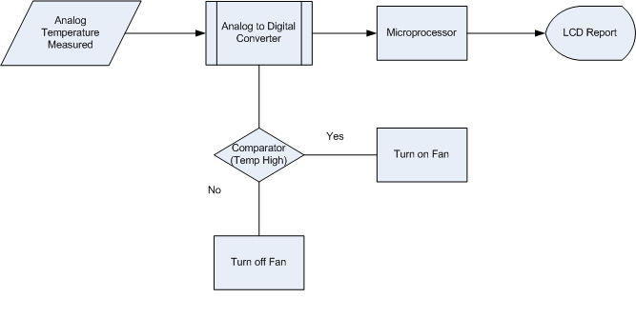
Figure 13 - Temperature Flow Diagram

There are several ways to measure, record and report temperature, some of which are discussed below.
Standard Approach—Analog Sensors
An analog temperature sensor can be used and connected to each component where temperature monitoring is desired. The LM335A, made by National Semiconductor, is an example of an integrated precision temperature sensor that can operate continuously in temperature ranges from -40°C to 100°C. The LM335 provides an output signal of 2.98V for 298 degrees Kelvin, 25 degrees Celsius or room temperature. Each LM335 temperature sensor costs approximately $1.35 and totals to $27 for a set of 20. The count of 20 is used to verify that all batteries, motor and microcontroller can use one. This is a widely used device and it is unlikely to be unavailable during time of production.

Another precision temperature sensor that can be used is from Texas Instruments, TMP20. This temperature sensor has a range of -55°C to +130°C with ±2.5°C accuracy and can be used much like the LM335 temperature sensor with a supply voltage of 1.8V to 5.5V. The TMP20 will send an output voltage of 1.8639V at room temperature similar to the 2.98V output at room temperature on the LM355. This temperature sensor costs about $0.87 individually and totals to $17.40 for a package of 20. This part is typically in stock and available as needed.

Each temperature is converted to a digital signal using a parallel or flash A/D converter if the microprocessor does not include an on board analog to digital converter port. If it does, this network is unnecessary. The number of comparators and resistors needed in the A/D converter will depend on the output bits desired. As the number of bits increases, the comparators and resistors increase rapidly. As N represents the number of bits, the number of comparators amount to 2^{N}-1 and resistors amount to 2^{N}. The number of required digital bits can be determined by the output of the analog temperature sensor. This provides more flexibility in choosing the dependency on the battery temperature and can be used to our advantage.

Standard Approach—Digital Sensors
As opposed to using an analog device, which continually monitors and reports the temperature on the batteries, a digital sensor can be used. The TMP03/04, manufactured by Analog Devices Inc, is a 3-pin IC temperature sensor. This sensor has an input voltage of 4.5 to 7 volts and measures temperatures between -40°C to +100°C. The TMP03/04 has ±1.5°C output accuracy between the ranges of -25°C to 100°C. The power consumption is approximately 6.5mW maximum at 5V, a minimal amount compared to the other components being powered. The difference between the TMP03/04 is the flexible open-collector output available on the TMP03 that is capable of driving a separate low voltage logic circuits. The TMP04 on the other hand has a CMOS output providing good communication to a microprocessor. The TMP03 is in stock by Digi-Key and is available for $5.04 per sensor or $126.00 for a package of 25. The TMP04 is currently out of stock.

“1-Wire” Technology
This relatively new technology utilizes a serial protocol through a single data line, hence the “1-wire” terminology. A 1-wire bus interfaces a master and possibly numerous slave devices that have their own 64-bit identification number stored in the ROM. Not only does the ID serve as the address on the bus but it also has the benefit of being unchangeable, unique and factory-programmed to each individual slave device. Another benefit to this system is that a standard 1-wire bus requires no additional power supply but receives its input voltage from the communication bus. Therefore the device has only two inputs, communication and ground. In such a case that there is a disconnection from the communication line, the 1-wire slave devices are in a reset state. When a connection returns, the devises are back on.

Prior Projects
The Electrical Engineering Department at the Pontificia Universidad Católica in Santiago, Chile administered a study on the temperature and voltage monitoring of an electric vehicle. The Chevrolet S-10, also converted from a combustible engine to an electric vehicle, contained 24 lead-acid batteries, each with a 12-volt and 55-amp rating. The operating temperature range is between 0°C and 40°C with an abnormal maximum temperature rating of 50°C. In their work, a “one wire” concept was used in which sequential monitoring by special integrated sensors would transmit data from all the batteries through the serial bus. By utilizing this method, the numerous wires that would typically connect the data path were reduced. An overall schematic of their monitoring system is depicted in Figure 14 below.

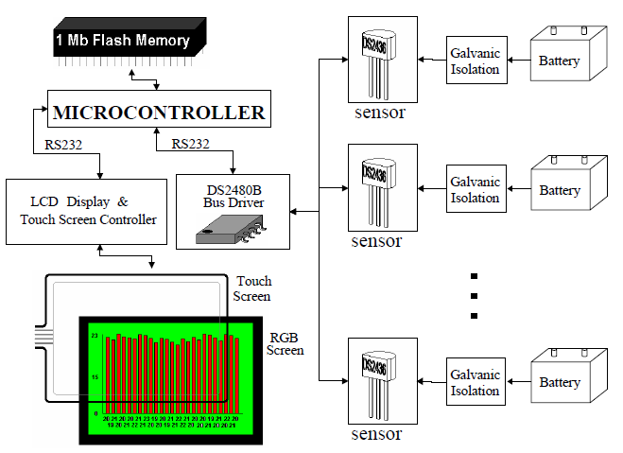
Figure 14 - "1-Wire" Schematic of Chevrolet S-10 - Reprinted with Permission from Juan W. Dixon, Pontificia Universidad Catolica de Chile

Within their design the “one-wire” system utilized Dallas Semiconductors integrated circuit devices, DS2436. This selection allowed monitoring of voltage and temperature simultaneously through bi-directional communication. In order to connect to the microprocessor within the vehicle, a bus driver was used. An additional DS2480 circuit converted the signal to RS232 for faster communication.

In order to achieve an accurate analog signal the galvanic isolation circuit was added between the sensor and the battery terminals. To linearize the data, an SLC800 optocouple was utilized and completed through the feedback circuit. Dallas Semiconductors has discontinued the production of the DS2436 integrated circuit and therefore another similar method must be obtained.

DS18S20/DS18B20
It is possible to utilize the Dallas Semiconductor integrated circuits DS18S20 or DS18B20, 1-Wire Digital Thermometers in order to obtain one wire technology communication that is solely responsible for temperature monitoring of the battery pack. Based off the same one-wire technology, the pin configuration still consists of only power and ground. The difference between these two devices is the resolution in the temperature. The DS18B20 allows the user to configure the bits of resolution as close as 0.0625°C with a 12-bit selection for output. In contrast to the DS18S20, which has a standard output of a 9-bit output temperature corresponding to 0.5°C resolution. Due to the fact that the batteries do not have a critical set point of temperature shutoff, resolution isn’t a key element.

Both devices operate from -55°C to +125°C and store the temperature into a register comprised of a 2’s compliment sign-extended 16-bit number that indicates a positive or negative value. Furthermore they equally have the capability to set a flag if a temperature is out of range on any of the slave devices. Utilizing T_{H} and T_{L} registers, a high temperature and low temperature can be stored for a comparison. The flag is updated for every temperature read and therefore may be turned off if the battery returns to an operating condition. These circuits are predicted to cost around $4.00 apiece, totaling a whole $48.00, not including any additional cables to connect the slave devices to the batteries. Despite the high cost, using this system will allow the temperature to be reported to the LCD display and further be used to enable a condition monitoring system.

    - AC Power Input
As electric vehicles and hybrids become more popular, so is the development of their charging stations, both public and private. The National Electrical Code (NEC) of 2005 has developed three levels of charging to electric vehicles as seen in Table 2 below.
Table 2 - NEC Charging Levels
 | Voltage  (VAC) | Current  (Amps) | Power  (kW) | Phase | Standard Outlet
Level 1 | 120 | 12 | 1.44 | Single | NEMA 5-15R
Level 2 | 208/240 | 32 | 6.7/7.7 | Single | SAE J1772
Level 3 | 480 | 400 | 192 | Three | No Standard
      - Level 1

As shown the Level 1 equipment provides 120 volts alternating current at 12 amps delivered and is the most common voltage found residentially and commercially in the U.S. This rating will supply a relatively low amount of power and therefore will take between 8 to 20 hours to fully charge the battery pack depending upon the chemistry of the batteries, current charge capacity and how much energy it is capable of holding. Despite the drawback of long charging time the user would never be left searching for a compatible voltage source. The EV is equipped with a NEMA 5-15P, the plug, and connect to a NEMA 5-15R, the receptacle, which fulfills the requirement of being a ground fault interrupter (GFI). By utilizing this plug, a simple household extension cord can be used to connect the power supply to load the EV. This type of plug will stop current from flowing when the current to ground measurement is between 4 to 6mA and prevent physical damage to the user or the vehicle.

      - Level 2
The Level 2 charging station is the most preferred method of charging which cuts down the charging time to approximately 3 to 8 hours due to the increase in power being delivered. The 240 volts alternating current and 32 amps delivered is the primary supply at local charging stations. Coulomb Technologies, for example, announced their contribution of building “4,600 electric vehicle charging stations in nine regions of the U.S, funded by $37 million in grants.”[2]. Those planned for public charging are to be equipped with the level two, 220V supply at 16 or 30 amps. These stations is supplied with an electrical vehicle supply equipment (EVSE) to fulfill additional safety requirements and utilize the Society of Automotive Engineers industry standard plug called SAE J1772, as seen in Figure 15. This type plug will also be used on the new Chevy Volt and Nissan Leaf.

Figure 15 - J1772 Level 2 Charging Plug - Reprinted with Permission from CleanTech Authority

Despite the advantage of creating an industry standard plug that will shorten charging time, it is understood that the batteries will increase in temperature where additional monitoring may be required.
      - Level 3

Fast charging stations are known as the level 3 stations, which are capable of charging an electric vehicle in less than half an hour in some cases. This increased voltage of 480 volts three phase alternating current is converted to direct current and will supply approximately 192kW. The decreased charging time of this type of station is argued to be the seller for electric vehicles and the reason for the increase in use of electric vehicles.

    - Power Conversion
There are three main locations that power conversion is deemed necessary.
- AC/DC between the charging supply and the battery pack
- DC/DC between the battery pack and the auxiliary battery
- DC/DC between the auxiliary battery and microcontroller
Each point of conversion is evaluated below converting methods for design.

      - AC/DC Conversion

By accepting a single-phase voltage source, valuable time and money is saved through the elimination of three phase converter options and the additional components. This limits the AC/DC design specification to strictly altering a single-phase alternating current. There are several ways to design this type of converter that will supply a specified value of DC current to the battery dependent on the state of charge, or how much power each battery currently withholds. A traditional method of charging is a direct AC-to-DC conversion through a rectifying circuit. Despite this simplicity this method is larger in physical size, has longer charging times and may cause overcharging due to lack of protection. To improve these shortcomings, an indirect method of conversion can be utilized through an AC to DC conversion that is then improved by a more specific DC-to-DC conversion. The progression throughout the converter is represented in Figure 16 and begins with the rectification of the sinusoidal input voltage waveform by eliminating the negative voltage component. After this simple rectification the output doesn’t have a constant DC voltage and therefore must utilize a filter for a cleaner DC output. Finally a voltage regulator can be used to improve the supply to the batteries as the state of charge changes. This point of contact is where the constant voltage/constant current supply comes into play depending on the charge of the battery.

Figure 16 - AC/DC Converter
Two common rectifying circuits are known as the half-wave rectifier and the full-wave rectifying circuit. The half-wave rectifier is the more simple circuit consisting of a transformer and a single diode to achieve the desired output voltage. The transformer has the capability of stepping up or down the input voltage to the required DC peak output voltage and after this point the diode passes only the positive voltage component. Despite the simplicity of design, the major downfall of this circuit configuration is the efficiency as the negative cycles are being unaccounted for.

In contrast to the half-wave rectifying circuit, the full-wave rectifier takes into account the negative cycles by inverting their sign and increasing the overall efficiency. This rectifier does this by using a center-tapped transformer with two diodes. The configuration of these diodes allows the voltage to pass only when it is positive. The transformer type allows isolation to reduce electrical shock to personnel between the power supply line and the electronic components. Another form of the full-wave rectifier is the bridge rectifier, which configures four diodes in the formation of a bridge. This arrangement doesn’t require a center-tapped transformer and still provides isolation to the circuit. The actual component values must be determined after an input voltage selection has been made.

Battery Charger
An alternative method to designing an AC/DC converter is that a battery charger can be purchased. Any battery charger would already include the expected configuration that is capable of supplying power more efficiently to the battery pack with even more additional features. The manufacturers often include thermal monitoring systems within the charger to cool the internal components that heat up during power conversion. Several battery chargers is presented in the following section for possible purchase.

Zivan NG3
The first option is the most popular power converter, manufactured by Zivan. This company is responsible for many high frequency motor controllers for battery dependent devices and has specialized in electric vehicle equipment for many years. There are seven charger types ranging from single-phase 115VAC converters up to the three-phase 480VAC converter option. All available converters operate at 85-90% efficiency as stated by Zivan.

The Zivan NG3 is the high frequency battery charger for a single phase 230/115 VAC selectable input. The NG3 would be the only model available from Zivan for the design due to the selected input of 110-120VAC. In addition to this model selection, a type must be selected which is dependent on the battery pack included in the vehicle. The expected type is the F7 RG based off a 144V nominal battery voltage due to the requirements provided by the motor selection. This model would therefore provide an output current rating of 15 Amps to the battery pack. This charger measures 3.5 inches in height, 8.7 inches in width, 16.9 inches in length, and has a total weight of 15lbs. For close proximity charging, the unit would be located in the trunk closest to the batteries. Fortunately, additional expenses would be saved since the NG3 is shipped with a pre-mounted structure for easy installation.

The standard operating temperature range is -20 to 50 degrees Celsius with an internal cooling fan for temperature control. In addition to this thermal protection, an optional thermal sensor is also offered. This measurement is taken off each of the batteries to prevent overheating during charging periods when the batteries increase the most in temperature. The NG3 comes equipped with an internal switch selector for various battery types and is controlled by a microprocessor providing protection from over-voltage, overload, short circuit and incorrect connections. An LED indicator will inform the driver of the battery charge status at the initial charge phase, 80%, and 100% state of charge. Additional alarm sounds will notify the driver of disconnection or thermal constraints being exceeded.

The disadvantage of this charger is that it does not include power factor correction for charging. Overall this charger costs $1,099.00 without the additional thermal protection if purchased from KTA Services. Before shipment, the charger would be programmed with input voltage selection, battery make/model, and battery capacity values.

Manzanita Micro PFC-20
The second most popular power converter is the Manzanita Micro manufactured by Manzanita Micro Power Systems, a proud distributor of EV components. This company is responsible for not only battery chargers but also batteries and solutions for both lead-acid and lithium-ion. Overall, this company would be able to assist in the application of their product and interfacing with subsequent applications due to their experience with EVs.

This particular brand of chargers is responsible for power factor correction, making them more versatile and powerful. Regardless of the charger type this brand also provides a trimmer pot to allow the driver to change the output voltage to the batteries depending on the system at hand. This would be beneficial if the number of batteries changed throughout the testing of the vehicle for the motor performance enhancements. Manzanita Micro offers three models of their battery charger dependent upon the input current.

As seen in Table 3 below the model depends on the input/output current. From this it can be determined that the PFC-20/30 model would be the comparable battery chargers depending on the decided input current. This model would draw 20 or 30 amps respectively from the commercial socket to the battery charger and finally supply a selectable voltage value to the batteries. Due to the low input voltage in comparison to the output voltage to the batteries, the charger will run at a .9997 power factor with 88-96% efficiency.
Table 3 - Manzanita Micro AC/DC Converter Models
Model | Input Voltage | Input/Output Current | Output Voltage
PFC-20 | 60-240VAC | 20 Amps | 12-450VDC
PFC-30 | 60-240VAC | 30 Amps | 12-450VDC
PFC-40 | 60-240VAC | 40 Amps | 12-450VDC

The entire unit weights approximately 16lbs and has measurements equivalent to 14 inches in length, 10.5 inches in width and 5.75 inches in height. Similar to the Zivan model, this battery charger also comes equipped with a safe mounting structure to save some additional fees. Furthermore, the PFC-20/30 can be additionally interfaced with a “Reg Buss Port” for a battery management system option. The PFC 20/30 models both have over-temperature controls set to 170 degrees Fahrenheit, curtailing the current input and using the cooling port.

Figure 17 illustrates the output current for the PFC-30 model. Keeping in mind that each battery charger produced by Manzanita works similarly, the PFC-30 can be used as a reference to show how the output voltage changes the output current and depends on the input voltage. The graph shows the DC output current, y-axis, in relation to the battery pack voltage, x-axis, for each standard voltage input of 120VAC, 208VAC and 240VAC. For a standard battery pack of 144V, the output current is equivalent to 20 amps at 120VAC input, 38 amps at 208VAC input and 36 amps for 240VAC.
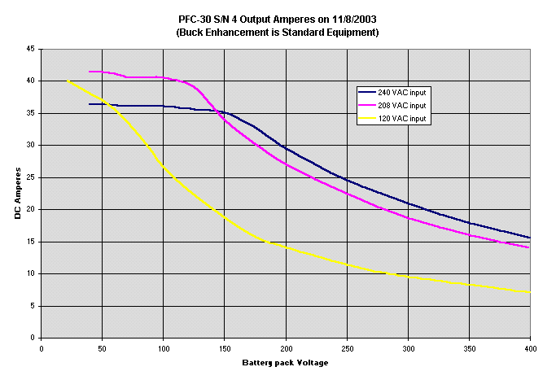
Figure 17 - PFC-30 Current versus Battery Pack Voltage – Reprinted with Permission from Manzanita Micro
Overall this battery charger will provide several benefits to the charging design such as power factor correction, efficiency, and options such as the battery management system. Unfortunately the cost of this unit is $2,050.00 from the manufacturer without the optional components.

Elcon HF PFC-1500 Charger
Finally the third battery charger option is the Elcon HF PFC-1500W charger. This charger, like the Manzanita Micro, also offers power factor correction greater than or equal to 0.98 to protect the internal circuitry from high current flow. The input voltage range is 85VAC to 265VAC, allowing both standard outlet inputs of 120VAC or 240VAC with a maximum 15 amps input current. This limitation on the input current will prevent tripping the main circuit breaker within the house or commercial location of charging. This charger is pre-programmed to the battery type in order to provide adequate charging despite the state of charge with 93% efficiency. Depending on the model selected, a number of output voltages are available. Due to the expected battery pack the TCCH-144-08 model would be selected. It is capable of providing an output voltage of 144VDC with a maximum of 203VDC.

The operating temperature range is from -40 degrees to 55 degrees Celsius with a storage temperature up to 100 degrees Celsius. An internal thermal protection system will reduce the current flow during charging if the temperature exceeds 75 degrees Celsius. A further automatic shutdown will occur if the temperature increases to 85 degrees, but will resume operation after decreasing back down to 80 degrees Celsius. The Elcon comes equipped with an LED alarm indicator for battery repair, disconnections, and charging status. The charger is approximately 14 pounds and measures 13.86 inches in height, 6.89 inches in width and 5.47 inches in length. Two respectable electric vehicle conversion companies distribute this 1500W Elcon charger: EV Assemble and KTA Services. The charger purchased from KTA Services would cost approximately $555.00, whereas EV Assemble sells the charger for $340.00 with 18 units in stock.

      - DC/DC Conversion
The necessary safety and D.O.T. requirements are powered by a 12 volt battery within the combustible vehicle. The battery in this case is kept charged through the use of an alternator. Following the conversion to electric, the alternator is removed and therefore an alternative method of charging must be provided. There are several options of powering this battery that over the years of electric vehicle conversions have proved their disadvantages. The first option is to use a deep cycle battery that is only charged when the main battery pack is being charged. The disadvantage to this is the possibility of it losing charge before the main battery pack to the motor is empty. As the 12V battery loses charge the accessory components will die before the actual motor is dead. For night driving this scenario could be severely dangerous as the head lights, tail lights, and turn signals are disabled. If this battery is also responsible for the power to the microcontroller, which is a possibility, the driver could lose control of the vehicle as the microcontroller is no longer powered. Another option would be to use one of the batteries from the main battery pack. By tapping off of this source the main battery pack would no longer discharge evenly but that single battery would drain slower or faster than the others. The final and most popular option is to use a DC/DC converter that connects to the main battery pack bus. This connection transfers the pack voltage down to 12V with even discharging, high to low voltage isolation, and maintains power to the auxiliary battery while the battery pack still has power. Figure 18 below shows the progression of the AC input voltage to the previous battery charger which converts the voltage to DC. The DC/DC converter then connects to the battery pack main bus and then to the auxiliary battery. There are several DC/DC converters built specifically for this application and specified depending upon the battery pack voltage.

Figure 18 - DC/DC Converter

ElCon 400W Isolated DC/DC Converter
Evolve Electrics, a distributor of EV equipment, supplies a 400W isolated DC/DC converter with 92% efficiency. This converter comes with several models variable to the nominal battery pack voltage, a range of 36 to 192 volts, and the desired output voltage, either 12 or 24 volts. The output voltage is ±.2V accuracy from 12.5V and ±.1V accuracy from 13.8V during charging time. This is beneficial to the system since under charging the 12V battery, voltage must exceed the rated voltage to ensure charging. Nominal output current is equivalent to 20 amps with an output excess current limitation of 30 amps to ensure that the additional electronic components, such as the microcontroller, will not be damaged. It is able to output maximum current to the battery after one hour and is in continual operation under heavy loads. This temperature limitations, similar to several other components within the vehicle, ranges between -40°C to +55°C. An overheat protection switches off at an internal temperature rating of 90°C and after decreasing to 60°C it resets. The physical dimensions are 6.9 inches in length, 6.2 inches in width and 3.25 inches in depth with an overall weight equal to 5lbs. This part is available for $250 in comparison to another EV supplier, Electro Automotive, for $357.50.

300W HWZ Series DC/DC
Another option is the HWZ Series DC/DC Converter supplied by Cloud Electric, LLC. This company is also a wide distributor of electric vehicle equipment ranging from batteries and motors to switches and cabling. This particular converter provides 300W of power by transferring 144VDC to 12VDC with an output current of 25 amps. The HWZ Series converter is more restricted than the Elcon 400W converter as its limited to -10°C to +40°C. But similarly both models come equipped with over temperature protection and isolation between the high input voltage and low output voltage. Overall this product weighs approximately 4lbs and measures 7.8 inches in length, 5.5 inches in width and 2.8 inches in height. This product is readily available by Cloud Electric for $125.00

      - Small DC/DC Conversion

Following the DC/DC conversion from the battery pack to the auxiliary battery a further conversion must be applied. The smaller components such as the microcontroller, lights, and wipers are powered by a smaller 5 volt system. Therefore another step down voltage conversion must occur. This conversion can happen through two possible methods:
- Linear Regulator
- Switch-Mode Regulator

At a first glance the linear regulator would be the selected method for conversion due to the fact that design experience and familiarity with the component is greater. Furthermore the linear regulator is known to have a more simple design and integration. But as the vehicle is required to use the most efficient means of conversion for power saving, both methods are compared below to determine which method is the best for the overall design of the electric vehicle. The benefit to the switch-mode regulator is that it is capable of stepping the voltage up or down or inverting it, whereas the linear regulator is limited to stepping down the voltage. In this particular instance a step down voltage is required and therefore either regulator could be used. In terms of efficiency the switch-mode regulator is very efficient especially with high load currents in comparison to the linear which is only capable of high efficiency when the difference between the input and output voltage is very close in value. The determining factor is how close in value do the input and output voltage need to be. If the linear regulator has a large differential the excess voltage will burn off the regulator in heat and may require a heat sink to keep the IC from damage. On the other hand if the supply to the additional components, such as the microcontroller and lights, is less than 10W then the switching regulator will stay below thermal limitations. Unfortunately this regulator is more complex in design and includes additional components consisting of an inductor, diode and capacitor. The linear regulator is a very simple design, requiring the IC and a low rated capacitor. The size of both regulators are relatively similar depending on the power level where a linear regulator uses a heat sink, the switch regulator would be smaller. Due to the external components of the IC the switching regulator is obviously more expensive in comparison to the linear regulator. Furthermore due to the switching, the output voltage ripple is larger than for the linear regulator. In terms of noise the linear regulator proves to be the better selection. All of these characteristics are summarized in Table 4 from Maxim IC.

Table 4 - Linear Versus Switching Regulator Comparison
 | Linear | Switching
Function | Only steps down; input voltage must be greater than output. | Steps up, steps down, or inverts
Efficiency | Low to medium, but actual battery life depends on load current and battery voltage over time; high if V_{IN}-V_{OUT} difference is small. | High, except at very low load currents (µA), where switch-mode quiescent current is usually higher.
Waste Heat | High, if average load and/or input/output voltage difference are high | Low, as components usually run cool for power levels below 10W
Complexity | Low, which usually requires only the regulator and low-value bypass capacitors | Medium to high, which usually requires inductor, diode, and filter caps in addition to the IC; for high-power circuits, external FETs are needed
Size | Small to medium in portable designs, but may be larger if heatsinking is needed | Larger than linear at low power, but smaller at power levels for which linear requires a heat sink
Total Cost | Low | Medium to high, largely due to external components
Ripple/Noise | Low; no ripple, low noise, better noise rejection. | Medium to high, due to ripple at switching rate

From this comparison it is obvious that a switching regulator is the best approach. Despite the lack of experience in utilizing this component, this method allows a step down voltage conversion with high efficiency, low heat and small size at the expense of medium complexity, cost and output ripple. Overall the switch regulator is selected for its efficiency which is very important when interfacing with the component that will control the vehicle. The ability to properly supply this voltage determines whether or not the microcontroller is powered, the D.O.T. requirements are met, and overall the ability to drive the vehicle. There are three types of switching regulators: buck (step down), boost (step up), and buck-boost (both). All topologies consist of a capacitor, a diode and an inductor oriented in slightly different manners to achieve their specific function. The buck converter is the selected option to convert the 12V to the necessary lower voltages. The rest of the design is dependent on the load current from the additional components.
    - Controls

The controls section of the early electric vehicle conversion is a simple design. The controls involve applying voltage to the motor and monitoring the voltage output that is fed to a simple voltmeter. The smart EV on the other hand maintains a high level of control and monitoring. Controls give the user the ability to optimize performance, to increase the range of distance traveled, and add a level of protection that is more intelligent than simple fuses for overload protection. The controls will need to have a programmable logical controller (PLC) or some type of microcontroller. The controller can be programmed to automatic and/or manual, where the output data is transmitted to a display screen or data logger. The smart control of the system will consist of a voltage sensor, current sensor, and microcontroller. Control is necessary due to the added dangers of a fully electric car. If the battery were to die while at high speeds, or in a highly populated area without any power, a severe situation is at hand. The only way to ensure the battery doesn’t reach that critical level is with a smart controller. Figure 19 below shows a basic diagram of the smart controller with the additional sensors that the microcontroller can use to control the use of the battery.
Figure 19 - Battery/Motor to Controller Diagram

  - Computer Systems

The computer systems consist of the data display screen to the driver, the interface between the display screen and the controller, and the individual controls for each mode of operation.

    - FPGA versus Microprocessor

From the design requirements, there is a need to process complex computations to control external devices. The two main devices that must be controlled are the motor and the user’s display. Two methods of control that are further researched below are FPGA’s and microprocessors. In this section they are compared and contrasted based on specific needs and abilities.

Programming and Application
Microprocessors and FPGAs are fundamentally different in their design and programming. FPGAs are programmed either schematically or through the use of a Hardware Description Language (HDL). HDLs are fairly limited in the programming paradigms and data structures that they allow. The upside is speed; FPGAs are generally faster when programmed for specific functions. Microprocessors, on the other hand, are made for general purpose processing. Most can be programmed in common languages such as C, and compilers are widely available. Furthermore, higher-level languages, such as C, offer the ability to program and use more complex algorithms and data structures with less effort than an HDL. This is useful as the motor is controlled, the status of several sensors is tracked, and this information is displayed. In addition to using higher-level languages, many microprocessors are designed and marketed for driving modern graphical displays. Useful documentation and APIs for our specific applications are continuing to be researched for reducing labor. Also, many microprocessor boards generally have the ability to accept analog inputs, whereas FPGAs generally on take digital. This allows some flexibility in choice of sensors and controls in other parts of the system.

Cost and Availability
Since FPGAs are made by only a few companies and are marketed to a specific audience, they are naturally expensive. The FPGAs cost between $75 and $250 for lower-end models. Microprocessors, on the other hand, are licensed and made by a plethora of companies and can be found for as low as $40 for a processor/board combo. Table 5 shows the overall comparison between the two methods.
Table 5 - FPGA versus Microprocessor Comparison
 | FPGA | Microprocessor
Cost | >$75 | >$40
Programming | HDL (VHDL or Verilog) | Assembly, C,and possibly others
Inputs | Mostly Digital | Digital and Analog
Application | Specific to Task | General

    - Microprocessor Selection

In selecting a microprocessor two key criteria used are (1) appropriate application and (2) availability of documentation and support. The decision to use an ARM-based system is discussed starting with the issue of documentation and support.

Documentation and Support
With limited exposure to different types of hardware and software the availability of documentation and support is critical to the success of the project. Many companies design and manufacture microprocessors, but these usually contain proprietary design and documentation. Furthermore, support is usually provided only by the designer. For this reason, an ARM-based microprocessor is selected. ARM-based architecture is licensed to many different companies and is quite ubiquitous. There is a plethora of documentation freely available for this architecture on the internet and within the UCF library. In terms of support, the ARM Holdings have a large knowledge base; in addition to the official support, there is a large community of developers and forums.

Appropriate Application
There are two main roles for the microprocessor in the project: (1) help control the motor and batteries; and (2) manage the user display. These tasks require a powerful system capable of handling complex tasks. Many ARM-based microprocessors are able to fill these requirements. Currently, many ARM-based systems are designed for use in automotive controls and displays. Furthermore, manufacturers provide motherboards that are geared towards a specific application.

One Versus Two Application Units
Due to the dual roles for our controlling unit two units with unique roles is a possible approach. Since motor control is a mission critical role, it may be best to use a dedicated microcontroller. In order to implement a user interface application on a unit, a small operating system will need to be used. The operating system and user interface application results in increased overhead on the unit. This overhead has the possibility of delaying the motor controls which may decrease performance of the motor and potentially cause safety hazard. In addition to safety and performance, the overall design may be simpler due to the fact that many controllers are designed specifically for use in automotive vehicles while others are designed specifically for application use.

    - Software Development
This section discusses the various tools and environments needed to develop the software for this project.

RDVS Toolchain
This is a complete solution for software development supporting all ARM processors, and is provided by ARM Holdings. This product allows software development, optimization, and testing before implementing on the hardware. The RVDS Toolchain is available in two editions: Standard and Professional. The Standard edition is provided free of charge and contains everything needed for this project. The Professional edition is not free of charge and provides support for the latest ARM processors, as well as the ARM Profiler which helps to optimize code. The RVDS Toolchain Standard Edition contains the following components: ARM Compiler, ARM Workbench IDE, and ARM RVD Debugger.

ARM Compiler
The ARM Compiler is able to compile C and C++ and supports the ARM, Thumb, Thumb-2, VFP, and NEON instruction sets. Also, the ARM Compiler supports building of ARM Linux applications and libraries. Furthermore, the compiler features an optional C library called “microlib” which can reduce the runtime code size by 92 percent. In addition to the reduced code size, the microlib C library provides a completely C-based development environment without the need to use assembly language.

Operating System
One objective of this project is the development of a user interface for a touchscreen display. The creation of an operating system to handle such an objective is complex and time consuming, therefore, an existing operating system is used for this project. There are two options that are being considered: one being the Android operating system and the other being the Debian GNU/Linux operating system. Both are discussed in the following section.

Android
Android is an open source operating system designed for use on mobile devices. It supports ARM-based microprocessors and has support for touchscreen devices. Furthermore, it includes a graphical toolkit which makes application development simpler and more streamlined. Android includes many different applications and support for hardware that are not necessary for this project. Therefore, all unnecessary components is removed. The first Android enabled device, the T-Mobile G1, had 256MB of flash memory. Currently, it is planned to have 32MB of flash memory for the User Interface System, and it is believed that removing all unnecessary components will allow this amount of memory to be sufficient. If needed, more flash memory is added to the system.

The Android kernel will need to be customized for this project. Many components is removed such as support for Bluetooth, accelerometers, cameras, etc. The touchscreen display chosen for the project includes open source drivers. These drivers will need to be modified and added to the Android kernel. The drivers are designed for the Linux kernel, which the Android kernel is based on; therefore, the process should be fairly straightforward.

Debian
Debian is an open source operating system designed for general purpose. There exist ports for many different architectures including ARM. Application development on Debian is more complex due to the modular nature, which includes packages for many different programming languages and graphical toolkits. Like Android, many components are not necessary for this project and they will need to be removed. However, it is predicted that 32MB of flash memory is not enough even after minimization, and so the system memory must be increased. Adding the touchscreen drivers is trivial since the Debian kernel is fully GNU/Linux based.

Android is the first choice for this project due to its optimization for embedded systems. However, if porting and customizing the Android operating system proves too difficult or if an unforeseen issue arises, then Debian is used for this project. BeagleBoard.org has information about loading Ubuntu (a derivative of Debian) onto a BeagleBoard. This information will prove useful if the need to use Debian arises.

There is two microprocessor units (MPUs) in this project; each will have its own operating system. The MPU used as the motor controller will have a custom made minimalist operating system. The MPU used for the User Interface System will run a custom made minimalist version of the Android operating system. Android was selected because it is freely available under the GNU Public License, it is compatible with the ARM architecture, and it will make application development simpler. The Android kernel will need to be able to load the driver modules for the touch screen monitor. If using Android proves to be too difficult or cumbersome, then the project will use a custom made minimalist version of the Debian Linux operating system. Debian also supports the ARM architecture but unlike Android, it is supported by the touch screen display vendor. The downside to Debian is that developing applications is not as simple as Android.

Application Development
The motor control application is coded in a mixture of C, C++ and assembly language as needed. The Thumb-2 instruction set is used to reduce code size, if possible. The User Interface application is coded in Java using the Android SDK. If Debian is used instead of Android, then the User Interface application is coded in Vala and C in order to take advantage of the GTK+graphics toolkit that is used by Debian.

    - Touch Screen Options

There are two options for this project. First, a prebuilt touch screen monitor bought from a number of companies. Second, a touch screen system custom built for this project. Both options are compared in Table 6 by their respective advantages and disadvantages. These are based off of 7 different areas of interest: system, housing, drivers, support, labor, expense and power consumption. Many companies offer complete touch screen systems for uses such as Point-of-Sale machines, medical equipment, kiosks, and other options. Whereas the custom built systems will contain any component that may be needed for use in the project. Even though Option 2, the custom built screen, is less expensive and provides customization, these pros are overshadowed by the amount of labor required. Option 1 costs $50-$100 more than Option 2 but can save at least 20 hours of labor. Furthermore, since this project is meant to be used for public display, a cleaner and more professional looking monitor from a manufacturer is preferable to a custom built system. For these reasons and other, the project is using Option 1.

Table 6 - Touch Screen Comparison
 | Pre-built |  | Custom Built
 | Advantages | Disadvantages | Advantages | Disadvantages
System | All necessary components are intact, e.g., touch screen, display, power system, controller, etc. | May not be optimized for use in this project | Optimized for the project’s specific needs, e.g., screen size, brightness, power requirements, etc. | Complex design: touch screen, display, power system, controller, etc. must be matched.
Housing | Professional looking housing |  |  | Housing must be custom built
Drivers | May be available | May not be available leads to difficulty to develop |  | Custom drivers must be written.
Support | By company |  |  | None
Labor | < 30 hours |  |  | >50 hrs
Expense |  | $400 to $1000 depending on specifications | <$350
Power Consumption |  | At least 40W

    - Touch Screen Selection

It has been decided that this project will use a prebuilt touch screen monitor system. There is a variety of sizes and technologies available. As LCD monitors, these screens come in standard sizes such as 15”, 17”, etc. For this project nothing more than 15” is required, so this is come our required diagonal size. Besides the size of the screen, other factors are important such as the technology used, the brightness of the screen, aesthetics, the cost, the interface, available drivers, and technical support.

Touch Screen Technology: Resistive versus Capacitive
The two main technologies that are available for this type of application are Resistive (5 wire) and Capacitive. Resistive touch screens can be used with any time of touch such as finger, gloved finger, and stylus, etc. because the pressure from the object compresses two layers of the screen to create a resistance. Capacitive touch screens can only be used with uncovered fingers as they use the skin to create a capacitance on the screen. At first thought, it seems that either of these two technologies can be used for this project, but certain scenarios exist that make resistive touch screens more applicable. One scenario involves the user wearing some type of glove, whether driving gloves or winter gloves; in the case, capacitive touch screens would not work at all. Furthermore, resistive touch screens are generally less expensive than capacitive touch screens. For these reasons, this project will use a touch screen using resistive technology.

Brightness
Since this screen is used in a vehicle and is surrounded by daylight, it must be bright enough for the operator to clearly see all the important information displayed. For reference, a computer monitor with 300cd/m² of brightness was inspected during peak daylight. It was found that the display was still very readable. This shows that a brightness of around 300cd/m² is adequate for use in a sunlit environment. Some companies are offering “Transportation” application products for use in vehicles; these products have a brightness of over 1000cd/m², screen size of 12”, and cost over $1000. It was decided to use a more mainstream product with brightness around 300cd/m² to save on costs since it was verified that this amount of brightness is sufficient for the project.

Cost, Aesthetics, Drivers and Technical Support
A number of companies were considered including GVision, 3M, Planar, and HP. After comparing all the above, it was decided that Planar model PT1545R is best suited for this project. This product has a simple look, and is less expensive than other comparable monitors. Furthermore, the software drivers are readily available with source code, and 24/7 technical support is provided. The overall properties are detailed in Table 7.
Table 7 - Touch Screen Characteristics
Product Name | PT1545R
Viewable Size | 15” diagonal (11.97” horizontal x 8.98” vertical)
Touch Screen Type | 5-wire Resistive
Brightness w/touch screen | 200 cd/m²
Display Resolution | 1024 x 768
Weight | 9.0lbs
Power Consumption | 20W
Estimated Price | $400

    - User Interface

The User Interface System is an embedded system built around an ARM-based Application Processor. It is comprised of the following components:
- Processor
- Power Management
- USB Transceivers
- Video Controller
- Audio Codec
- RAM
- Clock

The use of Texas Instruments products was decided due to the large knowledge and user bases available for their parts. For example, Texas Instruments provides a wide selection of possible applications for their products, including block diagrams and recommended parts. A relevant application provided at TI.com was the Single Board Computer for HMI (Human Machine Interface) and POS (Point of Service) shown in Figure 20.
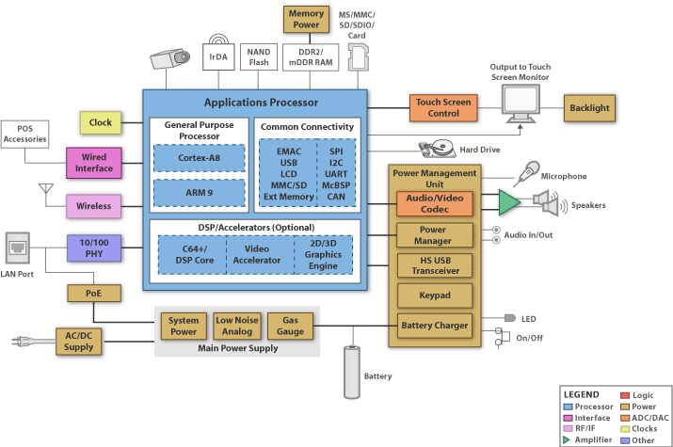
Figure 20 – Block Diagram for Single Board Computer for HMI and POS – Reprinted with Courtesy of Texas Instruments
Many of the selected parts were chosen based on the recommendations from this block diagram. For this project the use of the Cortex-A8 series MPU was decided because it “provides a 4x improvement over ARM9 and achieves laptop-like performance at handheld power levels” according to Texas Instruments.

OMAP 35xx Cortex-A8 Applications Processor
This series of microprocessor was chosen due to its availability and wide consumer adoption. For example, the community-driven open source project “BeagleBoard” uses this series for developing consumer available open development boards. BeagleBoard.org contains a plethora of information on how to develop operating systems and applications for this series of microprocessor.
Texas Instruments provides four base models in this series: 3503, 3515, 3525, and 3530. All four models have the same software compatibility and peripheral sets. In addition, the 3515 & 3530 are able to display 2D/3D graphics; the 3525 and 3530 include additional DSP processing. These different functions are represented in Figure 21 below.
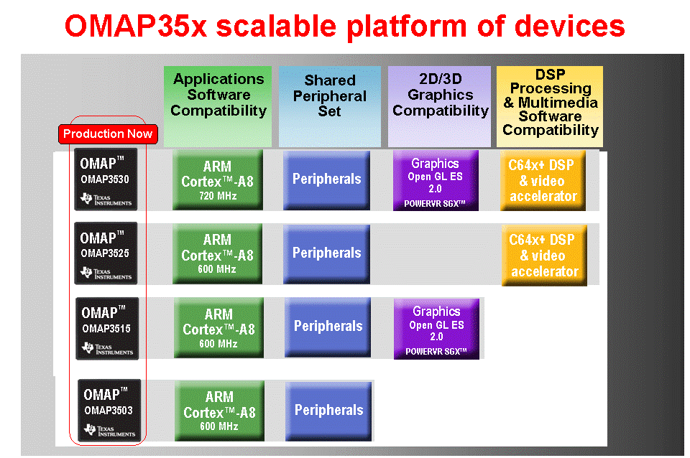
Figure 21 - Functional Block Diagram for OMAP35xx – Reprinted with Courtesy of Texas Instruments
Since one of the objectives of this project is to develop a graphical user interface, the use of the OMAP3503 and 3525 are not applicable since they lack any graphics capability. The decision then falls between the OMAP3515 and 3530. The 3530 is the superior product; pros include more powerful (higher frequency plus DSP), used in BeagleBoard, available in PCB design software, and widely available for purchase. The only con for the 3530 is that it costs about $10 more than the 3515 but the ease of use of the 3530 will result in a net gain due to increased productivity and time saved. For these reasons, the OMAP3530 model processor was chosen for this project.

Many of the application diagrams suggest including a touch screen controller. This project uses an LCD touch screen monitor with built in controller. The monitor interfaces with the processor through USB. The processor is chosen to fit the role of providing a user interface on a touch screen. This led to the decision to use an application processor rather than a microcontroller. There are a number of recommended processors, but the one shown below was selected for a number of reasons. First, this processor has been in the market for some time and there is considerable support and tutorials available from Texas Instruments as well as third parties. Second, it is compatible with all the other required components. Third, it is less complex due to its low pin count (around 500 versus up to 1000 with other models). The overall properties are detailed in Table 8.
Table 8 - Texas Instruments Processor
Model | OMAP3530
Frequency (MHz) | 720
On-Chip Memory | 32KB (L1); 256KB (L2)
McSPI | 4
USB | 2
Core Supply (Volts) | 0.8V to 1.35V
IO Supply (Volts) | 1.8V, 3.0V
Pin/Package | ~500 BGA depending on specific model
Estimated Cost | $30-$40

The following part was chosen because it contains all the above listed components. Furthermore, it uses the same method as the processor to mount to a PCB. Two is used to support two USB ports.

Model | TPS65950
Vin (Volts) | 2.7 (Min), 4.5 (Max)
Pin/Package | 209 BGA
Regulated Outputs | 13
Audio Codec | 5 DAC/ 2 ADC
Estimated Cost | $6 each x 2 = $12

USB Connector
Two mini-B type USB receptacles is used to interface with the processor.

Manufacturer and Part Number | Tyco Electronics 1734035-2
Type | USB mini-B receptacle
Estimated Cost | $2 each x 2 units = $4

Audio Connector
In order to connect to the LCD display’s built-in speakers, a standard 3.5mm audio jack is used.
Manufacturer and Part Number | CUI Inc. SJ1-3515-SMT
Type | Stereo 3.5mm Audio Jack
Estimated Cost | $1

Power Connector
Manufacturer and Part Number | CUI Inc. PJ1-023-SMT
Type | Shielded Male Power Jack
Estimated Cost | $1
Video Connector
In order to connect to the LCD display a DVI connector is needed. Only digital signals is used in this project.
Manufacturer and Part Number | Molex 74320-3004
Type | DVI-I, Dual Link
Estimated Cost | $5

Boot Block Flash Memory
Manufacturer and Part Number | Intel 820972-ND
Type | Advanced + Boot Block Flash
Size | 32M (2M x 16)
Pin/Package | 47-MBGA
Estimated Cost | $6

Estimated Total Cost
Components | $59
PCB | $50
Wires and other accessories | $10
Total | $119

Figure 22 is a possible representation of the interconnections between all the components of the User Interface System. Single sided arrows represent one way communication and double sided arrows represent two way communication. It is still unclear whether or not it is required to have a system of power electronics between the power connecter and the power management system. There are two TPS65950 parts, but only one of them is used fully. The other one is used only to provide and extra USB transceiver to the processor.

Block Diagram
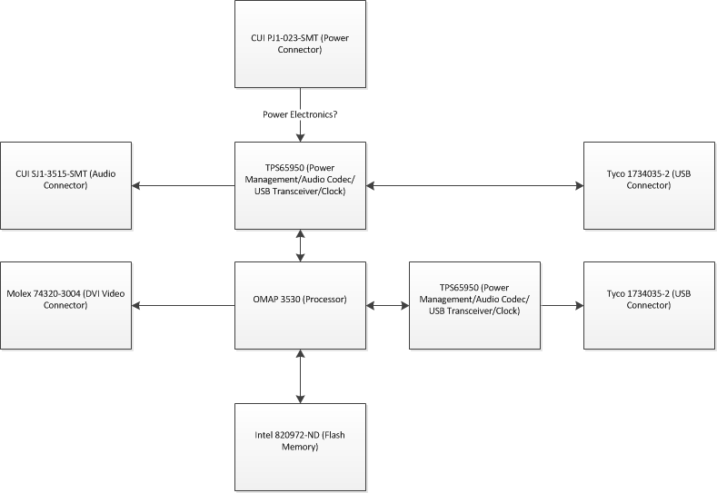
Figure 22 - Texas Instrument Processor Block Diagram
- Design

The overall design of the electric vehicle includes an electric motor, motor/sensor controller, motor drive controller, batteries, solar panel, microcontroller, and user interface. Each of these items is discussed in further details in the sections below. Figure 23 displays the overall view of the major part locations in the EV. The two views are separated for the ease of viewing, but work as one complete power system.
Figure 23 - Electric Vehicle Model
The design intent is to incorporate the researched items mentioned earlier to accomplish the projected specifications and requirements. The way in which all these components operate is broken down into three major categories: the mechanical system, electrical system, and computer system. The mechanical system is mostly the motor/transmission adaptor and the mounting brackets, to mount the motor in the engine compartment. These are purchased in a complete kit with bought with the WarP9 DC electric motor.

The electrical systems consist of a primary AGM lead-acid battery bank that powers the WarP9 DC electric motor for movement. This system is in conjunction with a secondary lead-acid battery, also referred to as the auxiliary battery, which powers all the other components, such as the microcontroller and motor drive controller and a PIC32 sensor/motor controller. Two DC/DC Buck converters are included in the design to step down the secondary battery for the temperature sensors and controllers. A solar charger, placed on the top of the vehicle as seen in Figure 23, charges the secondary battery when the vehicle is in motion, and finally an AC/DC charger is included in the design to charge all of the batteries of the electrical system via residential power connection.

The computer system consists of Texas Instruments OMAP3530 microcontroller which displays the sensor information to the user through the PT1545R touch screen interface. This is where data is displayed as well as where the user can select different modes of operation. The details of each component in each of the systems is discussed as well as what options and deciding factors behind the component selection.

  - Mechanical Systems

The design of the mechanical system is determined by decreasing the weight of the overall vehicle. Therefore once a vehicle is found for the conversion, the next step requires removing all of the components that are used for the combustion engine. These systems include the following:
- Gasoline engine
- Exhaust system
- Fuel tank
- Radiator
- All of the hoses and lines that are used for the combustion engine
Due to the fact that the main mechanical components will remain in place, such as the chassis, the drive train and the wheels, no further design is necessary.

  - Electrical Systems

The following sections will detail the electrical designs for the electric vehicle conversion including the voltage pedal, motor, motor controller, battery supply thermal monitoring, power conversion, voltage control and the wiring harness.

    - Voltage Pedal

A traditional internal combustion engine vehicle (ICEV) uses a gas pedal in order to accelerate, but for the EV the gas pedal is converted to a voltage pedal. This conversion will provide the same effect of accelerating in the EV. The two ways to complete this conversion are evaluated below.

The simplest way is use a pressure switch which is capable of converting the pressure applied to the gas pedal into low voltage levels that is interrupted by the microcontroller unit (MCU). The second method is to use a potentiometer which changes with respect to the resistance applied. When the voltage pedal is not pressed, and no acceleration is desire the potentiometer would have zero resistance. Once a force is applied to the pedal the voltage will increase proportionally. Similar to the way in which the pressure switch would be interrupted by the MCU, the voltage across the potentiometer is monitored by the MCU. The voltage from the abundance of power contained in the battery pack is too large for the MCU to control it directly. Therefore to control this high current and voltage supply a contactor is added to the circuit.

Figure 24 shows a block representation of the electric schematic for the voltage pedal connection. The voltage on the variable resistor is constantly monitored by the MCU. The MCU will thereafter output the voltage on the speed control circuit to further increase the voltage supplied to the motor. The voltage on the motor will therefore increase proportionally to the force on the pedal through the MCU, and speed control circuit.

Figure 24 - Voltage Pedal Electric Schematic

The existing gas pedal is used so the driver will not have to re-adjust to a new style pedal or acceleration method. The gas pedal is mechanically attached to a slide resistor, so that as driver applies a force to the pedal, the voltage across the potentiometer will increase proportionally. As the pedal is pressed the voltage across to variable resistor will signal an “ON” for the MCU input and then output a voltage to turn on the contactor. Following this, the normally open contact, which is in series with the battery bank and motor, closes allowing the motor to turn. Figure 25, shown below, is a mechanical view of the gas to voltage pedal conversion. This illustrates how the variable resistor is influenced by the typical gas pedal assembly through the fabricated metal rod.
Figure 25 - Voltage Pedal Mechanical Diagram

Both options are possible methods for the design of the project. Prefabricated voltage pedals are already available on the market. Since an amount of background research will have to be conducted to make a good design of the voltage pedal, it would be in the best interest of the project to purchase a pre-fabricated voltage pedal. In this case the only thing needed for operation is to mount it in place and wire it to the MCU. There are three options available as shown in Table 9 below.

Table 9 - Voltage Pedal Options
Unit | Price
WarP-Drive Hall-Effect Pedal Assembly | $135.00
Soliton1 Hall-Effect Throttle Assembly | $139.00
Evnetics Throttle Pot Box Assembly | $165.00
The first two options require that the existing acceleration pedal be removed and be replaced by the prefabricated acceleration pedal. The option that would best fit this project would the Evnetics, shown in Figure 26, because it has more flexible as to where can be installed, and there is no need to replace any existing part that can be used. Using this simple potentiometer design also minimizes the wiring installation and coding.
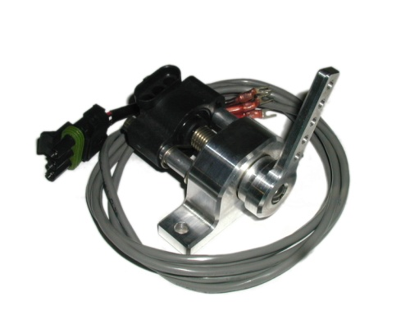
Figure 26 - Evnetics Throttle Pot Box Assembly – Reprinted with Permission from Evnetics
    - Motor
There are many electric motors to choose from outside of the ones mentioned in the research motor section. The selection of motors is due to the fact they are very easy to obtain from multiple distributers. The other electric motors choices on the market that were not evaluated also have a considerable long lead time and may not be available in time to complete the project. Figure 27 shows a comparison of the motors previously discussed in terms of a compatible controller, cost, hp peak, torque, battery voltage, etc. Overall both AC motors stand out for their 89% efficiency rating and the 20% rating from dynamic breaking. Either one of these motors would be the top selection if cost was not an issue. On the other hand the DC motor options are approximately $1000 less according to this table and a more suitable selection closer to our budget.

Between the WarP 9 and ADC FB1-400 the latter of the two is the best option. The ADC motor is over $500 cheaper than the WarP 9 and achieves 2% more efficiency. Despite these outstanding characteristics the current rating is significantly different amounting to 145 more amps drawn from the ADC model. From the research section it is understood that the more current pulled the more battery capacity is deteriorating. This factor stands to reason as there is also a higher RPM and hp peak value. By comparing these factors of horsepower, weight, and speed, as completed in the research section, the WarP 9 is the overall better option.

Figure 27- Motor/Controller Comparison - Reprinted with Permission from NetGain

Due to the fact that different distributors may sell this motor at different prices the cost listed could vary. Another benefit to the WarP 9 motor is the brush lifetime. The brushes within the motor have improved the WarP 9 motor maintenance requirement where several EV converters are choosing this model based on this enhancement. Therefore this higher cost expense may indeed save money in the long run. Since this vehicle is being represented as a power saving device, with three modes of operation this motor is more suitable for this application. The lower current, torque and horsepower will improve the efficiency of the motor in these power saving modes. Figure 28 shows the diagram of the WarP 9 motor with physical dimensions and electrical connection points labeled.

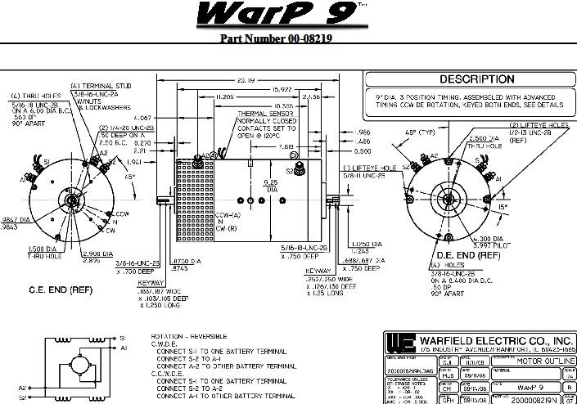
Figure 28 - WarP 9 Motor Schematic - Reprinted with Permission from NetGain Motors, Inc.
    - Motor Controller

The following section evaluates the possible motor controllers for the electric vehicle design. These controllers are seen in the previous section in conjunction with a suggested or compatible AC/DC motor. A controller for the design is selected by the end of this section.

      - AC Motor Controllers

DMOC445 AC Motor Controller
The DMOC445 AC motor controller is digital motor controller that is designed and built by the Azure Dynamics Company. This controller is designed to be used on three phase AC motors and generators. This controller is ideal for EV applications that are small to mid size vehicles. Because the controller is digitally controlled the user can configure the motor controller to operate in standalone mode or be controlled from another device using the CAN communication module. This factor makes the controller extremely versatile for any motor or generator application that requires a unique high voltage and high current three phase drive system. The controller has several built in safety controls that prevent the controller from being damaged. The overall efficiency of the controller makes it an ideal controller that has limited cooling capability such as the AC24 Azure Dynamics Company brushless AC induction motor. Table 10 below has the detail characteristics and requirements of the DMOC445.
Table 10 - DMOC445 Controller Specifications

Curtis 1238-65 AC Motor Controller
The Curtis 1238 AC motor controller is designed by the Curtis motor control company. The motor controller is designed to operate AC induction motors that require medium voltage drive with very high currents. This controller is also ideal for EV applications that are small to mid size vehicles. The controller contains a digitally controlled smart technology that can optimize the drive characteristic automatically after first operation of the motor that it is controlling. It can save these characteristics for future motor operations. The Curtis 1238 can also be controlled from another device through the use of the CAN communications module. The controller can also operate standalone via voltage pedal. The low battery voltage requirement makes it ideal for use with multiple 6 volt batteries that supply heavier currents than 12 volt batteries. Table 11 below has the detail characteristics and requirements of the Curtis 1238-65.

Table 11 - Curtis 1238 Controller Specifications
      - DC Motor Controllers
Curtis 1231C-86XX
The Curtis 1231C-86XX motor controller is designed by the Curtis motor controller company. It is designed to drive small to medium size electric vehicles that use a DC PWM motor. The controller consists of a PWM driven power MOSFET switch that controls the low side of the large DC motor. The PWM can operate up to 15kHz with and efficiency over 90% because of the very low voltage drop of 0.3VDC. This is the recommended controller for the ADC FB1-400 brushed DC motor. The unit has thermal protection in the event the controller is outside its recommended temperature range. The thermal protection folds back the current which limits the speed of the vehicle instead of just shutting off the motor. This is ideal because having a motor that just shuts down do to over temperature is not desirable when travelling on a busy highway. The controller has interlocks to disable the motor in the event that the key is turned on while the voltage pedal is depressed. The units are completely sealed so that the environmental conditions outside an EV don’t affect the circuitry. Table 12 has the detail characteristics and requirements of the Curtis 1231C-86XX.
Table 12 - Curtis 1231C Controller Specifications

NETGAIN WarP-Drive #201-WD-160/1000
The NETGAIN WarP-Drive is an extremely high power motor controller designed and built by NETGAIN Controls, Inc. The controller is capable of operating up to 160 VDC at 1000 Amps in a basic design and is available in much higher power. The controller is capable of operating with CAN bus so that it can communicate and be controlled from other devices. The controller is extremely powerful in a small package. The controller is designed to operate with the WarP9 motor and can easily power the motor to its full efficiency. The controller also has built in over temperature protection that folds back the voltage drive in the event that an over temperature occurs. The WarP-Drive is also capable of driving the WarP9 and the TranswarP9 in tandem for twice the motor drive capability, which is ideal for electric vehicles that are direct drive. This controller is the drive selected for this EV project because it is optimized for the WarP9 motors. This selection ensures that the motor and controller are the most efficient as possible. Table 13 below has the detail characteristics and requirements of the NETGAIN WarP-Drive #201-WD-160/1000.

Table 13 - NetGain WarP-Drive Controller Specifications

These motor controller choices are just a fractional amount of controllers available on the market. The EV project will also design a custom controller that communicates with the touch screen display so that all of the motor and controller characteristics and can be constantly monitored. The new design is the prime drive choice unless the WarP-Control can be easily accessible through the CAN bus and all of the desired current, voltage, thermal and RPM monitoring circuitry.

    - Battery Supply

The design of the power system consists of the three major components: the primary battery bank, the secondary battery, and the solar charger. The primary battery bank is the total battery power needed to run the electric motor efficiently using lead-acid batteries. As the data was shown in the battery supply research section, lead-acid battery achieves the power needed to power the electric motor, but the major factor in choosing lead-acid over its competitor is that it is inexpensive, the most widely used battery in early EV conversion, and it is the oldest battery of the all the options. There are three different types of lead-acid batteries consisting of: flooded, absorbed glass mat (AGM), and gel. The battery chosen for this project is the AGM Universal Battery, Model:UB121100, shown in Figure 29.

Figure 29 - Universal Battery Model UB121100 – Requested Permission from Universal Battery

Table 14 below shows the specifications for a variety of the lead-acid batteries that meet the design criteria for the electric motor. The twelve volt battery is selected over the six volt battery because even though you get more power per battery out of six volt, the physical dimensions are just slightly different. This in turn means that choosing the six volt batteries twice as many as batteries are required, and therefore twice the weight. Since weight is a key factor in selecting the motor, the twelve volt option is the best choice for this design. The battery with the least amount of weight and the smallest capacity isn’t the cheapest, and the battery with the greatest amount of the weight and the largest capacity is the most expensive. The cheapest battery in the table has good capacity, fair weight by comparison, and it is an overall decent battery for the lowest price.

Table 14 - Lead-Acid Battery Selection
Brand | Model | Voltage | 20Ah | Weight | Price
Exide Orbital | 34XCD | 12 | 50 | 41 | $125.00
Optima | D750 | 12 | 65 | 45 | $155.00
Trojan | SCS200 | 12 | 115 | 60 | $140.00
Optima | D31T | 12 | 75 | 60 | $180.00
Deka | 9A31 | 12 | 100 | 69 | $140.00
Dynasty | DCS100 | 12 | 100 | 69 | $178.00
Universal Battery | UB121100 | 12 | 110 | 73 | $100.00
Odyssey Hawker | PC2150 | 12 | 104 | 75 | $236.00
Trojan | J-150 | 12 | 150 | 84 | $180.00

Battery Box Dimensions
Figure 30 shows the dimensions for fabricating the rear battery box. The rear battery box consists of three pieces, sheet metal box, plywood length separator, and the plywood width separator as shown in Figure 33. This diagram shows the total length of 54 inches, smaller than the width of a standard vehicle’s trunk, to fit four batteries side by side. The box is 14.6 inches wide to fit another parallel row of four batteries. This diagram also shows the distance between each battery of 0.5 inches. Figure 31 shows the dimension of the total height of the sheet metal and the width of the individual battery compartment.
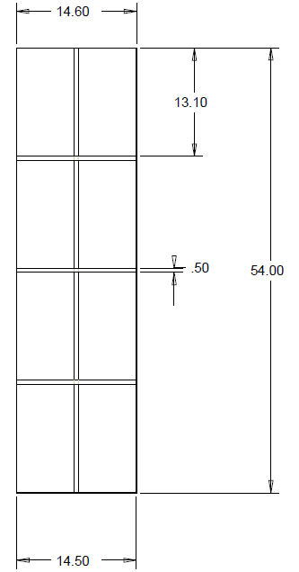
Figure 30 - Rear Battery Box Top View
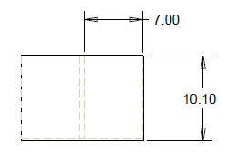
Figure 31 – Rear Battery Box Front View
Figure 32 shows the dimension of the length and height of the length separator. The summary of the dimensions are shown in Figures 29-31 which is understood as the sheet metal box has an overall dimensions of 54” x 14.6” x 10.10” with an overall thickness of 0.05”. The length separator has dimensions of 53.9” x 10” x 0.5”. The width separator has dimensions of 14.5” x 10” x 0.5”. The front battery box is construction the same as the rear battery box except for is design for quantity of four batteries instead of eight like the rear. So, for the sheet box for the front battery box has overall 26.8” x 14.6” x 10.10’ with an overall thickness of 0.05”. The length separator has dimensions of 26.7” x 10” x 0.5”. The width is exactly the same in both battery boxes.
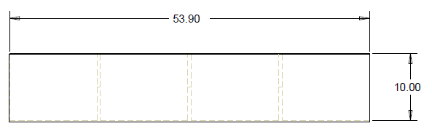
Figure 32 - Rear Battery Box Side View
Figure 33 shows an example of the notches on each of the interconnecting walls of each battery box for easy of connection. This slit also assists the battery wiring for the temperature sensors out of the battery box to the sensor/motor controller. The outer walls are constructed from aluminum, and the inner walls are constructed with 0.5 inch plywood. The square holes house a 120mm exhaust fan controlled by the sensor/motor controller. The main purpose behind the design of the battery boxes is to secure the batteries in the trunk and the engine compartment.
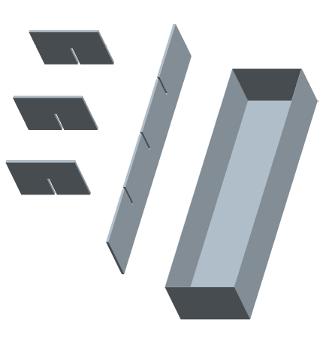
Figure 33 - Rear Battery Box Model
The secondary battery, also known as the auxiliary battery, and the solar charger are shown in the schematic below. The secondary battery does the same job as the traditional starting, lighting, and ignition of the internal combustion engine. The secondary battery will power the user interface, interface microcontroller, various sensors, the lights, and the sensor/motor controller. The secondary battery is charged in one of two different ways, either with the 120VAC charger or with the solar panel. When the EV is at the charging station or residential home then the secondary battery is solely charged through the AC charger. The way that this is accomplished is when the primary battery bank is fully charged then the primary battery bank is charging the secondary through the DC/DC converter.

When the EV is in motion it is charged through the solar panel. At this point the primary battery bank is completely disconnected from the secondary battery so that all available power is used solely for the electric motor. This charging scheme is done with circuit breakers on the cables going to the DC/DC converters, and a circuit breaker on the output on the solar panel. The solar panel used for this project is the PowerFilm Rollable solar charger R14, which is a 14 watt flexible thin-film amorphous-silicon solar panel, seen in Figure 34. The reason this solar panel is chosen over the other choices is because it is one of the few that fit the projected dimensions. It has the highest power output among the others within it dimensions, and the peel and stick design is ideal for installation of this nature. A schematic of the auxiliary batter is shown in Figure 34 illustrating the multiple charging sources. It also shows the key switch which is represented as a normally open toggle switch that powers up the components mentioned earlier.

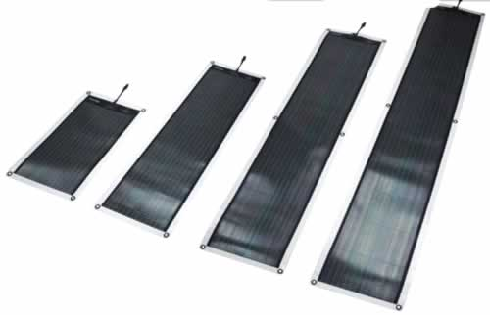
Figure 34 – PowerFilm R14 – Reprinted with Permission from PowerFilm Solar
    - Sensor/Motor Controller

For the task of interfacing with all of the sensors in the vehicle and controlling the motors operation, the Microchip PIC32 processor technology is used. The device model is the PIC32MX795F512L. It’s a 100 pin LCC that is more than adequate to perform this task due to the following specification shown in Table 15.

Table 15 - Controller Specifications

The main reason that the PIC32 is selected for the sensor/motor task is because the device closely matches the requirements for interfacing with all of the sensors. The other features are that the device is very user friendly and inexpensive. The average cost of the individual IC is less than $10 and the development cards for coding and debugging are less than $60. Figure 35 illustrates the overall operations and interactions of the PIC32 processor. For example the 32 bit connection to the bus matrix and then able to communicate through USB, DMA, CAN, or Ethernet. Furthermore this diagram displays analog comparators to the peripheral bus that is accessible.


Figure 35 - PIC32 Motor Controller Connections/Functions – Reprinted with Permission from Microchip
Figure 36 is an overall diagram showing the interfaces with the sensor/motor controller including but not limited to the voltage pedal connection, and current and voltage measurements. This figure is followed by Figure 37, a detailed schematic of the sensor/motor controller circuit card assembly. The schematics contains all of interconnects between the sensors and the microcontroller. All of the digital I/O is buffered using a driver that is connected to 5VDC. The 5VDC logic will also drive the gate of the MOSFET switches to make sure that the MOSFET switches are completely switched on. The circuit card assembly also creates all of the supply voltages using efficient buck converter technologies. The analog circuitry will use the 12VDC battery voltage to do all of the amplification. This voltage is filtered so that the signals will have some noise rejection. The operational amplifiers have resistor networks on all of the legs so that during the debug stage they can be configured to any gain selection. The connector is of a ribbon type cable connector to allow for a large amount of connection but the wire used will not be ribbon cable. Each one of the temperature sensors will have twisted and shielded cable to make the signals less susceptible to electromagnetic interference. The PWB is routed such that a power and ground layer is added to help with noise immunity. This will add cost but since this card is driving a 500 amp PWM switch, the need for proper grounding is required. The IGBT’s is mounted to cold plate beside the circuit card.
Figure 36 - Sensor/Motor Controller Diagram

Figure 37 - Sensor/Motor Controller Circuit Card Assembly
The Figure 38 and Figure 39 below are the PWB layout and routing of the circuit card respectively. Because of the large amount of I/O required to connect to the sensors, a large connector is needed. Also seen in the diagram are excess connections on the circuit card if modifications are needed during the debugging stage.
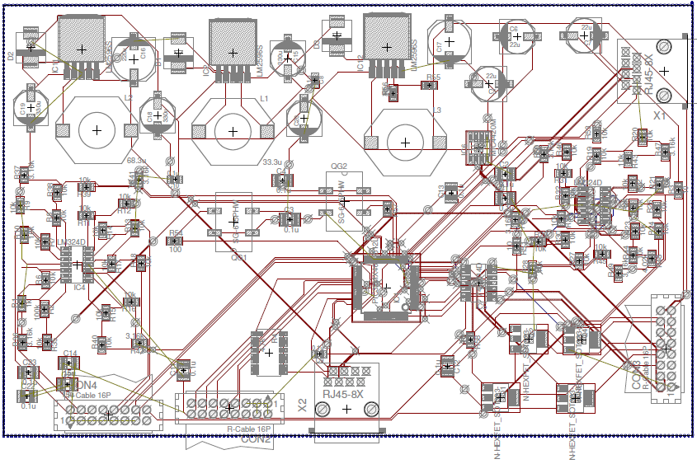
Figure 38 - PWB Layout
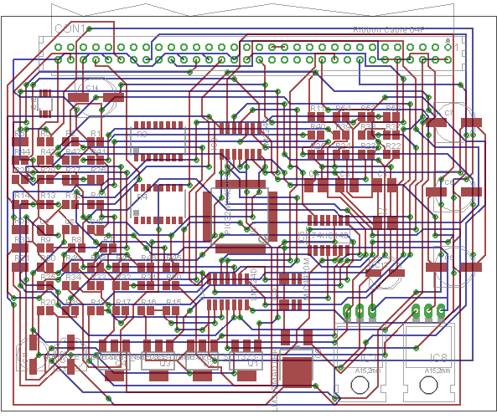
Figure 39 – Routing CCA
Power Calculation
The controller multiplies the voltage times the current to get average and peak power. The voltage and current inputs pass through low pass filters in the controller to generate the average power reading. The calculated power data is sent to the microprocessor and displayed on the touch screen display in the form of power usage charts. The controller also compares the power being used to the estimated power in the batteries to determine the amount of drive time left.

DAC Interface
The 12 Bit DAC will interface between the motor controller serial speed control output and the motor control electronics voltage pedal input. The microchip MCP4821-esn is a serial 12 Bit DAC and is designed to give a precision analog output. The DAC will utilize a SPI bus from the microcontroller and is used to drive the voltage pedal input of an existing motor controller. The DAC’s supply voltage is 5VDC. When the DAC voltage is at zero then the motor is completely shut down. When the DAC is at full voltage then the motor drive is at 144 VDC. The 12 Bits of data gives the motor control 4095 steps in speed control. The circuitry also contains an override switch that automatically grounds the pins if the soft emergency shutdown button is depressed on the touch screen display.

BIT
The controller will continually perform BIT on the automobile subsystem and report the status back to the touch screen display. The controller’s built in voltage sensing circuitry reports brown out conditions and over voltage conditions.

Voltage reference
The controller has an internal reference at 1.2V and the DAC has an internal 2.048VDC reference. The only reference that is to be created is a 6VDC reference used by the current sensor circuitry. This reference is created using a Linear Technology LM4121 which is an adjustable output reference. This reference voltage is buffered by individual operational amplifiers so that adequate current can be supplied to each of the current measurement sensors.

Voltage Conversion
The 12VDC Bus used for the automobiles general power source is used to generate all of the power for the sensor/motor circuit card assembly. This voltage range is between 10VDC and 14.4VDC and is filtered and conditioned using a combination of inductors and capacitors to limit the EMI noise on the controller electronics. The 3.3VDC and 5VDC is created form the filtered 12VDC. This voltage is used primarily by the controller and the DAC. The 3.3VDC and the 5VDC is created by using a buck converter technology. These converters is designed to be able to supply 4 amps of peak current and 2.5 amps average current for 3.3VDC and peak current of 1 amps and average of .5 amps. Each required to meet an average efficiency of 80% with a 5% regulation.

PWM Interface
The digital output PWM is a 12 BIT data stream at a frequency of ~10kHz and interfaces to the IXYS power MOSFET driver IC IXDN414Y. The 3.3VDC digital output is translated to a 12VDC that will guarantee that the three IGBT switched is in full conduction to minimize power dissipation. The IXDN414Y is a high current switch that can drive a large amount of capacitance at frequencies greater than 200kHz. The controller will generate the PWM using the Output Compare Mode routines. This is a series of counters that compare the input data and generate a PWM data stream based on that input requirement. The Output Compare will look at three inputs to the controller to determine the PWM serial data going to the MOSFET Driver.

- Voltage Pedal Input Voltage. This is a proportional input to output voltage.
- Mode of the Intelligent Driving System. This will limit the level of the output depending on whether the mode is set to economy, performance or normal mode.
- Optional Cruise Control. This is sent by the touch screen display microcontroller and will take over the control of the output based on a desired speed value selected.

Motor PWM Switch
The motor speed is controlled by the PWM drive output. This proportional PWM will switch three High Voltage and High Current IGBT devices. These devices are IXYS IXGK320N60B3 IGBT’s. Each one of the IXGK320N60B3 devices are rated at 600VDC and average currents at 320 Amps with peaks currents up to 1200Amps. The voltage drop at 320 amps is only 1.2VDC so the power dissipation during the steady state motor drive is minimized. The combination of the three devices will give less voltage drop on the devices because each one will switch 1/3rd the power and as result power dissipation will reduce. These devices will connect to the negative side of the motor and is the return path for the motor. The devices is mounted to finned heat sink’s with a fan blowing across them. The IGBT will have a protection diode going from the collector to the motor positive terminal to limit the amount of voltage that can be developed when the IGBT motor switches are in the off cycle of the PWM. There will also be a large capacitor bank on the motor to help clamp these voltage spikes. Figure 40 below shows the IGBT gate drive voltage and collector voltage during the PWM.
Figure 40 - IGBT PWM
Figure 41shown below illustrates the overall connection of the DC motor to the motor controller including the PWM Switch and the IGBT’s used to interface this high current and high voltage to the motor.

Figure 41 - DC Motor Drive Electronics
Speed control Interface
The EV project will execute parallel paths for the motor control electronics. The project will purchase existing control electronics and built the automobile and test the existing electronics, while completing the design of more efficient set of motor electronics. This will allow the project of experiment will multiple drive types to find the best solution for the project. This may involve several iterations of motor switching electronics. The Speed control output will connect to the purchased motor controller electronics Voltage Pedal input. The microcontroller will look at three inputs to determine the output serial data going to the DAC driving the controller. The first is the Voltage Pedal input voltage. This is a proportional input to output voltage. Second is the mode of the Intelligent Driving System. This will limit the level of the output depending on whether the mode is set to economy; performance or normal mode. The last input that is compared is the optional cruise control. This is sent by the touch screen display microcontroller and will take over the control of the output based on a desired speed value selected.

USB Interface
There are two USB interfaces that is used but the microcontroller. The first is used during the debug and integration phase of the project. This dedicated interface is implemented in the PWB so that data can be captured from the microcontroller and analyzed for refinement of the microcontroller during the entire project. The second USB is used to communicate with the Touch Screen Display microcontroller. This is the path that all of the I/O data will pass between the microcontroller’s.
.
Automobile Speed
The automobile speed will measured in two ways. The first is an GPS tied to the touch screen display and microcontroller. This will provide and accurate measurement of the Automobiles speed provided that there is good satellite reception. The second is to utilizing the existing speed sensor on the automobile. This sensor is usually located in the output of the manual transmission and is either a Hall Effect sensor output or a transformer coupled output. This output is connected to the Sensor / Motor Microcontroller circuitry and be converted into either an analog or digital format that can be inputted into the microcontroller. This drive shaft speed vs. wheel speed data can then be calibrated by comparing the drive shaft speed to the vehicle with the GPS. This ratio is stored in the flash and updated once during each vehicle power off and on operation. The update will compensate for tire rubber loss over the life of the tires. This stored data is used when GPS data is not available.

Motor RPM
Figure 42 shows the optional Hall Effect sensor RPM ring that attached to the side of the WarP9 motor and an exciter ring that contains four magnets that are 90 degrees out of phase from each other. The output of the hall effect sensors are optically isolated from the Hall Effects and connects to a logic pull up resistor and can be read by the microcontroller digital input . The microcontroller can clock off the first falling edge to begin the RPM measurement. This data can be passed the touch screen display microcontroller and displayed. The four pulses per revolution can also be used to get motor acceleration and deceleration. See Figure 43.

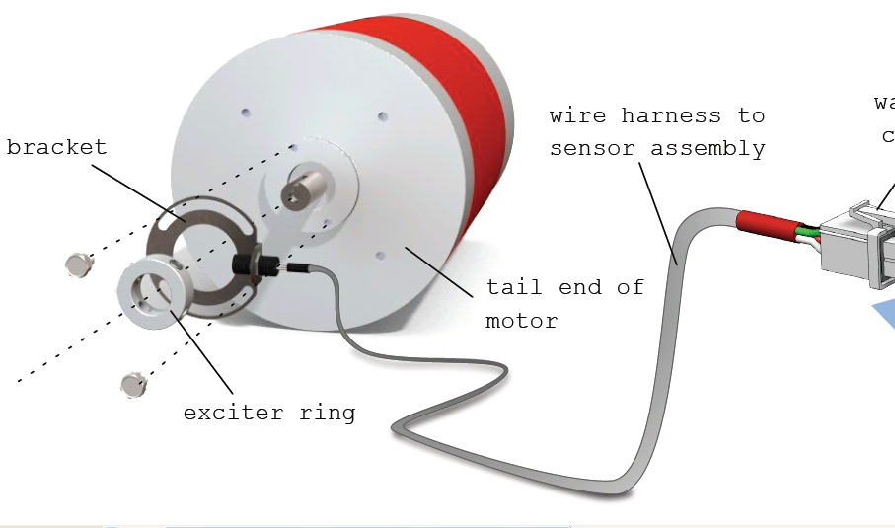
Figure 42 - RPM Sensor Connection- Reprinted with Permission from NetGain

Figure 43- Hall Effect Output RPM
Buffered Digital Outputs.
The 3.3VDC outputs of the microcontroller is buffered by an 74HCT7541 to allow for a 3.3VDC to 5VDC translation and to be able to supply adequate current. The 74HCT7541 can supply in excess of with 25ma current capability at 12ns transition times.

Motor Capacitor and Protection Diode
The motor drive electronics will require a fast protection diode and large capacitor form ground to the positive terminal of the motor. The MURTA60060R dual diode will conduct only when the PWM switch is switched to an off position, the inductance in the motor will make the negative side of the motor rise above the 144VDC level and the diode will clamp that voltage to ~1.5V above 144VDC. Each diode is capable of handling 600Amps and both together will have to be able to handle peak currents greater than 1000 Amps and reverse voltages over 600VDC at a 220ns rate. The ~220uf capacitor bank will help reduce the source impedance between the motor and the batteries due to the inductance in the wires. The capacitor is a low impedance load to the large DV/DT that is is generated by the motor during the PWM switching.

Soft Emergency Shutdown
The microprocessor constantly monitors all of the voltage, current, and temperature using the analog comparators. If any of these values exceed a predetermined safe operating condition on a continuous basis then the microprocessor will shut down the motor drive circuitry and report the faults to the touch screen display microprocessor. The controller will continue to monitor the condition of the fault and if it hasn’t subsided with the motor off then the display will recommend that the driver turn off the automobile completely and check the system for short circuits.

Interlocks for safety
The microcontroller will monitor the clutch switch, door interlock and the break switch to verify they are all SAT during the first initialization after the ignition key is turn on. If all are SAT condition, then the microcontroller will take inputs from the Voltage pedal and enable the motor drive electronics. There after the switch inputs are not active until a reset of the ignition switch. If the switches are UNSAT then the microcontroller keeps motor drive controls off until a SAT condition occurs.

Figure 44 below is a sealed metal box that contains the sensor/motor electronics and the IGBT power switches attached to a heat sink with fans. A metal cover is located over the circuit card to help shield it from the EMI generated during the pulse width modulation motor switching. The fans is controlled from the controller as mentioned above.
Figure 44 – Sensor/Motor Controller Black Box
    - Temperature Sensors & Thermal Control

The design of the temperature monitoring and control is based upon the sensor selection. Whether the sensor is analog, digital or one-wire will determine the overall configuration and additional parts that might be required. Table 16 shows a comparison between six temperature sensor devices. It can be easily decided that economically the TMP20 would be the best selection with the widest operating temperature range. Despite this factor the additional components for an analog to digital converter design would make up for its benefit. In terms of the best component to reduce the number of wires included in the wiring harness, from the rear of the vehicle to the controller in the front, would be the DS18S20/DS18B20. The only disadvantage of this component is that its relatively new technology that may not have a large number of application engineers that are able to assist in malfunctions. The final option is the TMP03 sensor which despite its high cost provides a reasonable temperature range and can be further interfaced due to its open collector output. This temperature sensor requires a 4.5 to 7 V input which can be regulated from the 12V battery.

Table 16 - Temperature Sensor Comparison
Part Number | Type | Temp. Range | Input Voltage | Output | Cost
LM335 | Analog | -40°C to +100°C | 1.8V to 5.5V | Voltage | $1.35
TMP20 | Analog | -55°C to +130° | 1.8V to 5.5V | Voltage | $0.87
TMP03 | Digital | -40°C to +100°C | 4.5V to 7V | Open Collector | $5.04
TMP04 | Digital | -40°C to +100°C | 4.5V to 7V | CMOS/TTL | --
DS18S20 | 1-Wire | -55°C to +125°C | N/A | Digital 9-bit | $4.00
DS18B20 | 1-Wire | -55°C to +125°C | N/A | Digital 12-bit | $4.00

Temp Sensor Interface
The EV has very high switching currents so the possibility of EMI affecting the TMP03 remote digital temperature sensor is very likely. The temperature sensors on the batteries in the rear of the vehicle has to be over 20 feet long and the sensor on the drive motor have to be shielded for a high magnetic field. Because of this the all three of the wires coming from the sensors are twisted, shielded and terminated at the Circuit Card Assembly (CCA). The VCC voltage for the sensors originates on the CCA so that all of the current goes through these wires and returns back, reducing the chance for ground currents. A 10µF and .01µF capacitors are added to a small circuit card that the temperature sensors attach to so that proper filtering can be achieved. As mentioned previously the TMP03 is an open collector device so that the 3.3k ohm pull-up resistor pack is located on the CCA close to the microprocessor. The temperature sensor output is approximately a 35Hz square wave at 25°C. The controller can decode the data using the following formula. Temperature °C=235-(400*T1/T2). T1 is the High time (which is typically constant at 10ms) and time T2 is the low time which varies based on temperature (-55°C=15ms and 125°C =35ms). See Figure 45. The microcontroller can sample the data clocking on the rising edge to start a counter and when T1 time goes low the processor will read trigger on the next rising edge. The time T2 can then be decoded. Depending on the speed of the counter the TMP03 had an average accuracy of 1.5°C. The temperature data can then be analyzed and compared to temperature limits so that the microcontroller can take action such as turning on fans or go into emergency shutdown of subsystems. The temperature data is also shift loaded into the serial data being passed to the microcontroller that is controlling the touch screen display.
Figure 45 - TMP03 Temperature Measurement
Fan controls
There are several fan controls from the sensor/motor controller. These individual fan controls are the outputs from the 74HCT7541device, mentioned in the buffered output section and drive the gate of small N channel power MOSFET transistors that switch the negative side of the 12VDC fans to ground. The main fans that are on the Sensor/ Motor Controller electronics will run continuously unless a mode control is requiring a economy mode then the fan control is based on the temperature of the output bridge and the microcontroller internal temperature. The second set of fans is on the batteries for the motor drive. These fans are controlled based on the ideal temperature of the batteries and are turned off completely if the mode control setting is selected to the economy settings.

For the smaller application of the electric vehicle only five TMP03 sensors are used. They are located on the microcontroller, motor switch, each of the rear wheel motors and on the auxiliary battery. The fan remains on in all modes of the operation but can be modified through the control system quite easily for later development.

    - Voltage Measurement

The voltages from Table 17 that are being sensed have to be conditioned before they can be read by the microprocessor. Because the motor, battery, and solar voltages can be very high, the use of a precession high common mode input difference amplifier is used. The AD629BRZ is ideal for this application. The AB629BRZ can handle input common mode differences up to 300VDC. This will ensure that the expected voltage spikes >150V generated by the large drive motor will not damage the first amplifier or the microprocessor. The 12V, 5V and 3.3V will utilize a standard operational amplifier to sample the voltages. The LT1114 is used for the purpose because it is a rail to rail output device that is designed to operate well with just a single supply. The rail to rail feature can easily measure voltages near ground level which can allow for large dynamic range voltage measurements.

The amplifiers will use a the battery supply voltage of 12VDC so the outputs of the amplifier amplifiers will have to be scaled by a resistor divider network because the microcontroller A/D inputs can only handle voltages in the range of 0 to 3.3VDC. A resistor ratio of ¼ in which a 10K ohm resistor is in series with voltage going to the microcontroller input and a 2.49k will go to ground to achieve this ratio.
Table 17 - Voltage Sources

The microcontroller has a 16 channel 10 bit A/D that is will utilize to sample the voltages that are outlined in the sensor/motor controller section. The microcontroller uses an analog MUX to sequence through the 16 channels and sample and holds each value. As the next data sample is passed to the sample and hold the previous value is converted to a digital value and loaded into the ADC buffers. The data is compared against predetermined values coded into the processor and if a threshold has been crossed then the microprocessor will flag that fault condition and take appropriate action. These digital values are also loaded onto the serial bus going to the touch screen display processor and can be accessed at any time by the user.

    - Current Measurement

The controller A/D inputs is used to measure currents of the motor batteries, motor, 12VDC Bus and the solar cell. The currents of the motor and motor batteries is extremely large pulsed peaks up to 1000 amps but average current is 200 amps. There are two safe ways to measure current of the magnitudes that are generated during the motor switching. The first is a high current sensing transformer with a turns ration near 1:1000 or a high current Hall Effect transformer sensor. The current sensor chosen for this application is the F.W.Bell RSS-200-A Hall Effect sensor. The RSS-200-A is a current sensor that has a linearity over the +/-200A range and can also handle ranges up to +/- 500A with some minor non-linearity effects. The output sensitivity is 8mV/A centered around the 6VDC reference voltage.

The F.W.Bell RSS-100-A is chosen to handle the smaller currents generated by the solar panel and lead-acid batteries. The RSS-100-A is a current sensor that has linearity over +/-100A range and can also handle ranges up to +/- 250A with some minor non-linearity effects. The RSS-100-A outputs 16mV/A centered around the 6 VDC reference. Both of these types of sensors require a power supply voltage 12 to18 VDC and the reference voltage of 6VDC. Figure 46 shows the dimensions and connection chart for the Hall Effect Sensors.

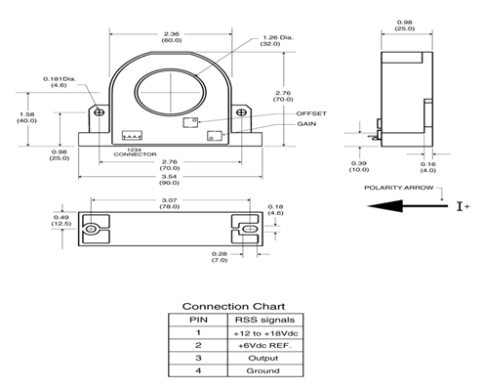
Figure 46 - Hall Effect Sensor – Reprinted with Permission from Pacific Scientific
The outputs of the current sensors are inputted into an operational amplifier that current sensor outputs input op-amp configured as a voltage follower. The output of the voltage follower will pass through a resistor divider ratio of ¼ in which a 10K ohm resistor is in series with voltage going to the controller input and a 2.49k will go to ground to achieve this ratio. This is inputted into the controller A/D input. Because the voltage is centered on a reference voltage at 1.5VDC the controller will have to be coded to recognize positive and negative currents. Because of the motors large current swings the resolution of the current data is approximately 1 lsb/Amp. The microcontroller will have to take the PWM type current and average it over the 16kHz clock used to generate the motor drive. The 12VDC bus is monitored to determine the state of usage of the lead-acid batteries and the charging system.

The following diagram, Figure 47, illustrates the connection between the current sensor and the battery terminals. This figure also shows the use of the operational amplifier to limit the amount of voltage and current into the controller circuit.
Figure 47 - Buffer Circuitry
    - AC/DC Power Converter

In order to provide the most efficient means of charging the batteries, without danger of overcharging and limiting the life of the batteries, a battery charger is used for the design. A summary of the overall physical characteristics of each charger can be seen in Table 18. The Elcon charger would be the best option in terms of physical specifications. It has a total weight of 14 pounds and is the lightest of all the charger options. The heavier the vehicle and the components within it requires more power to move, therefore the lighter the components that are chosen for the design the better. Due to the fact that the charger needs to be in close proximity of the batteries to charge them, this weight is added to the heaviest part of the vehicle. Another benefit to the Elcon is the two methods of mounting the device as seen in Figure 48. This property gives more flexibility to the configuration of batteries and the charger in order to provide both with the appropriate amount of ventilation and access to cabling.

Table 18 - Physical Comparison of the AC/DC Converter Options
Physical Comparison
Type | Weight  (lbs) | Height  (inches) | Width  (inches) | Length  (inches) | Volume  (inches³)
Zivan | 15 | 3.5 | 8.7 | 16.9 | 514.61
Manzanita | 16 | 14 | 10.5 | 5.75 | 845.25
Elcon | 14 | 13.86 | 6.89 | 5.47 | 522.36

Figure 48 - Mounting of AC/DC Converter Options – Reprinted with Permission of Cloud Electric, LLC
Table 19 details the electrical aspects of each battery charger in order to decide which charger is most beneficial to the design. Overall a battery charger with power factor correction would improve the charging capabilities depending on the current flow into the circuit. This factor could provide further protection to the internal circuitry of the charger and increase efficiency. Therefore the Zivan wouldn’t be the best option despite its wider temperature range in comparison to the other units. The Manzanita Micro perceives to be the best charger available based on the pure efficiency rating of 96 percent, the greatest of the chargers. Secondly the power factor correction capability of .9997 is the most impressive feature, if in fact the input voltage source is less than the output source. In contrast to the other battery chargers the Manzanita provides an output voltage range in case more or less batteries were to be used further design changes would not have to be made. Despite these characteristics further evaluation is required.

Table 19- Electrical Comparison of the AC/DC Converter Options
Electrical Comparison
Type | V_{in}  (VAC) | V_{out}  (VDC) | I_{out}  (Amps) | Efficiency  (%) | Temp.Range  (Celsius) | PFC
Zivan | 115/230 | 144 | 15 | 90 | -20 to +50 | N/A
Manzanita | 100-240 | 12-360 | 20 | 96 | -28.8 to +48.8 | 0.99
Elcon | 85-265 | 144 | 8 | 92 | -40 to +55 | >.98
It is known that the battery pack is approximately 144VDC with an input voltage to the battery charger of either 120/240VAC. For the most convenient means of charging a 120VAC source is used but 240VAC is also evaluated. It is important to note that the standard 120V outlet in a home will trip the circuit breaker if the current being pulled is greater than 15 amps and greater than 20 amps for the 240V outlet. Typically this 15/20 amp rating is for an inrush current flow and therefore approximately 10/15 amps is the maximum input current to the battery charger dependent on the input voltage supply. With this in mind the input power is approximately 1200/3600 watts maximum. Using the provided efficiency from the charger specifications the input current can be calculated for each charger depending on the input voltage as in Table 20. From this calculation the only charger available for a 120VAC input source is the Elcon charger due to the 10.32 amp input current value that won’t trip the circuit breaker. Both the Zivan and Manzanita chargers would provide the proper configuration for the 240VAC power source with the highest current rating of 12.5 amps.

Table 20 - Input Current Calculation of the AC/DC Converter Options
Type | Power Out  (Watts) | Power In  Including Efficiency  (Watts) | 120VAC  Input Current  (Amps) | 240VAC  Input Current  (Amps)
Zivan | 2160 | 2400.00 | 20.00 | 10.00
Manzanita | 2880 | 3000.00 | 25.00 | 12.50
Elcon | 1152 | 1238.71 | 10.32 | 5.16

Finally a purchasing comparison is detailed in Table 21. This shows that the Elcon 1500W HF/PFC charger is the most economical of the three options, regardless of shipping prices. Overall this unit meets all necessary requirements of converting AC/DC power to provide the 144VDC to the battery pack with 92 percent efficiency. By selecting this part for use the 120VAC input is used to limit the input current to 10.32 amps and prevent tripping a circuit breaker.

Table 21 - Purchasing Comparison of the AC/DC Converter Options
Purchasing Comparison
Type | Part Number | Cost
Zivan | F7 RG NG3 144-15 | $ 1,099.00
Manzanita | PFC-20 | $ 2,050.00
Elcon | 1500W HF/PFC | $ 340.00

    - DC/DC Power Converter

To sufficiently provide the 12V auxiliary battery with power, a DC/DC converter is purchased. The two options were either the 400W ElCon isolated converter or the 300W HWZ series converter. In the combustible vehicle the 12V auxiliary battery is located in the front of the car to power the accessory components. It is only logical to place the same 12V battery and DC/DC converter for the electric vehicle in close proximity of the original location. This reduces the number of wires in the underbody of the vehicle if the conversion is located in the front. Furthermore this location assists in balancing the weight throughout the vehicle, and provides a safe location for mounting. Table 22 below compares the physical characteristics of both units. The differences between the two models are one pound in weight and approximately 19 cubic inches in volume. Neither of these characteristics is critical decision factors for the design unless the vehicle chosen doesn’t have a suitable location for mounting in the front.

Table 22 - Physical Comparison of the DC/DC Options
Physical Comparison
Type | Weight  (lbs) | Height  (inches) | Width  (inches) | Length  (inches) | Volume  (inches³)
ElCon | 5 | 3.25 | 6.2 | 6.9 | 139.04
HWZ | 4 | 2.8 | 5.5 | 7.8 | 120.12

The two models are both capable of providing 12VDC to the battery in order to charge it and provide power to the auxiliary components with slight variations in output current. The ElCon model outputs 20 amps to the battery in comparison to the 25 amps the HWZ series converter provides, as seen in Table 23. In either case this current needs to be limited before interfacing with any subcomponents. Another noticeable factor of the ElCon charger is its increased temperature range. Overall there are no critical differences between these charger electrical options to make a distinct decision.
Table 23 - Electrical Comparison of the DC/DC Converter Options
Electrical Comparison
Type | Input  Voltage  (VDC) | Output  Voltage  (VDC) | Output  Current  (Amps) | Efficiency  (%) | Temperature  Range  (Celsius)
ElCon | 144 | 12 | 20 | 92 | -40° to +55°
HWZ | 144 | 12 | 25 |  | -10° to +40°

Finally the financial evaluation is the deciding factor of the DC/DC converter. In order to supply the best product with the most economic value, the HWZ series converter is selected. Overall this product cost $125 from Cloud Electric as seen in Table 24. Despite the limited temperature range and the higher output current this charger will save $125 to the budget.

Table 24 - Purchasing Comparison of the DC/DC Converter Options
Purchasing Comparison
Type | Manufacturer | Cost
ElCon | Evolve Electrics | $250.00
HWZ | Cloud Electric | $125.00
The flow diagram, Figure 49, shows the full transfer of power completed by the AC/DC power converter, the battery pack and the DC/DC converter.

Figure 49- AC/DC- DC/DC Diagram
For the smaller application vehicle a standard 120VAC to 12VDC battery charger is used. The battery charger is purchased with the vehicle and is the standard charging mechanism for the vehicle.

    - Small DC/DC Converter

As specified by the sensor/motor controller section there is a requirement to provide low DC voltages to the temperature sensors and controller. In order to maintain high efficiency and low heat due to high load currents, a switch mode regulator is used. The LM2596 simple switcher step down power converter is selected from National Semiconductor. This integrated circuit provides the functions of a buck converter with several output voltage options of 3.3V, 5V, 12V, and an adjustable version. Due to the fact that both 3.3V and 5V are needed two separate LM2596 circuits is designed. The LM2596 guarantees ±4% tolerance of an output voltage under a specific load and input voltage. This component is also rated at 150 kHz switching frequency allowing smaller capacitor values than a lower switching frequency. The IC is a 5-lead TO-263 surface mount chip with the pin configuration shown in Figure 50.

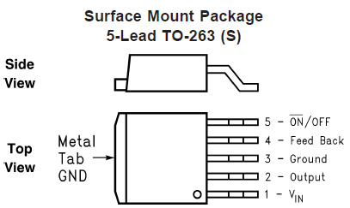
Figure 50 - LM2596 Surface Mount Package Pin outs

LM2596S-5.0 Design
The following specifications are used to design the first DC/DC converter:
- V_{in} = 12V
- V_{out} = 5V
- I_{out} = 1A
Following the design procedure from the LM2596 datasheet the input/output capacitor, diode and inductor values are computed.
Inductor Selection (L1):
Using Figure 51 the inductor value is equal to 68µH using the 1 amp load current and the 12 volt input voltage. The L30 from this figure corresponds to a number of possible inductors, both through hold and surface mount types, from various suppliers. The Coilcraft surface mount inductor, part number DO5022P-683, is chosen with a 2.3 amp RMS current.
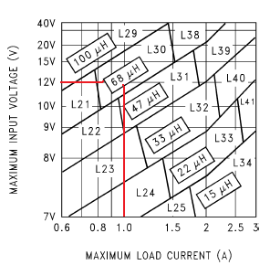
Figure 51 - Inductor Selection Graph 1
Output Capacitor (C_{out}):
The National Semiconductor datasheet for the LM2596 uses Table 25 as a quick design component selection table and the details guidelines below for selecting the output capacitor consisting of:
- Capacitor voltage rating > 1.5*V_{out}
- Capacitor values no larger than 820µF
- Low ESR capacitors

Table 25- Output Capacitor Selection Table 1
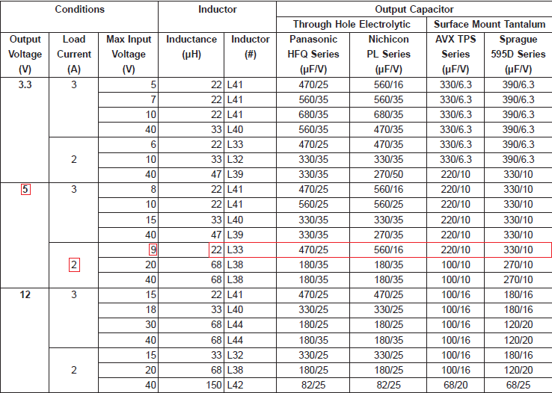

This table suggests that a 220µF output capacitor with a 10V rating is appropriate from AVX TPS series. This surface mount tantalum capacitor is rated at 20% tolerance with a temperature range from -55°C t0 125°C. The DC voltage rating is 10V which is twice the value of the output voltage and abides by restriction number 1. Furthermore the ESR is equal to 0.1 Ohm and is in concordance with restriction number 3. This part can be ordered from Digi-Key, part number 478-4110-2-ND for $2.21.

Catch Diode Selection (D1):
The datasheet further details the guidelines for selecting the catch diode as follows:
- Current rating >1.3*Maximum Load Current
- Reverse Voltage Rating > 1.25*Maximum Input Voltage
- Short Reverse Recovery Time

Using these given restrictions the Schottky diode from Diodes Inc. is selected; part number 1N5820DITR-ND. The forward current rating is equal to 3 amps to fulfill restriction number 1 where the maximum load current is 1 amp. Furthermore the reverse voltage rating is 20V, more than 1.25 times the input voltage, and adheres to requirement number 2. Finally this particular diode is a Schottky known for its short reverse recovery time and suggested by the National Semiconductor datasheet for use. This part can be ordered from Digi-Key for $1.06.

Input Capacitor (C_{in}):
The restrictions for the input capacitor are as follows:
- RMS current rating > ½ DC load current
- Use an aluminum electrolytic capacitor
- Capacitor voltage rating ≈ 1.5*Input Voltage

The 330µF aluminum electrolytic capacitor from Panasonic complies with the restriction from above; part number EEE-FK1V331P. The RMS current rating is .85 amps, which is at least half of the DC load current, and the DC voltage rating is 35V, over twice the input voltage, to fulfill requirements 1 and 3. This part is available from Digi-Key for $0.47.

The final schematic of the 12V to 5V DC/DC buck converter is seen in Figure 52.
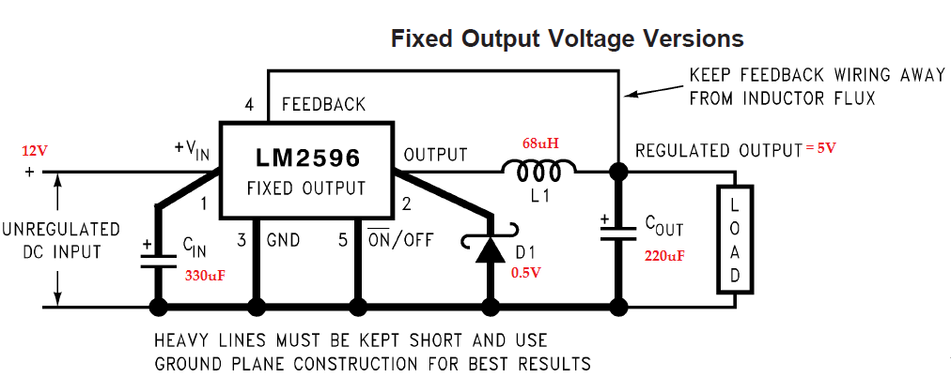
Figure 52 - 12VDC/5VDC Buck Converter Schematic
LM2596S-3.3 Design
A similar design procedure is followed from above with new specifications based on the new load current and output voltage. The new specifications are as follows for the second DC/DC buck converter:
- V_{in} = 12V
- V_{out} = 3.3V
- I_{out} = 2A

Inductor Selection (L1):
From Figure 53 the 33µH inductor is chosen for the LM2596 regulator with an input voltage and load current specified above. This particular component from the L32 description in the LM2596 datasheet is selected from the four possible manufacturers: Schott, Renco, Pulse Engineering or Coilcraft. The DO5022P-333 surface mount part is rated at 33µH and 2.5 Amps.

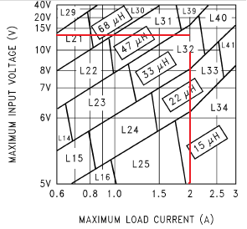
Figure 53 - Inductor Selection Graph 2
Output Capacitor (C_{out}):
Using the same quick selection guide in the LM2596 datasheet the Table 26 shows the four possible capacitor manufacturers and parameters. The 330µF capacitor is chosen with a 35V voltage rating from AVX Corporation. The TPS series part number is 478-5637-2-ND from Digi-Key for $1.35. This part fulfills the requirements stated in the previous design procedure for the output capacitor by having a voltage rating of 6.3V which is over the 1.5*output voltage. The ESR is also very small amounting to .1 Ohm.
Table 26- Output Capacitor Selection Table 2
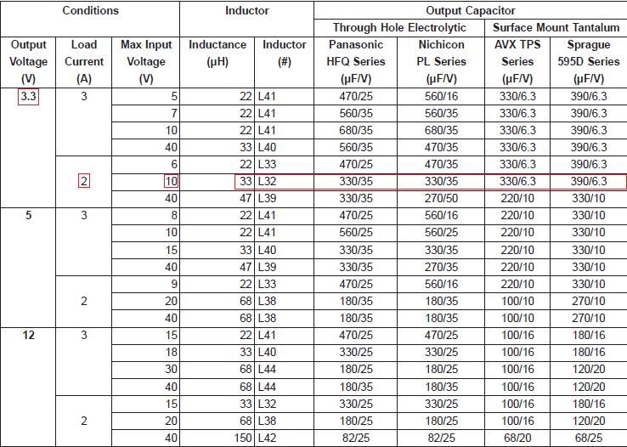
Catch Diode Selection (D1):
Using the previous restrictions set by National Semiconductor the same diode from the 5.5V buck converter design is used. This Schottky diode from Diodes Inc. is selected; part number 1N5820DITR-ND. The forward current rating is equal to 3 amps to fulfill restriction number 1 where the maximum load current is 2 amps. Furthermore the reverse voltage rating is 20V, more than 1.25 times the input voltage, and adheres to requirement number 2. Finally this particular diode is a Schottky known for its short reverse recovery time and suggested by the National Semiconductor datasheet for use. This part can be ordered from Digi-Key for $1.06.

Input Capacitor (C_{in}):
Similar to the catch diode the input capacitor is the same for the 3.3V buck converter as the 5V output buck converter. This capacitor continues to fulfill the requirements set by the National Semiconductor Company in terms of voltage rating and the current. This part is available from Digi-Key for $0.47; part number EEE-FK1V331P.

The final schematic of the 12V to 3.3V DC/DC buck converter is shown in Figure 54.
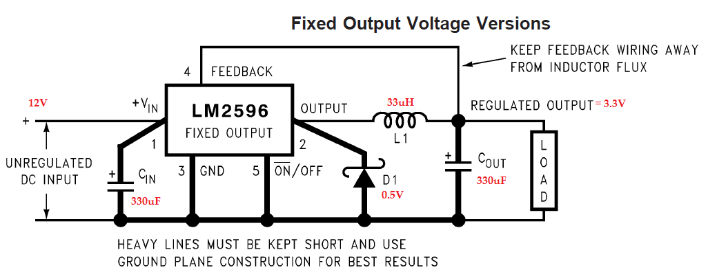
Figure 54 - 12VDC/3.3VDC Buck Converter Schematic
    - Modular Wiring Harness

A modular wiring harness or scheme makes it easier from multiple groups to work simultaneously, but provides separate wiring components so that the electric vehicle wiring may be delegated. There are several parts that are common in an EV conversion such as; batteries, motor, sensors, and solar panel. Each group would differentiate by how to utilize the various sensing tools for optimal performance. The wiring harness will incorporate the sensor/motor controller, the motor speed controller, DC/DC converter, and touch screen/user interface. Without such harness it could possibly take a day or week to change out, and mistakes can be made with wiring up a completely different components.

Figure 55 below shows twelve of the selected batteries are connected in series. The location box, denoted by the dashed green rectangle, shows the quantity and location of each battery box. One set of batteries is in the front engine compartment and the remaining in the trunk compartment. The reason for this setup is to evenly distribute the total weight of the batteries so that the suspension of the electric vehicle does not have to be redesigned to support all of the batteries in one location. Each battery box houses the batteries and temperature sensors separately to improve the performance of the temperature monitoring. The current transformer is not located inside either battery box due to the fact it is better to the have the sensor as close to the microcontroller as possible. The specific location of the current transformer is discussed later.
Figure 55 - Battery/Temperature Connection
The next figure, Figure 56, shows the connection of the auxiliary battery located in the front of the vehicle. The green dotted line represents the DC/DC converter from the 144V large battery pack in the rear of the vehicle to the battery terminals on lines 202 and 204. Line 202 is seen to follow to line 211, the 14.4 auxiliary battery. At this same terminal line 207 shows the solar panel connection to the terminals through the use of a diode. Furthermore this representation shows the connection to ground when using either the DC/DC charger or the solar panels. Line 211-2 and 211-3 lead to page 3 of the wiring harness off of the connection to the battery. The speed reference is located on line 215 of this diagram connected at ground and begins from page 5.
Figure 56 - Auxiliary Battery Connection
Figure 57 and Figure 58 show the I/O the sensor motor controller. The inputs are denoted by the << much less than symbol or plug/jack and the outputs are denoted by the >> much greater than symbol or jack/plug. The other indicator whether it is input or output is the source/destination which is denoted a ”Ƨ” and gives the reader wire number or line reference, to or from, description. From means it is an input and to means it is an output.
Figure 57 - Sensor/Motor Controller Connection
Figure 58 - Sensor/Motor Controller Connection Continued
Figure 59 show several components are that semi-realistic representation of the actual component. Some are schematic component that representation the actual component that does not look the same, but the basic operation is similar. Component VR0501 is the voltage pedal, but the actual component is the EVnetics throttle assembly is shown in Figure 26. Component RECPT0501 is female 120VAC outlet, but is use the represent the male NEMA 5-15 plug. The component between the “speed controller” and component MOT0501 is a current transformer, which is also shown in Figure 46.

Figure 59 - AC/DC, Speed and Motor Connection
Figure 60, Figure 57, and Figure 58 are the total representation of the I/O ports of the sensor/motor controller, and the same explain stated earlier applies to this same figure. Figure 61 shows the components connected to the inputs and outputs of the Figure 60. The circuitry for the wiring diagrams shown in Figure 55 through Figure 61 are shown in Figure 36, Figure 41, and Figure 47.
Figure 60 - Sensor/Motor Connection Continued
Figure 61 - Fan to Sensor/Motor Connection

  - Computer Systems
    - Class Diagrams for Motor Control System

The following section describes the software classes, variables, methods, and relations for the Motor Control System followed by the diagram, .

Sensors
Type: Class Depends on: From Sensors (signal)
The Sensors class is used to collect and organize the information from the sensor signals. This information can be temporarily stored within the class. Long term data is stored to Flash Memory. Sensor data is constantly updated within this class. The Status classes from the User Interface System is able to retrieve sensor data from the Sensors class as needed.

Motor Control
Type: Class Depends on: Sensors, Mode Buttons, Voltage Pedal
The Motor Control class will directly control the output to the motor. It will contain information related to the three modes. The Mode buttons from the User Interface System is able to set the mode in this class. The Motor Control class will also be able to calculate the appropriate output by using information from the Sensors class and the signal from the Voltage Pedal. The way that this class calculates the output will also depend on the current mode. The specific values used to find the output is determined experimentally. There is optimization for switching modes, meaning that going from Performance mode to Economy mode will not result in a sudden loss of power but a smooth transition. In addition, the Motor Control class has the ability to automatically set the mode to Economy and communicate this to the User Interface System.

From Sensors
Type: Signal Depends on: N/A
The “From Sensors” signal is the digital signal from the sensors within the vehicle. These signals will most likely be binary data that is decoded by the Sensors class.

To Motor
Type: Signal Depends on: Motor Control
The “To Motor” signal will represent the appropriate current needed to be supplied to the motor based on the calculations performed in the Motor Control class.

Voltage Pedal
Type: Signal Depends on: N/A
The “Voltage Pedal” signal is a voltage representing the amount that the operator has pressed on the accelerator. This signal is used in the Motor Control class to calculate the appropriate motor output.

Status Classes
Type: Interface Depends on: Sensors
The Status classes are those used in the User Interface System to collect information about the vehicle and display this information to the user. This interface depends on the Sensors class to collect the sensor data.

Mode Buttons
Type: Interface Depends on: N/A
The Mode Buttons interface is used to connect the Motor Control class to the Mode Buttons on the User Interface System. The Motor Control class is able to get the current mode from the Mode Buttons. This button will also read in mode data from the Motor Class in the event that the vehicle is automatically put into Economy mode.
Figure 62 - Class Diagram for Motor Control System
    - Class Diagrams for User Interface
      - Standard Classes

In the following section, the class diagram for the User Interface System’s Standard Classes is discussed. The Standard Classes are those classes that are common between all three views. All the classes, methods, variables, and relations is explained. Following the explanation is the diagram itself in Figure 63.

Sensors
Type: Interface Extends: N/A Depends on: N/A
The Sensors interface is used to get the sensor data from the sensors, through the motor controller. The method “getSensorData()” will return an array of bytes containing the needed information. This information is processed and stored in the appropriate memory locations.

Speed
Type: Class Extends: N/A Depends on: Sensors
The Speed class will contain all variables and methods related to the speed of the vehicle. This class will get the RPM and Distance in miles data from the Sensors interface. It will also calculate the speed based on the RPM at the wheels of the vehicle.

Efficiency
Type: Class Extends: N/ADepends on:Speed,BatteryPack Status
The Efficiency class will contain all variables and methods related to the efficiency of the vehicle. This class will get speed and distance information from the Speed class; it will also get power information from the Battery Status class. It will then calculate the remaining charge for the battery pack. Furthermore, it will use the mentioned information to calculate the instantaneous efficiency and average efficiency in Miles per kilowatt; and it will calculate the estimated range of the vehicle.

Efficiency History
Type: Class Extends: N/A Depends on: Speed, Efficiency
The Efficiency History class is used to save efficiency data for later use by the History View. It is able to sort the data in such a way that it is able to return information based on the unit of time provided. For example, it is able to return all efficiency information from the past week. This class will also create and manage a file structure for storing historical data. The values is stored in a specified file format, such as comma separated values.

Status
Type: Abstract Class Extends: N/A Depends on: Sensors
The Status class is an abstract class for the Battery, Battery Pack, and Motor status classes. It contains methods and variables for extracting temperature, current, and voltage data from the Sensors interface.

Battery Status
Type: Class Extends: Status Depends on: N/A
The Battery status class is used to create instances for each battery in the system. This class extends the Status class and collects information from the Sensors interface related to each individual battery in the system. If a battery’s temperature, voltage, or current breaks one of the set thresholds, the “batteryStatus” value is set to “True” symbolizing an issue; otherwise, the value will remain “False” symbolizing that there is no issue.

Battery Pack Status
Type: Class Extends: Status Depends on: Battery Status
The Battery Pack status class contains information about the battery pack as a whole. It extends the Status class and uses the set of instances of the Battery status class to collect information about the battery pack. If any of the instances in the set are reporting an issue, then the variable “batteryPackStatus” is set to “True”; if no issue is reported then the value remains “False”. This class also contains information about the voltage and current of the battery pack as a whole.
Motor Status
Type: Class Extends: Status Depends on: N/A
The Motor Status class contains information related to the motor. It extends the Status class. If the motor’s current, voltage, or temperature breaks a set threshold then the “motorStatus” value is set to “True” to symbolize an issue; otherwise, it remains “False”.

Charging Status
Type: Class Extends: Status Depends on: N/A
The Charging Status class is able to return whether or not the vehicle is charging. Furthermore, it contains methods for finding the “rate of charging” from the solar panels and the power grid.

Display Widget
Type: Abstract Class Extends: N/A Depends on: N/A
The Display Widget class is a base class for all the on screen elements. It contains values for the length and width of an element; values for the position of an element; values for any static text within an element; and values for any dynamic text within an element. There are also methods used for setting these values.

Motor Control
Type: Interface Extends: N/A Depends on: N/A
The Motor Control interface is the link between the User Interface System and the Motor Control System. It will contain methods to get and set the current driving mode.

Mode Button
Type: Class Extends: Display Widget Depends on: N/A
The Mode Button class extends the Display Widget class and also acts as an abstract class for the three mode buttons. It contains methods for setting the mode and for changing the screen’s color.

Normal Mode
Type: Class Extends: Mode Button Depends on: N/A
The Normal Mode class extends the Mode Button class. When pressed, it will set the driving mode to Normal and it will change the display’s background color. When the system is forced into Economy mode, this button is disabled.

Economy Mode
Type: Class Extends: Mode Button Depends on: N/A
The Economy Mode class extends the Mode Button class. When pressed, it will set the driving mode to Economy and it will change the display’s background color. When the system is forced into Economy mode, this button is enabled automatically and will remain so until the system decides.

Performance Mode
Type: Class Extends: Mode Button Depends on: N/A
The Performance Mode class extends the Mode Button class. When pressed, it will set the driving mode to Performance and it will change the display’s background color. When the system is forced into Economy mode, this button is disabled.

Display Background
Type: Class Extends: N/A Depends on: Mode Button
The Display Background class controls the background color of the display. It is set by pressing a mode button. The values used here is experimentally determined based on the ergonomics testing done with the touchscreen display installed in the vehicle. The colors is balanced to provide a good aesthetic but must also allow the other widgets to be seen clearly by the operator.

View Button
Type:Class Extends:Display Widget Depends on:N/A
The View Button class is a display widget that represents a button. When pressed, the view on the display is changed and the button will remain active.

Basic View Button
Type: Class Extends:View Button Depends on:N/A
The Basic View Button class is a display widget that represents a button. When pressed, the view on the display is changed to the Basic View. The button will remain highlighted as long as the display is in this view.This button may be used anytime.

Advanced View Button
Type:Class Extends:View Button Depends on:N/A
The Advanced View Button class is a display widget that represents a button. When pressed, the view on the display is changed to the Advanced View. The button will remain highlighted as long as the display is in this view. This button may be used anytime.

History View Button
Type:Class Extends:View Button Depends on:N/A
The History View Button class is a display widget that represents a button. When pressed, the view on the display is changed to the History View. The button will remain highlighted as long as the display is in this view. This button is disabled while the vehicle is in motion as the information displayed by the History View is not relevant to the operation of the vehicle.

Figure 63 - Class Diagrams for the User Interface System's Standard Classes

      - Basic View

Speedometer
Type: Class Extends: Display Widget Depends on: Speed
The Speedometer class is a Display Widget that displays the vehicle’s current speed. The speed information is taken from the Speed class.

Average Miles per kilowatt
Type: Class Extends: Display Widget Depends on: Efficiency
The Average Miles per kilowatt class is a Display Widget that displays the vehicle’s average efficiency in miles per kilowatt. The efficiency information is taken from the Efficiency class.

Charge Remaining
Type: Class Extends: Display Widget Depends on: Efficiency
The Charge Remaining class is a Display Widget that displays the vehicle’s current amount of charge. The charge information is taken from the Efficiency class.

Fuel Gauge
Type: Class Extends: Display Widget Depends on: Efficiency
The Fuel Gauge Class is a Display Widget that shows the number of bars representing the amount of “Fuel” (read Charge) that remains in the system. The class contains values representing the number of bars, the bar height, the bar width, and the bar positions. Also, there is a method called “calcActiveBars()” that takes in the charge information from the Efficiency class and calculates how many bars should remain on the screen.

Estimated Range
Type: Class Extends: Display Widget Depends on: Efficiency
The Estimated Range class is a Display Widget that displays the vehicle’s current estimated range. The information is taken from the Efficiency class.

Miles per kilowatt
Type: Class Extends: Display Widget Depends on: Efficiency
The Miles per kilowatt class is a Display Widget that displays the vehicle’s current instantaneous efficiency. The information is taken from the Efficiency class.

Check Battery Pack
Type: Class Extends: Display Widget Depends on: Battery Pack Status
The Check Battery Pack class is a Display Widget that displays the current status of the vehicle’s battery pack. The widget will remain unobvious while the battery pack status is good. When the battery pack status is bad, the widget is come obvious by changing color. The information is taken from the Battery Pack Status class.

Check Battery
Type: Class Extends: Display Widget Depends on: Battery Status
The Check Battery class is a Display Widget that displays the current status of the vehicle’s system battery. The widget will remain unobvious while the battery status is good. When the battery status is bad, the widget is obvious by changing color. The information is taken from the Battery Status class.

Check Engine
Type: Class Extends: Display Widget Depends on: Motor Status
The Check Engine class is a Display Widget that displays the vehicle’s current motor status. The widget will remain unobvious while the motor status is good. When the motor status is bad, the widget is obvious by changing color. The information is taken from the Motor Status class.

Charging
Type: Class Extends: Display Widget Depends on: Charging Status
The Charging class is a Display Widget that displays the vehicle’s current charging status. The widget will remain unobvious while the vehicle is not charging. When the vehicle is being charged, the widget is obvious by changing color. The information is taken from the Charging Status class.

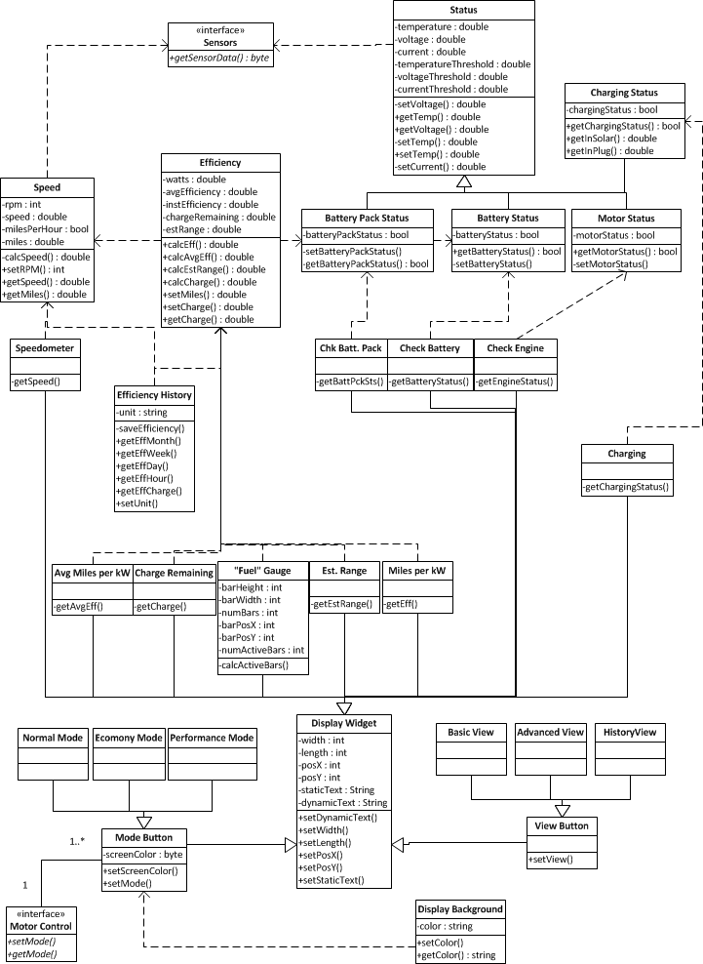
Figure 64 - Class Diagram for the User Interface System's Basic View
      - Advanced View

This view contains many of the same classes as the Basic View. Only new or changed classes are mentioned in the following section. This view is intended for the advanced user who wants to see every piece of sensor data. Or it can be used for simple diagnostics, such as pinpointing which battery in the battery pack is failing.
Check Battery Pack
Type: Class Extends: Display Widget Depends on: Battery Pack Status
The Check Battery class is a Display Widget that displays the vehicle’s current battery status. The widget will display the current temperature, voltage, and current of the vehicle’s battery pack. If any of these values falls below a set threshold, the widget will change color to make the operator aware of any issues. The information is taken from the Battery Pack Status class. This display may have an icon used to represent the battery pack, such as an image of multiple batteries grouped together.

Check Battery
Type: Class Extends: Display Widget Depends on: Battery Status
The Check Battery class is a Display Widget that displays the vehicle’s current battery status. There is thirteen (13) instances of this widget; one for each of the twelve batteries in the battery pack and one for the auxiliary battery. The widget will display the current temperature, voltage, and current of each of the batteries. If any of these values falls below a set threshold, the widget will change color to make the operator aware of any issues. The information is taken from the Battery Status class. This display may have an icon used to represent the battery, such as the battery light used in most vehicles.

Check Engine
Type: Class Extends: Display Widget Depends on: Engine Status
The Check Engine class is a Display Widget that displays the vehicle’s current motor status. The widget will display the current temperature, voltage, and current of the vehicle’s motor. If any of these values falls below a set threshold, the widget will change color to make the operator aware of any issues. The information is taken from the Motor Status class. This display may have an icon used to represent the motor, such as the engine light used in most vehicles.

Charge Solar
Type: Class Extends: Display Widget Depends on: Charging Status
The Charge Solar class is a Display Widget that displays the vehicle’s current charge intake from the solar panels. The information is taken from the Charging Status class. When the vehicle is not using the solar panels to charge, this display is dimmed. This display may have an icon used to represent the solar panels, such as a Sun.

Charge Plug
Type: Class Extends: Display Widget Depends on: Charging Status
The Charge Plug class is a Display Widget that displays the vehicle’s current charge intake from the power grid. The information is taken from the Charging Status class. When the vehicle is not using the power grid to charge, this display is dimmed. This display may have an icon used to represent the power grid, such as an electrical three-prong plug.
Figure 65 - Class Diagram for the User Interface System's Advanced View
      - Historical View

This view is used to show the user the historical data collected about the efficiency of the vehicle. The user will have the option seeing the data based on different units of time. Also, there is an option to export the data to a removable USB Flash drive.

Unit of Time Button
Type: Class Extends: Display Widget Depends on: N/A
The Unit of Time Button class is a Display Widget that displays the changes the unit of time used when calculating the efficiency history data. When a button is pressed it will remain pressed until another Unit of Time Button is pressed. When this button is pressed, it will send a signal to the Efficiency History class to change the unit of time used in displaying the graph. This will update the graph class.

Month, Week, Day, Hour, Last Charge Buttons
Type: Class Extends: Unit of Time Button Depends on: N/A
These buttons change the unit of time used when calculating the efficiency history data. This information is sent to the Graph class, where the graph is recalculated. When a button is pressed it stays active until another button is pressed.

Graph
Type: Class Extends: Display Widget Depends on: Efficiency History
The Graph class is a Display Widget that displays a graph representing the efficiency data given by the Efficiency History class and based on the set unit of time. It includes a method for creating the graph from the given data. The data is displayed as a line graph with the maximum, minimum, and average values drawn as horizontal lines on the graph. There may also be the ability to color the line different colors based on the “Mode” that the vehicle was in when this data was collected. For example, for the times that the vehicle was in Performance mode the line is colored red. This will help to show the user how efficient the vehicle was in the different modes, which may lead to a more efficient driver.

Export Data Button
Type: Class Extends: Display Widget Depends on: Efficiency History
The Export Data Button class is a Display Widget that exports efficiency history data to a USB drive when pressed. Its method will create an output file using the information from the Efficiency History class. This button will only be active when an compatible USB device that is writable is attached to the system. If there is no attached USB then this button is dimmed. When pressed, a loading screen is used to indicate to the user that the system is working, since this operation may take some time based on the amount data.

High, Low, and Average Efficiency
Type: Class Extends: Display Widget Depends on: Efficiency History
The High, Low, and Average Efficiency classes are Display Widgets that display their respective values based on the unit of time used when calculating the efficiency history data. The displays may be colored differently to emphasize the values. For example, the High Efficiency button is tinted in green, while the Low Efficiency button is tinted in red.
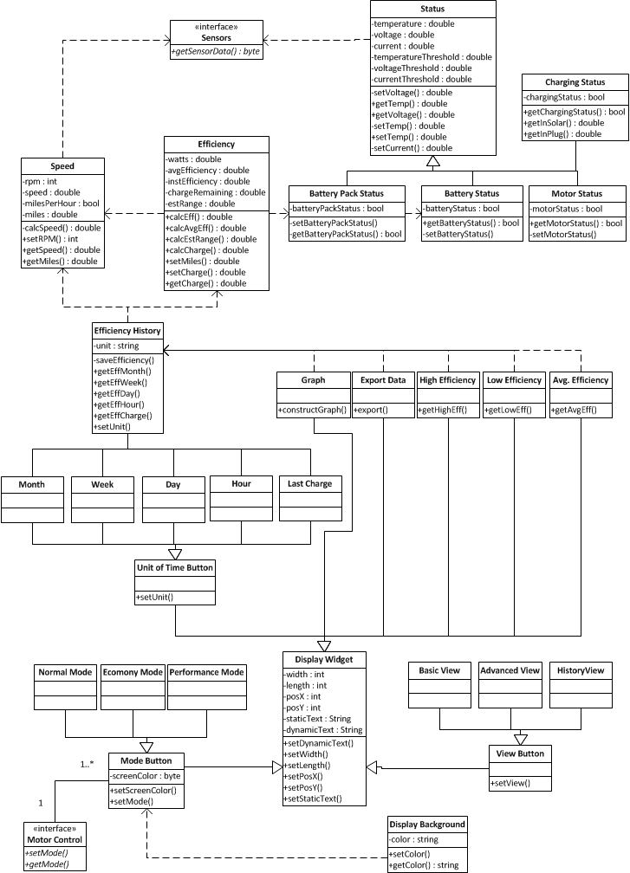
Figure 66 - Class Diagram for the User Interface System's History View
    - Touch Screen & User Interface

The project specifications call for a touch screen display that will provide real time data to the user. There are to be three “modes”: Normal, Economy, and Performance. These modes are presets that modify different attributes of the system. For example, Economy mode may restrict the rate of acceleration in order to conserve energy, whereas Performance mode will not so you can “floor it”. In addition to system controls, the display will have different “Views”. The different modes and views are described below.

    - Modes
Normal Mode
- Default Mode
- Rate of acceleration is balanced to an average rate for the given type of vehicle.
- Peripheral systems is used in a balanced way (e.g. A/C turns on and off to maintain the desired temperature).

Economy Mode
- The system will enter Economy mode when the charge level of the battery system reaches a set threshold (e.g. 20%charge left) or manually by the user.
- Rate of acceleration is reduced.
- Peripheral systems is shut down or reduced (e.g. A/C fan turned off or set to lowest setting).

Performance Mode
- The user must select this mode manually.
- Restrictions on the rate of acceleration is lifted.
- Peripheral systems can be used as the user pleases (e.g. A/C always on).

    - Views
Normal, Economy, and Performance View
- All three modes is represented with the same view but there is different background colors to indicate the mode.
  - Normal – Blue
  - Economy – Green
  - Performance – Red

Advanced User View
- This view will contain information for advanced users
  - Power draw
  - Battery status (i.e. charge and temperature) for each battery in the array
History View
- This view will contain history information
  - Efficiency (miles per kilowatt) and Energy used (total kilowatts)
  - Since last charge and over the past day, week, and month.
  - May indicate which mode was used when.
  - May have option to save log file to USB drive
  - May show amount of remaining energy per day

      - Basic View

Basic View, Figure 67, used for Normal, Economy, and Performance Modes. The color scheme of this view will change depending on the mode. The rounded rectangles symbolize buttons and the regular rectangles symbolize non-interactive display objects. The buttons are positioned to the left edge so that there are closer to the vehicle’s operator. The three modes are grouped towards the top and the three views are grouped together at the bottom. The use of space is to group buttons with similar functions together (i.e., modes together and view together). When a view or mode is active, its button is highlighted. On the right, the two most important pieces of information, the speed and the “fuel” gauge, are given a large amount of area so that they are clearly visible to the operator. At the bottom right are different displays related to energy and efficiency. At the top right are general displays used in any vehicle; the check engine, check battery pack, check battery, and charging displays will toggle between on and off accordingly.
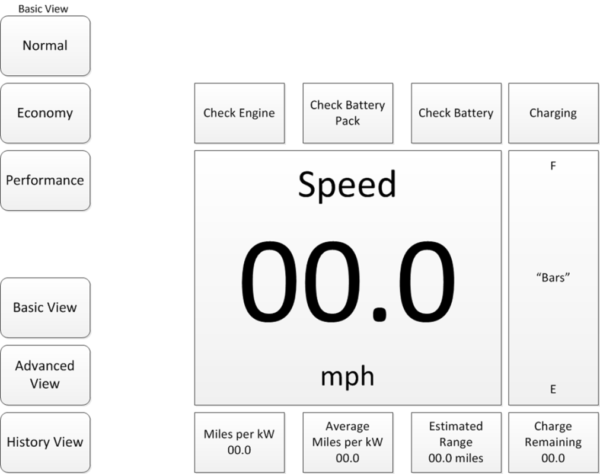
Figure 67 - Basic View
      - Advanced View

The Advanced View, Figure 68, is similar to the Basic View but includes more information about the system. At the top is a 2x6 grid of displays, reach representing a battery within the battery pack. The battery’s number, voltage, current and temperature is displayed. If any of the information falls below a certain threshold, the value and the display widget is highlighted. This information should help with the diagnosis of any battery issues; for example, a single bad battery is highlighted here. To the left of the Speed widget there are five more display widgets: the Battery Pack, Systems Battery, Engine, Charge from Solar Panels, and Charge from Plug. The Battery Pack widget displays information similar to the Battery widgets but it gives information related to the Battery Pack as a whole. The Systems Battery widget gives information related to the battery that powers the auxiliary systems such as lights, radio, etc. The Engine widget gives information related specifically to the motor. The Charge Input Solar widget displays the amount of charge that the solar panels are currently producing. The Charge Input Plug widget displays the amount of charge that the plug from the power grid is currently providing.

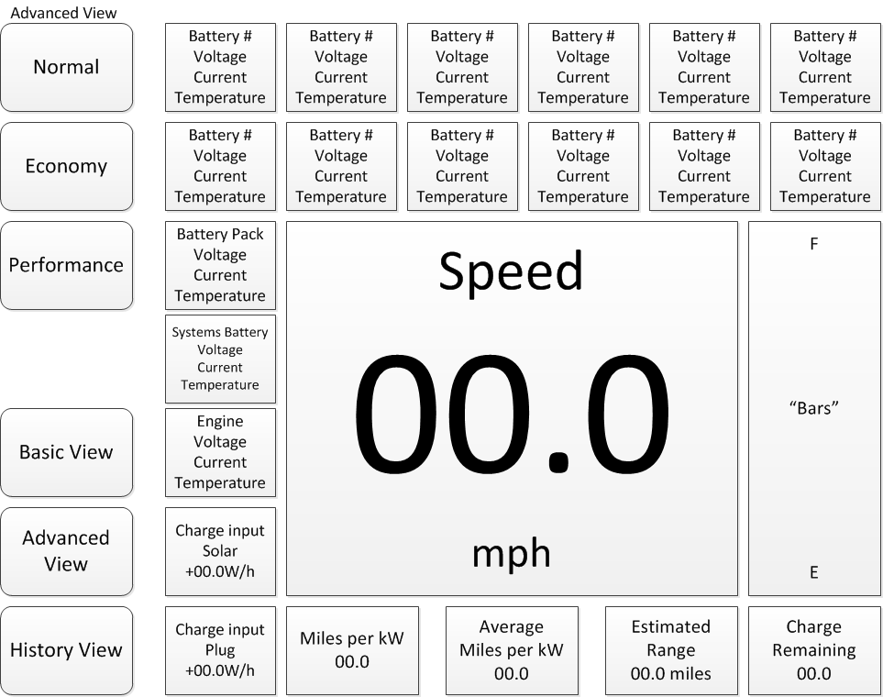
Figure 68 - Advanced View
      - Historical View

The History View, Figure 69, will provide past efficiency information to the user. This view will not be accessible while the vehicle is in motion since it does not provide information about the vehicle’s speed. At the bottom of the display are five buttons; these buttons provide historical data for each unit of time. When a unit of time is selected, the relevant data is displayed as a graph in the center. The graph will display Efficiency (Miles/kW) by sub-units of the selected unit of time. For example, if “month” is selected the sub-units is “days”; therefore the graph would be Efficiency by Days. In addition to the graph, when a unit of time is selected the average, highest, and lowest efficiencies for that unit are displayed at the top. The user has the option of exporting the data to a USB flash drive. The exported data will contain comma separated value files for all the data.

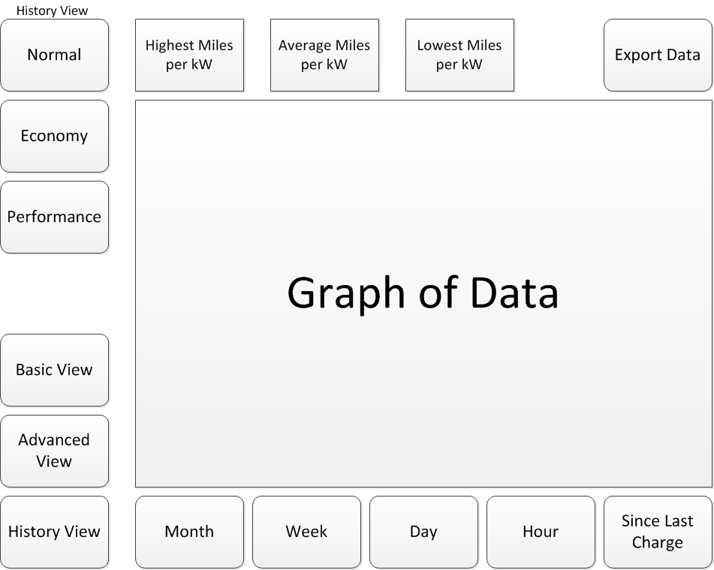
Figure 69 - Historical View

- Prototype

The parts included in the prototype of the electric vehicle are in Table 27 below.
Table 27 - Bill of Materials
  - Mechanical System

The prototype of the mechanical system consists of the restructuring of the actual vehicle. Due to stringent time constraints and the need to develop the design for better efficiency, a separate mechanical prototype will not be designed. Prior to changing the vehicle several knowledgeable resources is consulted such as mechanics, and prior electric vehicle converters.

    - Removing Existing Equipment

In order to convert the electric vehicle it is necessary to remove as much weight as possible from the existing system to make the vehicle more efficient. This process is to be completed by a group of people knowledgeable in using the mechanical tools listed below. It is necessary to follow proper safety precautions when using this equipment and tampering with the vehicle structure.

Tools Needed
- Air compressor
- Wrenches
- Socket set
- Air hammer
- Metal saw
- Screwdrivers
- Engine jacks and stands
- Engine hoist
- Fluid pump
- Fluid containers
- Drip pan
- Pliers
- Diagonal cutters

Procedure
Preparation
- Set the vehicle up on supports so that you can easily and safely maneuver under vehicle for disassembly
- Remove engine hood for ease in disassembly
- Remove the battery from the vehicle
- Removing all of the fuel from the gas tank with a pump and properly dispose of the old gasoline
- Remove the engine coolant out of the radiator by turning the water valve on the radiator and properly discard
- Remove the oil plug out of the engine and drain all of the engine oil and properly discard.
- Remove the transmission oil and properly discard
- Disconnect all of the electrical harnesses going to the engine

Removal
- Remove all of the coolant lines
- Remove the radiator fan and radiator
CAUTION: DO NOT DAMAGE the break and power steering pump lines
- Remove the fuel tank and all of the fuel lines going to the engine.
CAUTION: DO NOT DAMAGE the break lines
- Carefully remove all of the vacuum lines and any other hoses going to engine.
- Remove the exhaust system from the engine manifold all the way to the tail pipe.
NOTE: Do not dispose of the exhaust hangers because these may be used to connect the heavy gauge wire from the batteries to the electric motor when converting the vehicle to an electric vehicle
- Remove the power steering pump from the motor
- Verify that the engine is completely disconnected from the car other that the engine mounts
- Connect the engine lift to the motor and add slight tension to the motor
- Disconnect the bolts between the transmission and the engine
- Disconnect the engine mounting bolts and carefully lift the engine out of vehicle
CAUTION: DO NOT DAMAGE the power steering pump and lines, break lines, master cylinder and transmission
- Remove all of the remaining unwanted hardware that was used for the combustion engine, such as canisters for emissions and etc.
- Remove all of the harness ties and fasten the harness to firewall for use later.
- Inspect the vehicle to insure that nothing was damaged during the removal process
- Properly dispose of engine and all of the parts removed from the vehicle

    - Rebuilding and Installation

To finally convert the vehicle into an electrical machine several mechanical steps must be taken. Following this procedure the mechanical body of the vehicle should properly connect to the electrical components allowing the vehicle to perform like a gas-powered vehicle. A list of the following tools to complete the converting process is listed below. It is important to follow standard safety precautions while using the equipment and purchased parts.

Tools Needed
- Air compressor
- Wrenches
- Socket set
- Air hammer
- Torque wrench
- Metal saw
- Screwdrivers
- Engine jacks and stands
- Engine hoist
- Pliers
- Diagonal cutters
- Wire crimp tools

Parts Needed
- DC Electric motor (main drive motor)
- AC Electric motor Kit (power steering pump)
- Motor controller
- Speed controller (potentiometer box)
- Batteries
  - 12 volt battery for lights and existing reused electrical
  - Batteries for 144Volts (12v or 6 volt)
- Wire (several different sizes and types)
- Heavy duty Contactors
- Fuses
- Fuse links
- Sensors
  - Temperature
  - Rate
  - Current
  - Voltage
- Connectors and crimp lugs
- Microcontroller
- Touch screen
- AC to DC (charging main batteries)
- DC to DC (charging 12 volt battery from 144 volts)
- DC to AC (power steering motor)
- Vacuum pump(for existing breaks)
- Solar panels
- Metal conduit
- Aluminum for battery trays
- Misc. brackets hardware for mounting

Procedure
- Make a detailed interconnect wiring diagram of the electric vehicle. The diagram should contain all of the wire types and gauges and the detailed distribution of all of the batteries (trunk, engine, etc) so that proper sizing of the metal conduit can be determined
- Attach electric vehicle motor mounting bracket on the manual transmission as specified by the electric motor manufacture
- Temporarily install the electric motor onto the transmission bracket. Use the engine hoist if necessary.
- Determine a good location to add a support assembly between the electric motor and the automobile support structure. This assembly is unique to the vehicle that was selected for the EV conversion and will need to be fabricated.
- Fabricate the support bracket
- Remove the electric motor and install the support assembly onto the frame.
- Reinstall the electric motor onto the support assembly and mount to transmission and bracket
- Properly torque all of the bolts between engine, transmission and the support brackets
- Mount the motor controller on the fender wall, close to the motor
- Mount the metal conduit to the undercarriage of the vehicle between the trunk and the engine compartment (possibly reuse some of the brackets from the exhaust removal)
- Find location near the 12 volt battery holder so that the DC to DC convertor can be mounted (preferably on the automotive structure to help remove heat)
- Connect the vacuum pump assembly on the engine fire wall next to the master break cylinder and connect the hose to the master cylinder.
- Attach the electrical wires to a 12V switched relay connection in the fuse box.
- Mount the AC electric Motor kit to the existing power steering pump and fabricate a bracket to mount to the auto frame.
- Mount the DC to AC inverter to the firewall and connect the DC inputs to a switched 12 volt relay and connect the 115VAC to the AC electric motor
- Fabricate battery boxes for the front and back of the vehicle
- Install the sensor/motor controller CCA on the firewall but do not connect the motor leads because the purchased controller is used initially
- Run the wiring harness throughout the vehicle and attach with wire clamps and hangers to secure
- Fabricate battery brackets and holders for both the front and rear of the vehicle
- Mount the touch screen display, touch screen microcontroller CCA and emergency stop button to the inside of automobile
- Install the voltage pedal in place of the existing gas pedal
- Connect the new harness wiring into interlock and speed sensors
- Mount test connectors for both microcontrollers to convenient place
- Install the batteries and their boxes into the vehicle
- Wire up the batteries, contactors, fuse links according to schematic drawing but leave the positive battery wire disconnected until testing
- Mount charging connector to old gas fill door
- Mount recharging interlock into fill door
- Mount all of the temperature sensors to their predetermined location and wire to harness
- Mount all of the current and voltage sensors per the schematic
- Mount all of the cooling fans to the batteries and motor controller
- Wire the new 12V harness coming from the sensor/ motor electronics into existing 12v battery harness but disconnect the positive lead of the battery and protect from shorting
- Make brackets for solar panels and install on vehicle
- Mount solar panel to vehicle and wire negative lead to harness but leave positive lead disconnected and protected for shorting
- Make sure everything is secure and wired properly.

Preliminary Testing and Troubleshooting
Equipment Needed
- Multi-meter with voltage and current probes
- Wrenches
- Screwdrivers

Testing
- Make sure Automobile transmission is in 1st gear and emergency brake is on.
- Complete continuity checks and verify that no shorts exist on the 12V and 144V lines.
- Verify that all of the interlock switches work
- Connect multi-meter current probe on positive 12V motor lead and connect the lead to the battery. Make sure no lights are on the vehicle and verify the battery current is less than 100mamps
- Turn the vehicle ignition switch to the on position and verify that the motor current increases
- Verify that the touch screen display is operating and communicating with the display microprocessor
- Verify that the touch screen is getting valid data from the temperature sensors, voltage and current readings. This verifies that both microcontrollers are communicating
- Connect the positive lead of the solar panel to the wiring harness and verify the current changed on the battery if automobile is in sunlight
- Turn off the ignition switch and depress the clutch pedal and brake pedal.
- Turn the ignition switch back on and verify that the two large contactors on the batteries close
- Turn off the ignition switch and connect the positive lead to the battery.
- Connect multi-meter voltage and current to battery
- Depress the clutch pedal and break and turn on the ignition switch and verify the 144V current is less than 2 amps
- Place transmission to neutral and press voltage pedal and verify motor begins to spin
- Verify that the motor voltage and current reading are working and that the motor RPM sensor is giving valid reading on the touch screen.
- Remove foot off of voltage pedal and verify that motor completely stops spinning
- Shut off the ignition switch and place vehicle back in 1st gear.
- Verify that no damage has occurred and that the wiring us unstrained
- EV is ready for next level of complete testing and refinement before road test.

  - Electrical Systems
    - PIC32

This testing section is related to the sensor/motor controller development, testing and integration. The software development and the initial test and debug of the PIC32 microcontroller is performed on the DM320003-2 PIC32 USB II starter card development card. This is a relatively inexpensive card ~$60. The software for each of the functions is written and tested on the card before all of the functions are combined. The following is the order in which the code is written and verified.
Required Equipment and Parts
- Computer with USB
- DM320003-2 PIC32 USB II starter card
- Oscilloscope
- Multi-meter
- 5 k potentiometer
- LED’s
- Function generator

Development and testing
- GUI interface to display all of the data coming out of the microprocessor.
- Serial communication software and the control register.
- TheTMP03 temperature sensor software. To test this code A TMP03 sensor is tested on all sixteen temperature sensor assigned ports of the microcontroller to verify that each port accurately interprets the temperature sensor data and can output and display the value on the GUI.
- Analog inputs is coded with digital averaging filters to reduce expected motor noise. All of the inputs is connected together and a small power supply is connected to inputs and the GUI will display the analog voltages. The power supply is replaced by a 10 kHz pulsed input and verify that all of the analog inputs measure the same values. It should display an average voltage on the GUI.
- Power conversion code. Using the same technique as the analog input test the microcontroller analog inputs is tied together and a DC supply will input low value and the GUI will display these voltages and the corresponding power calculation based of these voltage.
- SPI interface, Mode control, digital controls, PWM and safety interlock interface. The going to the DAC and the Voltage Pedal input. The code is written to take analog input from a linear potentiometer tied between +3.3V and ground. The GUI will have a button for the various mode controls. The analog input voltage from the voltage pedal is displayed on the GUI and the output of the DAC is fed back into analog input number zero. Connect LED’s to the FAN and Relay digital output Pins and verify the LED’s are on.
  - Select the normal mode control button. The interlock digital inputs will have a toggle switch between power and ground which selects the two safety positions. Select the switch to the ground position. Quickly turn that potentiometer form low to high and verify the DAC output is a slow ramp but will eventually be equal to the voltage pedal input . Select the Performance mode button and repeat the same test and verify that the input and output directly correlate.
  - Select the Economy mode button and repeat the same test and verify that the output has a slow ramp and that the DAC output only reaches a maximum of 60% of the input voltage and that all of the Fan LED’s turned off.
  - Select the interlock button to +3.3V and verify that regardless of the voltage pedal input that DAC output remains at zero and the Relay LED goes off.
  - Attach an oscilloscope to the PWM output and measure the pulse width oscilloscope and repeat steps a-c and verify the pulse width very according the ratio of the input and output test.
- Speed and RPM interface. Connect a function generator that output a narrow low going pulse and connect the speed and RPM inputs. Verify that the frequency of the pulsed inputs agree with the frequency displayed on the GUI.
- Combine the code and repeat the testing.
- Integrate with Touch screen microcontroller
- End.

  - Computer Systems
    - User Interface

For developing the User Interface System, we will use the BeagleBoard-xM open development board. BeagleBoard is maintained by a group of volunteers, some of whom are Texas Instruments employees and is built on the same microprocessor used for this project, the Texas Instruments OMAP 3530. In addition, it includes a USB interface, DVI-D, 256MB NAND flash and 128MB RAM. The board is shown below in Figure 70. The cost of this device is $149 from Digi-Key as opposed to about $1000 for the professional Texas Instruments evaluation board.

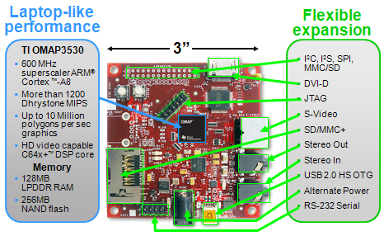
Figure 70 - BeagleBoard with Components Highlighted - Reprinted with Permission from BeagleBoard.org
Most user interface software development is done with this board. Some components may be developed using an emulator then ported to the development board. This is especially true of the Android operating system as it can be set to run as an emulator on a desktop PC. The software is developed and integrated together in a regular cycle. The order in which the software is developed is presented in the Development and Testing section.

Required Equipment and Parts
- Computer with USB
- BeagleBoard-xM
- Touchscreen Display
- ARM RVDS Toolchain

Development and Testing
- Operating System: The operating system is ported to the development board and optimized. This includes removing superfluous software components. Load time from cold start is emphasized.
- Basic View: The Basic View is developed with all planned display widgets. At this time, buttons is press-able but will not perform any action. Location and size of widgets is optimized for user interaction.
- Status Widgets: All widgets that display information, such as speedometer, fuel gauge, etc., is become functional. A class is developed to send artificial data to the system for use in testing.
- Mode Buttons: Functions for setting the mode is developed and connected to the mode button display widgets. Testing for the background adjustment is done to see which colors/tints are most clear for the user.
- Advanced and History View: Once the Basic view is found to be stable, the other two views is developed based on the Basic view. All extra display widgets is added and tested.
- View Buttons: The View buttons is connected and the appropriate restrictions is set.
- Motor Controller Connection: The User Interface System is connected to the Motor Controller. All the artificial tests is redone using the actual Motor Controller.
- Install in Vehicle: When the system is in the vehicle, test for the touchscreen display’s ergonomics. For example, are the buttons easily accessible while driving is the information readable in different light conditions, etc. Adjust any components as needed.
- End

- Testing
  - Mechanical Systems

The following section is to ensure that all the subsystems are properly integrated such as the mechanical changes with the electrical and computer interfaces. After performing the following tests, all specifications and requirements detailed by Power Grid Engineering should be met.

    - Linear Motion Test Plan

The motion test plan has three phases. The first phase of testing is to verify the electric vehicle conversion, and the second phase of testing is to verify that the different modes of operation maintain the same driving ability as phase one testing. Also, to verify the overall design according to all initial designs and any design changes as a result of phase one testing. Phase three will verify that power steering and brakes are enabled and functioning properly.

The first phase will test to verify engine start, proper gear shifting, and safety requirements. The electric vehicle will still start via key switch. The electric vehicle is a manual transmission, so only the first two gears and reverse is tested in the initial phase of testing. The safety requirements will check the stop lamps, seat belt, and backup lamps.

To test the engine start
- Press in the clutch
- Turn the key to the on position to start the EV
- Shift car into first gear
- Slowly let up on the clutch
- If, car moves forward then engine start test is complete
- Else, turn key to the off position to kill all power
- Check all connections, retest

To test proper gear shifting
- Check to see that the car shifts up to second gear
- Check to see that the car shifts down to first gear
- Come to a complete stop
- Shift gear into neutral

To test the safety requirements
- Shift to first gear
- Put car in motion, then come an abrupt stop
- Check seat belt and stop lamps
- Put car in reverse check backup lamps

The second phase of testing will test all design modes of operation of the electric vehicle. The main focus is on the smart controls which will go through all the modes of the user interface. The test plan is almost be identical to that of the phase one linear test plan but will include power steering and brakes. The first mode that is tested is the normal mode, and this mode will test the engine start, the gear shifting, power steering, brakes and safety requirements.

To test engine start
- Press in the clutch
- Turn the key to the on position to start the EV
- Shift car into first gear
- Slowly let up on the clutch
- If, car moves forward then engine start test is complete
- Else, turn key to the off position to kill all power
- Check all connections, retest

To test proper gear shifting
- Verify the EV is in Normal Mode
- Check to see that the car shifts up to second gear
- Verify speedometer readout
- Check to see that the car shifts down to first gear
- Verify speedometer readout
- Come to a complete stop
- Shift gear into neutral

To test the power steering, brakes and safety requirements
- Shift to first gear
- Put car in motion and make a right/left turn
- Come an abrupt stop by pressing the brakes
- Check seat belt and stop lamps
- Put car in reverse check backup lamps

The second mode that is tested is the performance mode, and this mode will test the engine start, the gear shifting, and safety requirements.
To test engine start
- Press in the clutch
- Turn the key to the on position to start the EV
- Shift car into first gear
- Slowly let up on the clutch
- If, car moves forward then engine start test is complete
- Else, turn key to the off position to kill all power
- Check all connections, retest

To test proper gear shifting
- Verify the EV is in Performance Mode
- Check to see that the car shifts up to second gear
- Verify speedometer readout
- Check to see that the car shifts down to first gear
- Verify speedometer readout
- Come to a complete stop
- Shift gear into neutral
To test the safety requirements
- Shift to first gear
- Put car in motion and make a right/left turn
- Come an abrupt stop by pressing the brakes
- Check seat belt and stop lamps
- Put car in reverse check backup lamps
The last mode that is tested is the economy mode, and this mode will test the engine start, the gear shifting, and safety requirements.
To test engine start
- Press in the clutch
- Turn the key to the on position to start the EV
- Shift car into first gear
- Slowly let up on the clutch
- If, car moves forward then engine start test is complete
- Else, turn key to the off position to kill all power
- Check all connections, retest

To test proper gear shifting
- Verify the EV is in Economy Mode
- Check to see that the car shifts up to second gear
- Verify speedometer readout
- Check to see that the car shifts down to first gear
- Verify speedometer readout
- Come to a complete stop
- Shift gear into neutral

To test the safety requirements
- Shift to first gear
- Put car in motion and make a right/left turn
- Come a stop by pressing the brakes
- Check seat belt and stop lamps
- Put car in reverse check backup lamps

  - Electrical Systems

The following test plans are created to verify the operation of several electrical systems within the vehicle. These systems consist of battery charging through AC/DC conversion, DC/DC conversion for auxiliary components, and a linear motion test plan to verify modes of operation.

    - AC/DC Conversion

This test plan will verify that the Elcon 1500W HF/PFC battery charger is properly functioning. Following this procedure the state of charge on the 144V battery pack should increase proving that the 120VAC input is converted to 144VDC supply for the battery pack.

To test the power curve setting
- Disconnect the 144VAC battery pack from the Elcon 1500W HF/PFC battery charger.
- Connect the 120VAC supply to the battery charger using an extension cord.
NOTE: The extension cord must be a 3 prong grounded plug with a minimum wire gauge of 16.
- Verify the LED indicator on the front of the Elcon charger is illuminated and set to the proper power curve. The power curve is indicated by the number of times the red LED flashes prior to a green flash.
NOTE: This should be pre-programmed to the battery type provided to the manufacturer.
- If power curve is incorrect contact manufacturer.

To test the output voltage of the Elcon battery charger
- Connect the Elcon battery charger to the 120VAC supply using the 3 prong grounded plug with a minimum wire gauge of 16.
- Connect a load bank to the output of the Elcon battery charger that has approximately the same resistance of the battery pack
- Check the output voltage and current on the load device using a multimeter
- The device should read approximately 140-160VDC on the output.

To test the connection to the battery pack
- Connect battery pack to the Elcon battery charger paying attention to polarity and ground connections
- Connect the Elcon battery charger to the 120VAC supply using the 3 prong grounded plug with a minimum wire gauge of 16.
- The LED should flash the power curve by the number of times the RED is illuminated until the GREEN LED flashes
- If the power curve is correct batteries should be charging
- Verify voltage across the batteries using a voltmeter
NOTE: voltage should measure approximately 12-14.4V due to charging mode
- Verify the LCD display shows an increased state of charge on the batteries
- If not, check if the Elcon battery charger reports a RED flash followed by a GREEN flash
- If it does the batteries are not connected properly to the charger.
- Check all wire connections, retest.

    - DC/DC Conversion

This test plan will verify the DC/DC Buck Converters are fully functional.

Equipment Needed
- DC power supply 0-15V at 2 Amps
- Multi-meter with leads
- Soldering iron and solder
- Hand tools
- Oscilloscope
- Connection wires
- Function generator
- Assorted power resistors less than 20 ohm
- Temperature probe

To test the 5V DC to DC Power Conversion
Prototype the LM2596 on a breadboard using the parts selected for the 5VDC configuration from the design section. This procedure will ensure the proper operation of the 5VDC converter and that it has sufficient design margin. The input voltage is varied to test for output voltage regulation.
- Attach a resistive load equivalent to .25 amps on the output of the 5V converter.
- Verify that none of the components have a temperature rise greater than 30 degrees during any of the testing
- Apply 12VDC to the input of the converter. Verify that the output voltage is 5VDC +/- 5% with multi-meter.
- Attach the oscilloscope to the output of the convertor and verify the ripple voltage is less than 100mV.
- Change the input voltage over the range of 10VDC to15VDC and verify the output remains within specified tolerance.
- Turn off the power supply
- Attach a resistive load to equivalent to 1 amp on the output of the 5V converter
- Repeat steps iii-vi
- Attach a resistive load to equivalent to 1.25 amps on the output of the 5V converter
- Repeat steps iii through vi
- Reduce the load resistor to .5 amps and add the test power MOSFET circuit as specified in Figure 71.
Figure 71 – DC/DC Test Configuration
- Attach a function generator from gate to source
- Set the function generator to square wave at TTL output at 100Hz.
- Apply 12VDC to the input of the converter. Verify that the output voltage is 5VDC +/- 5% with multi-meter.
- Attach the oscilloscope to the output of the convertor and verify that the voltage transients are less than 10%. See Figure 72 below. There are variations in the DC component of the voltages when the load is switched from 50% duty cycle to near 100% duty cycle. This is expected. This is a test of the dynamic loop response of the output voltage regulation. The loop bandwidth should be at least greater than 1 kHz to guarantee that fast transient loads will not cause major fluctuations in the output voltage regulation. The use of large bypass capacitors at the microcircuit power supply pins will provide both the power source and power sink for these fast transients power fluctuation created by the microcircuits. This will help alleviate the demand on the voltage regulator output control loop.
Figure 72 - Output Waveform for DC/DC Testing
- Turn off the power supply and the function generator

To test the 3.3V DC to DC Power Conversion

Modify the LM2596 circuit from the previous test into the 3.3VDC configuration from the design section. This procedure will ensure the proper operation of the 3.3VDC converter and that it has sufficient design margin. The input voltage is varied to test for output voltage regulation.

- Attach a resistive load equivalent to .5amps on the output of the 3.3V converter.
- Verify that none of the components have a temperature rise greater than 30 degrees during any of the testing
- Apply 12VDC to the input of the converter. Verify that the output voltage is 3.3VDC +/- 5% with multi-meter.
- Attach the oscilloscope to the output of the converter and verify the ripple voltage is less than 75mV.
- Change the input voltage over the range of 10VDC to15VDC and verify the output remains within specified tolerance.
- Turn off the power supply
- Attach a resistive load to equivalent to 2 amps on the output of the 3.3V converter
- Repeat steps iii-vi
- Attach a resistive load to equivalent to 2.5 amps on the 3.3 volt convertor
- Repeat steps iii thru vi
- Reduce the load resistor two .5 amps and add the test power MOSFET circuit as specified in Figure 71.
- Attach a function generator from gate to source
- Set the function generator to square wave at TTL output at 100Hz.
- Apply 12VDC to the input of the converter. Verify that the output voltage is 5VDC +/- 5% with multi-meter.
- Attach the oscilloscope to the output of the converter and verify that the voltage transients are less than 10%. See Figure 72.
- Turn off the power supply and the function generator

    - Auxiliary Power for DOT Certification Test Plan

The parts and accessories necessary for safe operation of a motor vehicle can be found at U.S. Department of Transportation [3]. With internal combustion engines being equal with electric vehicles as far as safety requirements there is no need to redesign the physical location of the minimum safety requirements. As stated from the U.S.D.O.T., the minimum safety devices are horn, speedometer, head lamps, tail lamps, turn signal, backup lamp, stop lamps, license plate lamp, windshield wipers, and hazard lamps. For any devices that are not mentioned will not be in effect after the electric vehicle conversion process.

Therefore, for testing we still have to verify that all of the fore mentioned safety requirements are working properly. The left turn indicator has to blink at a constant rate and work in conjunction with the left park lamp and left tail lamp. The right turn indicator has to blink at a constant rate and work in conjunction with the right park lamp and right tail lamp. The left and right turn indicator has to work with the head lamps on and off. The head lamps, tail lamps, and license plate lamps have to burn steady and work simultaneously. The backup lamps have to turn on when the electric vehicle is in reverse gear and has to burn steady until the car is put into another gear. The stop lamps must turn on when the brake pedal is pushed and burn steady until is it released. The horn has to honk when the button in the steering wheel is pressed, and constantly sound until the button is depressed. The hazards lamps encompass the left and right tail lamps, the left and right park lamps where they all have to blinking at a constant rate with the hazard button is pressed. They also must cut off when the hazard button is pressed a second time. The windshield wipers have to work at a minimum of a constant low speed. The speedometer has to work as the vehicle accelerates, decelerates, and hold a constant speed. It must be a smooth transition from each of the three states of motion.

The wiring of the electrical safety requirements will still use the existing wiring scheme, but if during initial testing show that any of the safety requirement measures are not working properly then the safety system will have to be redesigned. All these devices will work similar, if not the same as before in the internal combustion engine. The major difference is going to be how they are detected and/or controlled. The horn will still operate similar to that of the internal combustion engine, which will bypass the sensor/motor controller because control and/or sensing is not necessary for such an operation. Stop lamps are another component of safety that will not need control and/or sensing for its general operation, and is also similar to that of the internal combustion engine. Wiring of the horn and stop lamps are fairly simplistic. Both components is wired in parallel with various other components including the other safety devices that are also in parallel with the auxiliary battery as in Figure 73.

Figure 73 - Sensor/Motor Controller D.O.T. Control
The other safety components will need to be wired into the sensor/motor controller for control and/or monitoring. The above diagram is read left to right with the battery being rung zero and increment by one. Speedometer will use the traditional method of detecting speed with the of a rotation sensor. This will produce a voltage that the sensor/motor controller will monitor and output the speed to the user interface, the scheme can be seen on rung 10. Head lamp and license plate lamp can be controlled by the sensor/motor controller. The head lamp, tail lamps, and license plate lamp will operate using the existing setup with a slight alternation to the light detection. The lights are represented as one unit because the lights will operation simultaneously and can be seen on rung 4. Rung 3 shows the backup lamp on the sensor/motor controller which turns on when the electric vehicle is put into reverse. Rungs 5 and 6 are the left and right park lamps, respectfully. The park lamps is steady-burning unless the turn indicator in switched on. Rungs 7 and 8 are the left and right tail lamps, respectfully. The tail lamps is steady-burning unless the turn indicator is switched on. Rungs 5, 6, 7, and 8 all work in cooperation of each other when the turn indicator is switched on. For instance, the left indicator is activated and the sensor/motor controller knows to send out a stead pulse to rungs 5 and 7. If the head lamp is switched on the operation would still be the same, except it would affect rungs 6 and 8 steady-burning. Lastly rung 11 is the cabin lamp. Whenever a door is open the MCU will turn the light on but the user can also turn the cabin lamp on by just flipping a switch.

These ten devices is tested by one group member, the driver, sending the commands to the sensor/motor controller while the other group members verify the working operation of the safety requirements. The members external to the vehicle is located as follows to verify the test. One group member is positioned on the front-right, one group member is positioned on the front-left, and lasting one group member is positioned directly behind the vehicle. The safety check list can be viewed in Table 28.

Table 28 - D.O.T Testing Table
Item | Working Properly (circle one)
Horn | Yes / No
Head Lamps | Yes / No
Tail Lamps | Yes / No
License Plate Lamps | Yes / No
Turn Signal (left) | Yes / No
Turn Signal (right) | Yes / No
Windshield Wipers | Yes / No
Hazard Lamps | Yes / No

This check list only pertains to the safety requirements while the vehicle is in park. The unlisted requirements is tested in other sections.

  - Computer Systems
    - User Interface System Test Plan

This test plan will verify that the User Interface System is properly functioning.

To test proper start up
- From a cold start, turn on the vehicle.
- Verify that the touchscreen display turns on automatically.
- Verify that the operating system is loaded properly.
- Verify that the “Basic” view and “Normal” mode are set by default.
- If the system fails to start, check all wiring connections.
- If the operating system fails to load, check the computer board and the source code.
- If the proper view and mode are not set, check the source code.

To test proper shut down
- While the vehicle is on and the system is properly running, turn the vehicle off.
- Verify that the operating system goes through the proper shut down procedure.
- Verify that the touchscreen display turns off automatically.
- If the system turns off immediately, check wiring.
- If the operating system fails to properly shut down, check the source code.
- If the touchscreen display does not turn off automatically, check the wiring.

To test the changing of “Views”
- Press “Advanced View” button on the touchscreen.
NOTE: Button press should result in a small animation.
- Verify that the View changes to the Advanced View, that all widgets are properly displayed, and that the background color has changed.
- Repeat with the “Basic View” and the “History View”.
- Cycle between Views in various orders.
- If the action of pressing the button does not work, verify that touchscreen USB cable is connected properly to computer board, retest.
- If widgets are not displayed properly, check source code for errors. If necessary use a software debugger. Retest.

To test the updating of display values
- While one team member is operating the vehicle, another will watch the display and verify that the speed, fuel efficiency, etc. is being actively updated.
- If any values do not update or seem irregular, check motor/sensor controller and source code.
- Repeat with Basic and Advanced Views

To test the use of the “Check Battery” and “Check Engine” display widgets
- For each battery and the motor, disconnect a sensor.
- Verify that the “Check” widget is displayed.
NOTE: Software is developed to display “Check” widget in the event of a disconnected sensor.
- Repeat for every sensor: temperature, voltage, current, etc.
- Repeat again for every sensor by artificially creating “extreme” signals.
- If for any sensor and component combination the display is not shown, then check the motor/sensor controller source code for that sensor and component.

To test the changing of “Modes”
- While the vehicle is stationary, set a mode.
- Begin to accelerate the vehicle.
- Verify that the acceleration of the vehicle represents the correct mode; e.g. Performance mode should result in faster than normal acceleration and Economy mode should result in slower than normal acceleration.
- If there is no evidence of a change in mode, check the voltage pedal, motor controller, and source code.

To test the automatic setting of Economy mode due to set thresholds
- Start by having the vehicle’s amount of charge slightly above the set threshold.
- Operate the vehicle until the charge falls below the set threshold.
- Verify that the mode was automatically set to “Economy Mode”.
- If the mode was not set, check the motor/sensor controller and source code.

    - Interface Microcontroller Test Plan

This test plan will verify that the Interface Microcontroller is functioning properly. Since this controller has no user interface, it is connected to a computer through USB for debugging.

To test that sensor data is collected correctly
- For each sensor, disconnect the sensor and artificially set a value.
- Verify that the data is collected correctly by the controller.
- If the data is not correct, check the wiring, the computer board, and the source code.

To test that the Voltage Pedal data is collected correctly
- Press the Voltage Pedal.
- Verify that the correct information is collected by the controller.
- If the data is not correct, check the Voltage Pedal, the wiring, the computer board, and the source code.

To test that the Mode is read correctly from the User Interface System
- Set the mode on the touchscreen display.
- Verify that the correct mode is set in the controller.
- Repeat with each mode.
- If the mode is not set correctly, check the wiring, the board to board communication, and the source code.

To test that the correct current is being sent to the motor
- Place an ammeter at the motor.
- Set a value in the controller.
- Verify that the correct value is read by the ammeter.
- If the value is wrong, check the wiring and the source code.

- User Manual

The Intelligent Driving System (IDS) is to be used with converted electric vehicle or manufactured electric vehicle. IDS has three selectable modes and varies data output. See image below for details on the user interface. The IDS is design for seamless integration of an EV, and once it is installed it is a simple but powerful instrumentation reading out. The temperature is displayed in degrees Celsius. The motor indicator, battery indicator, and charging indicator are lights that come on similar to the check engine light in a traditional internal combustion engine.

The left of the display screen shows the three selectable modes: normal mode (N) for average acceleration which has balance battery usage, economy mode (E) for less acceleration which has the minimum battery usage, and performance mode (P) for the greatest acceleration which has the maximum battery usage. The top of the display screen has the temperature reading with corresponding temperature sensor and several indicators such as M, the check motor indicator, and B, the check battery indicator. Below the check battery indicator, is the battery gauge which tells you the percentage of the battery voltage remaining on the right side of the display screen. Located directly below the battery gauge is the charging indicator, which lets you know if the battery is being charged.

To operate the IDS simply turn on your EV and the IDS will boot up automatically. The default mode is the normal mode, and the modes can be changed while the EV is in motion. Select each of the different modes to verify that the IDS is working properly. As long as the battery gauge is above 30% then Normal and Performance modes can be selected. If the battery gauges reads 30% the IDS will automatically going into Economy mode to extend the range of the EV. At which time, the EV has to be charged above 30% before the other two modes become selectable again. The large icon centered in the middle of the display is the digital speedometer.

For the smaller application vehicle used the emergency stop button must be disabled for the connection to be made between the battery and the rear wheel motors. If this button is pressed please release it to allow the car to operate. After releasing this connection the rear wheels should begin to move. If this does not occur verify the fuse underneath the hood of the vehicle is not blown. If this fuse is malfunctioning please replace the fuse to ensure the connection and proper functionality.

After doing this the vehicle is running properly, to increase driving speed rotate the potentiometer, located to the left of the LCD display, counterclockwise, by doing this the resistance between the motors and the battery decreases allowing a greater voltage to be applied to the motors and essentially allow the car to move faster. In order to switch modes of the vehicle simply select the desired mode on the LCD display. If the LCD display isn’t on/functioning properly, disconnect the 12VDC power from the LCD display and reconnect. By doing this the LCD resets and the display is reconfigured. Depending upon the mode selected the potentiometer may or may not be functioning. If the user is in normal or economy mode the potentiometer becomes disabled and the control of the speed through this tool is no longer useful. If an emergency situation comes about the user can easily access the red emergency stop button located on the consol of the vehicle. By pressing/enabling this switch the power is disconnected from the rear wheel motors and the vehicle comes to a complete stop. Following an emergency event, if the user needs to move the vehicle disabling the emergency stop connects power to the rear motors and the vehicle then becomes fully operational at this point.

Appendices

A. Copyright Permissions – Figures

Figure 1 - Software Milestones 6
Figure 2 - Hardware Milestones 6
Figure 3 - AC24 Performance Curve – Reprinted with Permission from Azure Dynamics 9
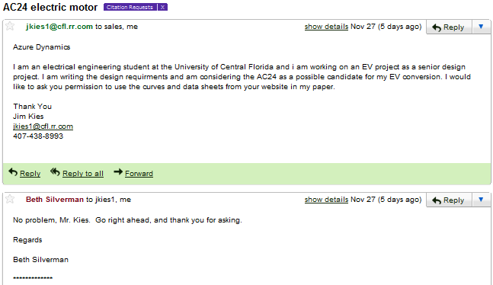
Figure 4 - AC50 Performance Curve – Reprinted with Permission from EVParts 10
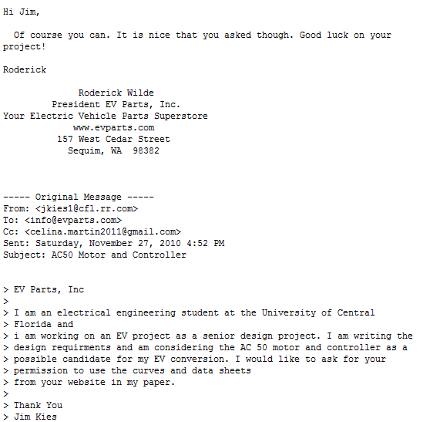
Figure 5 - EV Power vs Speed 3500lbs 12
Figure 6 - EV Motor HP vs Speed 3500lbs 13
Figure 7 - EV Weight vs Power at 40mph 14
Figure 8 - EV Weight vs HP at 40mph 14
Figure 9 - Cost vs Power 17
Figure 10 - Weight vs Range 17
Figure 11 - PV Solar Radiation – Reprinted with Permission from NREL 19

Figure 12 - Power vs Hours of Sunlight 19
Figure 13 - Temperature Flow Diagram 20
Figure 14 - "1-Wire" Schematic of Chevrolet S-10 - Reprinted with Permission from Juan W. Dixon, Pontificia Universidad Catolica de Chile 22

Figure 15 - J1772 Level 2 Charging Plug - Reprinted with Permission from CleanTech Authority 24

Figure 16 - AC/DC Converter 25
Figure 17 - PFC-30 Current versus Battery Pack Voltage – Reprinted with Permission from Manzanita Micro 28

Figure 18 - DC/DC Converter 30
Figure 19 - Battery/Motor to Controller Diagram 33
Figure 20 – Block Diagram for Single Board Computer for HMI and POS – Reprinted with Courtesy of Texas Instruments 40

Figure 21 - Functional Block Diagram for OMAP35xx – Reprinted with Courtesy of Texas Instruments 41
Figure 22 - Texas Instrument Processor Block Diagram 43
Figure 23 - Electric Vehicle Model 44
Figure 24 - Voltage Pedal Electric Schematic 46
Figure 25 - Voltage Pedal Mechanical Diagram 47
Figure 26 - Evnetics Throttle Pot Box Assembly – Reprinted with Permission from Evnetics 47

Figure 27- Motor/Controller Comparison - Reprinted with Permission from NetGain 48

Figure 28 - WarP 9 Motor Schematic - Reprinted with Permission from NetGain Motors, Inc. 49
Figure 29 - Universal Battery Model UB121100 – Requested Permission from Univeral Battery 53
Figure 30 - Rear Battery Box Top View 54
Figure 31 – Rear Battery Box Front View 54
Figure 32 - Rear Battery Box Side View 54
Figure 33 - Rear Battery Box Model 55
Figure 34 – PowerFilm R14 – Reprinted with Permission from PowerFilm Solar 56

Figure 35 - PIC32 Motor Controller Connections/Functions – Reprinted with Permission from Microchip 57

Figure 36 - Sensor/Motor Controller Diagram 58
Figure 37 - Sensor/Motor Controller Circuit Card Assembly 59
Figure 38 - PWB Layout 60
Figure 39 – Routing CCA 60
Figure 40 - IGBT PWM 62
Figure 41 - DC Motor Drive Electronics 63
Figure 42 - RPM Sensor Connection- Reprinted with Permission from NetGain 65
Figure 43- Hall Effect Output RPM 65
Figure 44 – Sensor/Motor Controller Black Box 66
Figure 45 - TMP03 Temperature Measurement 68
Figure 46 - Hall Effect Sensor – Requested Permission from Pacific Scientific 70
Figure 47 - Buffer Circuitry 71
Figure 48 - Mounting of AC/DC Converter Options – Reprinted with Permission of Cloud Electric, LLC 72

Figure 49- AC/DC- DC/DC Diagram 75
Figure 50 - LM2596 Surface Mount Package Pin outs 76
Figure 51 - Inductor Selection Graph 1 76
Figure 52 - 12VDC/5VDC Buck Converter Schematic 78
Figure 53 - Inductor Selection Graph 2 79
Figure 54 - 12VDC/3.3VDC Buck Converter Schematic 80
Figure 55 - Battery/Temperature Connection 81
Figure 56 - Auxiliary Battery Connection 82
Figure 57 - Sensor/Motor Controller Connection 83
Figure 58 - Sensor/Motor Controller Connection Continued 83
Figure 59 - AC/DC, Speed and Motor Connection 84
Figure 60 - Sensor/Motor Connection Continued 85
Figure 61 - Fan to Sensor/Motor Connection 86
Figure 62 - Class Diagram for Motor Control System 88
Figure 63 - Class Diagrams for the User Interface System's Standard Classes 92
Figure 64 - Class Diagram for the User Interface System's Basic View 94
Figure 65 - Class Diagram for the User Interface System's Advanced View 96
Figure 66 - Class Diagram for the User Interface System's History View 98
Figure 67 - Basic View 100
Figure 68 - Advanced View 101
Figure 69 - Historical View 102
Figure 70 - BeagleBoard with Components Highlighted - Reprinted with Permission from BeagleBoard.org 111
Figure 71 – DC/DC Test Configuration 117
Figure 72 - Output Waveform for DC/DC Testing 118
Figure 73 - Sensor/Motor Controller D.O.T. Control 120

B. List of Tables

Table 1 - Battery Comparison 16
Table 2 - NEC Charging Levels 23
Table 3 - Manzanita Micro AC/DC Converter Models 28
Table 4 - Linear Versus Switching Regulator Comparison 32
Table 5 - FPGA versus Microprocessor Comparison 34
Table 6 - Touch Screen Comparison 38
Table 7 - Touch Screen Characteristics 39
Table 8 - Texas Instruments Processor 42
Table 9 - Voltage Pedal Options 47
Table 10 - DMOC445 Controller Specifications 50
Table 11 - Curtis 1238 Controller Specifications 50
Table 12 - Curtis 1231C Controller Specifications 51
Table 13 - NetGain WarP-Drive Controller Specifications 52
Table 14 - Lead-Acid Battery Selection 53
Table 15 - Controller Specifications 56
Table 16 - Temperature Sensor Comparison 67
Table 17 - Voltage Sources 69
Table 18 - Physical Comparison of the AC/DC Converter Options 72
Table 19- Electrical Comparison of the AC/DC Converter Options 73
Table 20 - Input Current Calculation of the AC/DC Converter Options 73
Table 21 - Purchasing Comparison of the AC/DC Converter Options 74
Table 22 - Physical Comparison of the DC/DC Options 74
Table 23 - Electrical Comparison of the DC/DC Converter Options 75
Table 24 - Purchasing Comparison of the DC/DC Converter Options 75
Table 25- Output Capacitor Selection Table 1 77
Table 26- Output Capacitor Selection Table 2 79
Table 27 - Bill of Materials 103
Table 28 - D.O.T Testing Table 121

C. References

[1] | Woodbank Communications Ltd. (2010, Oct. 20). Traction Batteries for EV and HEV Applications [Online] Available: http://www.mpoweruk.com/traction.htm, 2005
[2] | M. LaMonica. (2010, June 2). Network of Web-savvy EV-charging stations on tap [Online] Available: http://news.cnet.com/8301-11128_3-20006555-54.html
[3] | Federal Motor Carrier Safety Administration. (2010, Oct. 15) Part 393: Parts and accessories necessary for safe operation [Online] Available: http://www.fmcsa.dot.gov/rules-regulations/administration/fmcsr/FmcsrGuideDetails.aspx?menukey=393,

